Homework
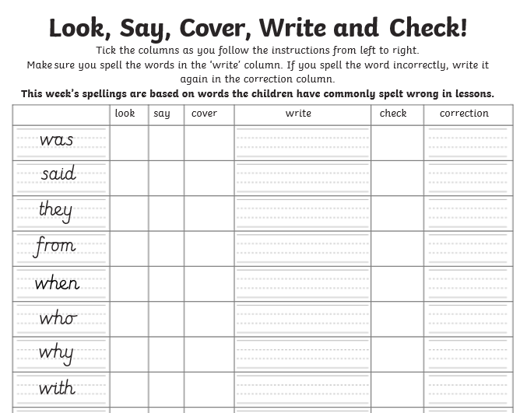
Look, Say, Cover, Write and Check!

Times tables
This week we would like all the children to have a go at TT Rockstars. The Arena or Garage mode will automatically adjust to their level.

