Tuesday/Wednesday

Read the Egyptian adventure story.
Does this story fit the criteria of a finding tale?
Section | Generic Structure | Egyptian Adventure
Opening | Introduce the main character (MC)
Build up | MC goes somewhere and finds something unusual/ amazing/important
Problem | Something goes wrong and it is the fault of the object
Resolution | MC has to put object back/throw it/hide it/call for help/ sort it out
Ending | All is well and lessons have been learnt

Create a story map of the ‘Egyptian Adventure’. See example of a story map below:
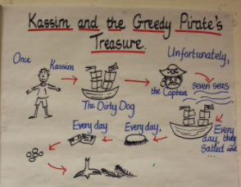

Then, add in actions to help you learn this story of by heart. Here is an example of Pie Corbett teaching some children a different story.
What actions will you use for your story?

