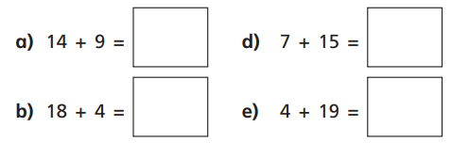


Using the number line method, can you solve the following in your books?

a)
b)
c)
d)
Thursday 22nd October 2020
LO: Add and Subtract
C: Add a 2-digit and 1-digit number - crossing 10

Using the number line method, can you solve the following in your books?

a)
b)
c)
d)
Thursday 22nd October 2020
LO: Add and Subtract
C: Add a 2-digit and 1-digit number - crossing 10

