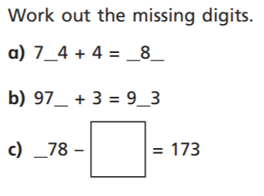
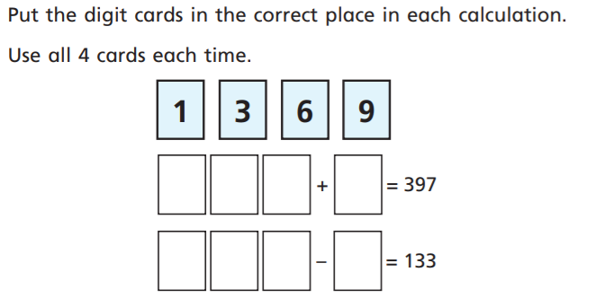
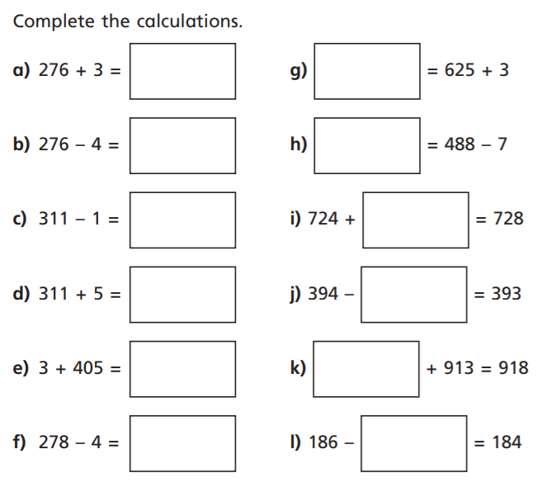
4.
2. Choose one question from question 1. Draw a bar model to show what you have done. Write a sentence to explain your method.
3.
2.
1.

