Wednesday 23rd September 2020
LO: To plan a diary entry
C: The Heart and The Bottle
Complete the plan and then spend the rest of the week writing your diary entry. Think carefully about how a diary is set out. https://www.bbc.co.uk/bitesize/articles/z6yxt39

 | Dear diary,
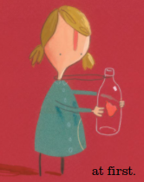 | _______________________________________________  _______________________________________________  _______________________________________________  _______________________________________________  _______________________________________________  Emotions/actions: tears trickling down my cheeks, filled with saddness | Time fronted adverbials  This morning,  Yesterday,
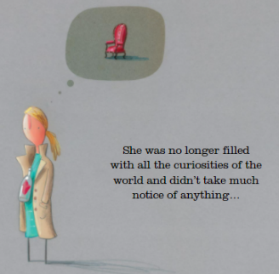 | _______________________________________________  _______________________________________________  _______________________________________________  _______________________________________________  Emotions/actions: lost, devastated, filled with grief | Time fronted adverbials
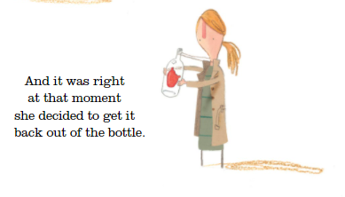 | _______________________________________________  _______________________________________________  _______________________________________________  _______________________________________________  Emotions/actions: | Time fronted adverbials  Finally,
Sign off

