Monday
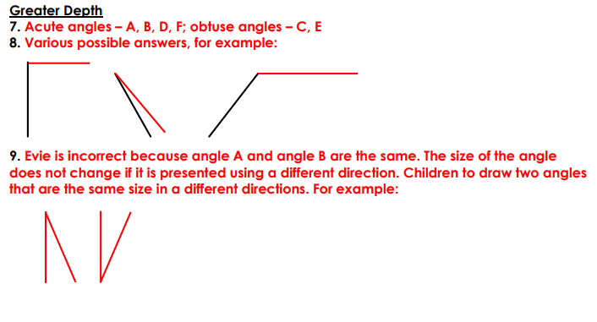
Tuesday
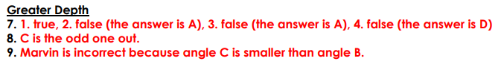
Wednesday

Thursday


