You no longer need to post Maths on Showbie.
Maths will continue to be White Rose with a Century Tech nugget relating to the work set on a Friday to be completed online.
Tasks are to be completed at home using the daily worksheets provided on our class page.
Answer pages have been included for marking at home.
Monday – Thursday you can also complete extra challenges.
You will find these below. The answers will be posted on our class pages too.

Week: 13/07/20

This week the videos are not in the usual place. Please click the link for each day to be taken to the correct video.
Monday 13th July

Please watch this video on identifying angles: https://vimeo.com/434624711

Please complete the worksheet on our class pages. We have posted the answers sheet too. Then if you feel like a challenge, try to answer these questions.

Challenge:

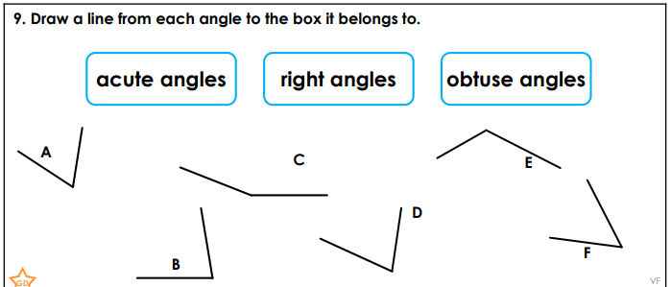
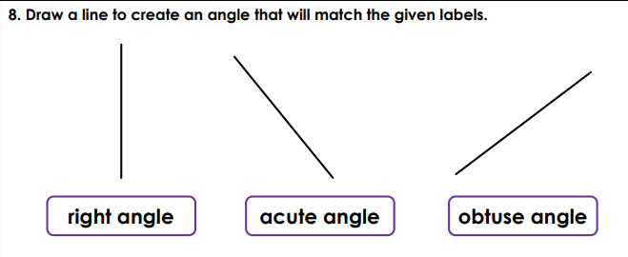
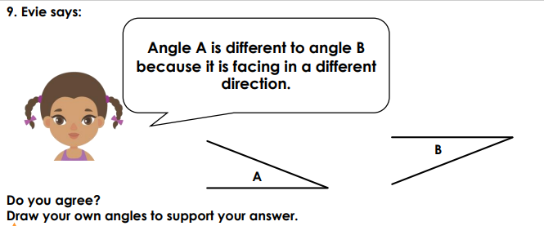

Tuesday 14th July

Please watch this video on comparing and ordering angles: https://vimeo.com/434624985

Please complete the worksheet on our class pages. We have posted the answers sheet too. Then if you feel like a challenge, try to answer these questions.

Challenge:

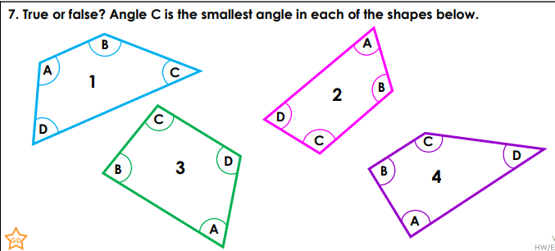
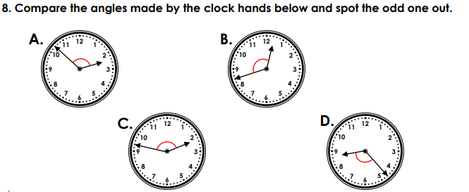
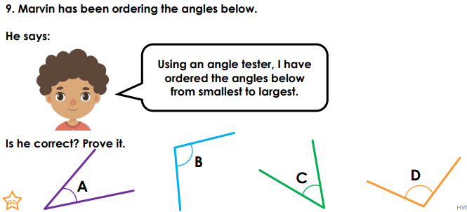

Wednesday 15th July

Please watch this video on triangles: https://vimeo.com/434625195

Please complete the worksheet on our class pages. We have posted the answers sheet too. Then if you feel like a challenge, try to answer these questions.

Challenge:

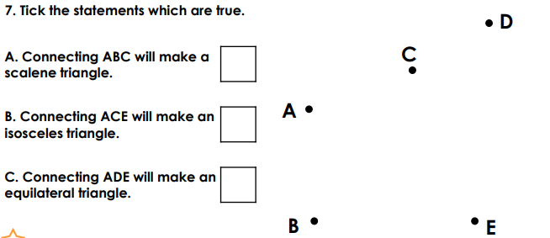
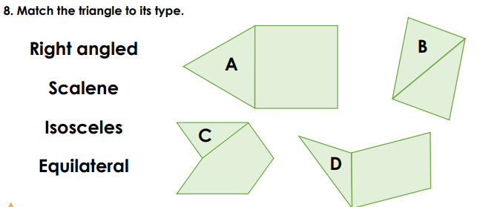
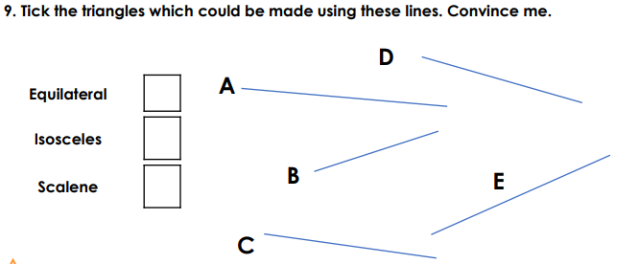

Thursday 16th July

Please watch this video on quadrilaterals: https://vimeo.com/434742962

Please complete the worksheet on our class pages. We have posted the answers sheet too. Then if you feel like a challenge, try to answer these questions.

Challenge:

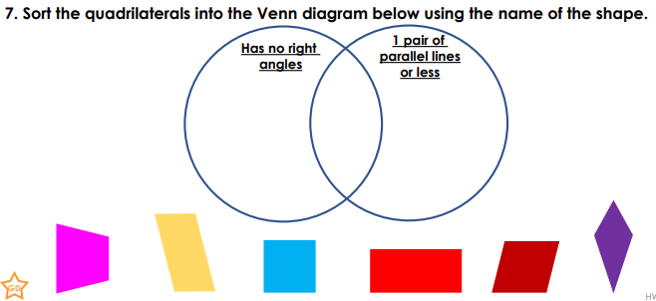
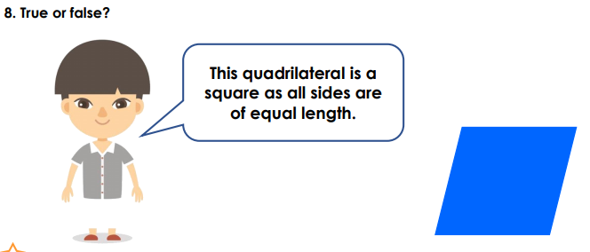
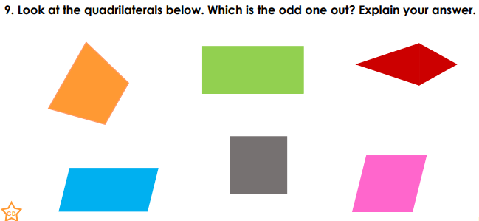

Friday 17th July

Please complete the 3 nuggets that have been set on Century Tech.

