Monday | TT Rockstars | Collective Worship | Maths  See daily plan on class page | Playtime! | English, including Reading | Spelling/  Handwriting | Lunchtime! | RE | Finish!
Tuesday | TT Rockstars | Collective Worship | Maths  See daily plan on class page | Playtime! | English, including Reading | Spelling/  Handwriting | Lunchtime! | Circle Time | Finish!
Wednesday | TT Rockstars | Collective Worship | Maths  See daily plan on class page | Playtime! | English, including Reading | Spelling/  Handwriting | Lunchtime! | Art | Finish!
Thursday | TT Rockstars | Collective Worship | Maths  See daily plan on class page | Playtime! | English, including Reading | Spelling/  Handwriting | Lunchtime! | Maths Games/  Practise anything you have found tricky this week or do some of the optional activities. | Finish!
Friday | TT Rockstars | Collective Worship | Maths  See daily plan on class page | Playtime! | English, including Reading | Spelling/  Handwriting | Lunchtime! | PE - an activity outside such as walking | Finish!

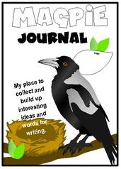
Reading
Spend 30 minutes each day either reading your own book OR completing Century Tech nuggets for “Primary English – KS2 Reading.”
(If you have a Lexia login then you can also go on Lexia for your reading.)

You can find some eBooks online at: https://www.oxfordowl.co.uk/for-home/find-a-book/library-page/

There is also a reading comprehension on our class page if you would like to complete it.

Challenge: Continue to add to your “Magpie Journal” and write down any impressive words from your reading that caught your attention and you would like to use in your own writing!

Maths
You no longer need to post Maths on Showbie.
**Maths on White Rose has been repeated again this week. We have found an alternative White Rose resource and you will need to look at the Maths Guidance document on our class page every day for both the link you will need and extra challenges.**
Maths will continue to be White Rose with a Century Tech nugget relating to the work set on a Friday (to be completed online).
Tasks are to be completed at home using the daily worksheets provided on our class page.
Answer pages have been included for marking at home.
Monday – Thursday you can also complete extra challenges. These challenges are trickier for those who are whizzing through the White Rose Maths.
The answers will be posted on our class pages too.
For those that want to challenge themselves even further, the below BBC Bitesize links may be useful:
https://www.bbc.co.uk/bitesize/topics/zrhp34j/articles/z8t72p3 - Lines of symmetry.
https://www.bbc.co.uk/bitesize/topics/zb6tyrd - lines and angles
https://www.bbc.co.uk/bitesize/articles/z64kvwx - parallel and perpendicular
https://www.bbc.co.uk/bitesize/articles/zxc9ydm - describing lines
https://www.bbc.co.uk/bitesize/articles/z2gcsk7 - comparing angles
https://www.bbc.co.uk/bitesize/articles/zwy3trd - turns and angles
Writing
Your English should be sent on Showbie this week.
This week we are going to be using all of our previous learning to help us write a story.
Please ensure you look at the English Guidance document on our class page for your English activities.

Grammar and Spelling
Grammar – You will find your daily grammar activity linked to your writing task on the English Guidance document on our class page.
Activities have been set for you on Century Tech:
Monday – Apostrophe for Contractions
Tuesday – Apostrophe for Possession
Wednesday – Apostrophe for Plural Possession
Thursday – Determiners
Friday – Commas After Fronted Adverbials
Spelling – our spelling focus for this week is apostrophes for possession and contractions.
Look at the “Spelling” document on our class page and work through the activities for this week.

RE
Remember that the main aim of the Buddha’s teaching of the Eight-Fold Path is to not bring harm to any living thing. That means not killing/harming: people, animals and the earth! It means not destroying the natural world around us.
Harm might not just mean physical harm but also emotional harm too, e.g. upsetting others / hurting someone’s feelings etc.
What do you think a Buddhist would say about:
- Eating meat?
- Telling someone what the strange person over there did today?
- Picking up a £10 note you spot in the corridor?
- Squashing a spider in the bathtub?
- Picking flowers in the garden?
- Shouting at a friend who upset you?
What would a Buddhist tell you to do instead of these actions?
Activity: Fold your page in half.
In one half – draw and illustrate a time when you were responsible for hurting another living creature. Who/what did you hurt? How did you hurt it/them?
In the other half – draw and illustrate what a Buddhist would have done instead.
Try to explain why you think they would have acted differently.
Challenge: how difficult is it each day to make sure you never harm anyone or anything?
Collective Worship
Look at the “Collective Worship” document on our class page and work through the activities and questions this week.
Art
This week we have found some lovely cartoon characters for you to try drawing:
https://www.youtube.com/watch?v=Yu2OZt7sPG4 - draw Jack Jack from The Incredibles 2
https://www.youtube.com/watch?v=C8Qk1YHd4As – Violet from The Incredibles 2
https://www.youtube.com/watch?v=8pi96F1irgs – Olaf
https://www.youtube.com/watch?v=Tg64kM4Q8ek – Elsa
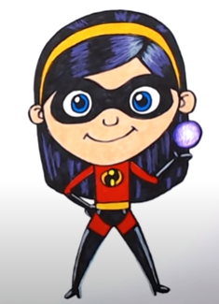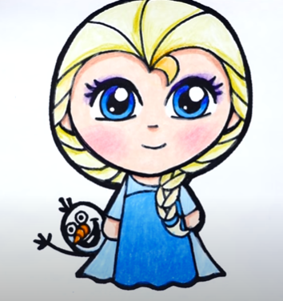
Handwriting
Look at the “Handwriting” document on our class page and work through the activities for this week.
Circle time
Complete the “Year 4 Memory Book” activity on our class page. It would be lovely for you to share some of your memories with us on Showbie!
Additional Activities
If you have some extra time, you may like to look at some of the lessons on BBC Bitesize: https://www.bbc.co.uk/bitesize/tags/z63tt39/year-4-and-p5-lessons
Geography Project (optional):
On our Year 4 class page, there are some “Extreme Earth” PowerPoints. Spend some time over the next few weeks reading through the PowerPoints and learning about ‘Extreme Earth.’ You may even like to do some research of your own on the computer or by looking in books you have at home!
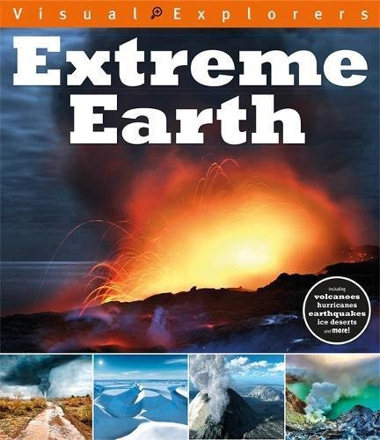
Here are some BBC Bitesize links you may want to look at:
https://www.bbc.co.uk/bitesize/articles/zxwjr2p - volcanoes.
https://www.bbc.co.uk/bitesize/articles/zbwckmn - weather and climate.
https://www.bbc.co.uk/bitesize/articles/zdqybdm – mountains.
https://www.bbc.co.uk/bitesize/articles/zkm2xyc – Latitude and Longitude.
https://www.bbc.co.uk/bitesize/articles/z4jbrj6 – Time zone.
https://www.bbc.co.uk/bitesize/topics/z849q6f/articles/zj89t39 - Earthquakes.
https://www.bbc.co.uk/bitesize/articles/zdysjhv – Hurricanes.
Using your knowledge of PowerPoint or Word, create a presentation which shows what you have learned about ‘Extreme Earth.’ Remember to include: text, pictures and diagrams. The text should be in your own words and not just copied from the PowerPoints or the internet/books.
**Take your time with this project! It should take you around 4-5 weeks to learn about ‘Extreme Earth’ and create your presentation.**
Suggested timetable:
Week 1: read through some of the PowerPoints and begin to make notes/draw diagrams.
Week 2: read through the rest of the PowerPoints and make notes/draw diagrams. If time, do some more research.
Week 3: continue to do your own research and make notes/draw diagrams.
Week 4: begin to type up your learning in PowerPoint/Word.
Week 5: finish typing up your learning in PowerPoint/Word and add any images/diagrams etc.
Spend some time in Week 5 or Week 6, editing your presentation.

