
Year 4 Distance Learning – w.b. 27.04.20
For more detailed information on activities, please see plans below the timetable!

Monday | Reading | Maths | Times Tables/Number Bonds/Telling the Time/Measuring | Playtime! | Writing | Grammar  and  Spelling | Lunchtime! | RE | French | PE
Tuesday | Reading | Maths | Times Tables/Number Bonds/Telling the Time/Measuring | Playtime! | Writing | Grammar  and  Spelling | Lunchtime! | History/Geography | Music | PE
Wednesday | Reading | Maths | Times Tables/Number Bonds/Telling the Time/Measuring | Playtime! | Writing | Grammar  and  Spelling | Lunchtime! | Science | Circle time/PSHCE | PE
Thursday | Reading | Maths | Times Tables/Number Bonds/Telling the Time/Measuring | Playtime! | Writing | Grammar  and  Spelling | Lunchtime! | Art/DT |  | PE
Friday | Reading | Maths | Times Tables/Number Bonds/Telling the Time/Measuring | Playtime! | Writing | Grammar  and  Spelling | Lunchtime! | Computing | Handwriting | PE

Reading
Please read either your school or a home reading book for 30 minutes every day.
Monday – During your reading today, write down 3 words that you don’t know the meaning of. Look up the meaning. Can you put these words into a sentence of your own?
Tuesday – During your reading today, write down 3 words that the author has chosen on purpose to have an effect on the reader. Explain what image this makes the reader think of. For example: snatched reminds someone of grabbing something from someone quickly, taking something that does not belong to them in a nasty way.
Wednesday – After your reading today, summarise what you have read and tell an adult. Can you summarise it in 50 words? 25 words? 10 words?
Thursday – After your reading today, write down how a character is feeling. Use evidence from the text to prove you are correct.
Friday – After your reading today, make a prediction about what will happen next. See if it is correct in your reading next week!

Maths
Your maths work will be on Showbie this week.

On Monday – please complete Sound Check on TT Rockstars independently. We can’t wait to see how well you’re doing!

Monday through to Friday there are daily videos for ‘Week 2’ of White Rose Maths (not Summer Week 2). Please follow this link: https://whiterosemaths.com/homelearning/year-4/ The first video of the week is titled: Divide 2 digits by 10.
**We know some of you have had trouble getting the videos to play when the website is busy. It may be a good idea to download the videos out of school hours in advance to ensure access to these videos.**
On our class pages there is a PowerPoint that has the questions the children need to answer in relation to each video for each day. Please answer the questions by using the comments section on Showbie under Maths for this week please.

Times Tables/Number Bonds/Telling the Time/Measuring
Spend some time revising these different areas of maths.
Over the week you could:
- Practise whichever ‘Maths Minutes’ you are on at the moment.
- You could watch a Percy Parker video on YouTube or play TT Rockstars.
- Have a look at some of the maths games you could play!
Complete some more Maths on Century Tech this week too.

Writing
This week we are going to be looking at Formal Letters and writing our own formal letters of thanks.

Monday – Read the example formal letters on the Year 4 class page of the school website (https://www.binfieldschool.co.uk/year-4/) and identify the features of formal letters.

Tuesday – Using a dictionary (or Google, Alexa etc.), look up the definition of gratitude.
Who do you feel thankful towards? Think about people who help us every day (especially in our current situation) but who may not get the appreciation they deserve.
How could we show people we are thankful?
Sending a letter can be a meaningful way to show gratitude.
Choose someone who has helped you to thank with a letter (e.g. doctors, nurses, delivery drivers, shop assistants etc.)
Bubble map what you would like to thank your chosen person for in your letter.

Wednesday – Look at the Formal and Informal Language PowerPoint on the Year 4 class page of our website.
Make sure you understand the difference between formal and informal language by completing the activities on the PowerPoint.
Look at the Word Mats on the last 2 slides and begin to plan some sentences you could include in your letter using some of these words. (Not all of these words will be appropriate for a letter of thanks).

Thursday – Using the example structure below; plan each part of your letter. What will you include in each paragraph?

Friday – Guided Reading; please spend your grammar time this week on Century Tech on the “Primary English – KS2 Reading” course.
You may like to spend 10-15 minutes a day on this, or do it all in one day – it’s up to you.
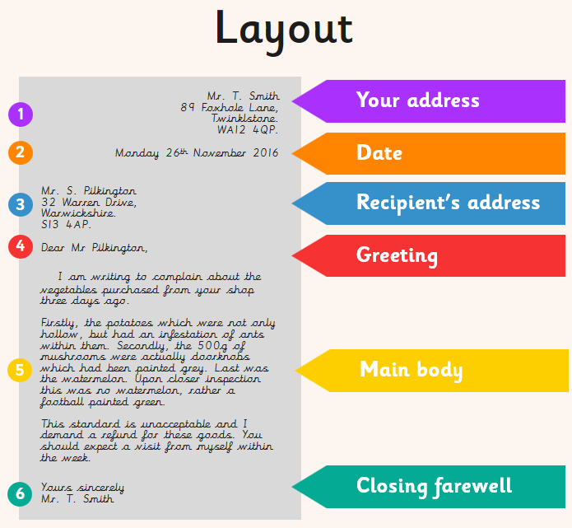
You should include:
- features of formal letters
- paragraphs
- subordinate conjunctions (because, if, when, although)
- different sentence types (compound, complex and simple)

Example Structure:
- your address and date at the top right hand of the page
- the recipients address on the left hand of the page
- formal greeting;
If you don’t know who to address your letter to, then you should begin with Dear Sir or Madam
If you know the name of the person you are writing to, then you should begin with Dear Mr, Mrs or Miss along with their surname, e.g. Dear Mr Smith
- introduction; introduce yourself and explain why you are writing the letter.
Who are you? Why are you writing this letter?
- first paragraph; the first reason you want to thank the person
- second paragraph; the second reason you want to thank the person
- conclusion
- closing farewell;
If you don’t know who to address your letter to, you should end with Yours faithfully,
If you know the name of the person you are writing to, then you should end with Yours sincerely,
- your name

Grammar and Spelling

Grammar
Please spend your grammar time this week on Century Tech on the “Primary SPaG – KS2” course.
You may like to spend 10-15 minutes a day on this, or do it all in one day – it’s up to you.

Spelling

Please practise the following spellings every day this week. You may like to use some of the strategies in the spelling video from last week (https://www.binfieldschool.co.uk/year-4/).

Decision | Confusion | Explosion
Recycle | Speedily | Examination
You might like to write out the words in different colours, try ‘look, cover, say, write, check,’ write sentences using the spellings in or ask an adult to test you on your spellings.
RE
Read The Life of the Buddha PowerPoint on our Year 4 class page of the website (https://www.binfieldschool.co.uk/year-4/).
Buddhists believe that everything changes all of the time.
Even a chair is changing as it has a person sitting on it one minute and not the next; dust on it one minute and not the next if you polish it etc.
Has anything about you stayed the same as you have grown from baby to a Year 4?
Think about what has changed in your life and how you may have changed because of these new experiences.
Did any of these changes cause suffering at the time? How? Why?
Some of these changes may have caused you to feel unhappy at the time because you wanted things to stay the same, but because they changed, it made you unhappy/uncomfortable.
Using the Road Map template on our Year 4 class page of the website: create your own road map showing the changes in your lives so far.
Annotate the changes; explaining what the changes were, whether they caused suffering and why (not).
French
Go to: https://www.french-games.net/frenchtopics.
Select Animals and then Animals – Pets.
Go through the tutorial and then play the games!
PE
Mr Gooch’s Weekly Challenge – See the video on the website for this week’s challenge. What score can you get?

Please make sure you get lots of physical exercise even whilst you are at home.

Joe Wicks is also doing a daily P.E. session for children from 9am every day this week!
Here is the link for his YouTube channel should you wish to participate. https://www.youtube.com/user/thebodycoach1

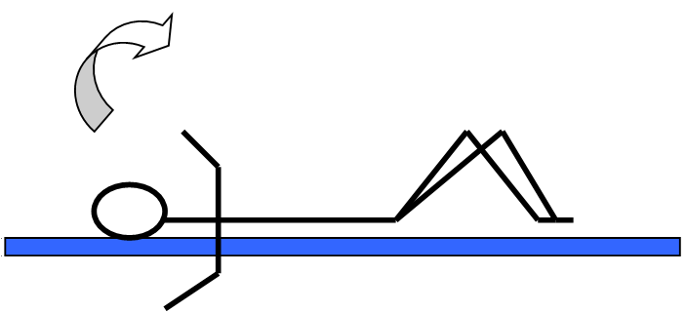
Sit Ups Circuit:
*Perform sit ups
*Curl up and down slowly
*Bend knees to support back
*Repeat

HARDER STATION: Perform sit ups slower or increase number of sit ups

EASIER STATION: Perform fewer sit ups

Remember GoNoodle is free to sign up to and play or the videos are on YouTube.
Which videos have you done?

History/Geography
Look at the PowerPoint and document on the school website. We would like you to make/draw a timeline for the Mayans detailing what you think are the most important events and marking them on your timeline. You can be as creative as you like with this – if the weather is nice maybe you could use chalk outside to draw your timeline. Feel free to upload pictures of this onto the Foundation tab on Showbie.
Challenge:
Can you mark decades, centuries and millenniums on your timeline?

Music
Now you know the names and positions of the notes, you are going to compose (create) your own piece of music!
Use: https://www.classicsforkids.com/games/compose_your_own_music.php to help you!

Science
Watch: https://www.bbc.co.uk/bitesize/topics/zgffr82/articles/zx9hcj6
Read the information on the How We Hear Things sheet on the Year 4 class page of our website (https://www.binfieldschool.co.uk/year-4/) and complete the cut and stick activity.
If you would like to challenge yourself: draw your own diagrams and write your own explanation for how we hear things.

Circle time/PSHCE
Take 5 minutes to sit still and breathe. Repeat regularly. You might like to use: https://www.youtube.com/watch?v=Bk_qU7l-fcU to help you.
Art/DT
Art
This week we’d like you to recreate the below picture by Pop Artist Andy Warhol (1962). You can use any media you like, pens, pencils, pastels, paint…

Cooking
What is your favourite sandwich filling? Can you make your own sandwich with your favourite filling in? Maybe you could take a picture and Tweet it to us at Binfield School.
Computing
We are going to be using Scratch in our Computing this week: https://scratch.mit.edu/
This week we are going to learn how to animate the letters of your name, initials, or favourite word on Scratch.
Follow the instructions on the Scratch Cards document on the Year 4 class page of the school website (https://www.binfieldschool.co.uk/year-4/).

Handwriting
Practice writing the following spellings correctly within the handwriting lines. Make sure your handwriting is joined like the example.
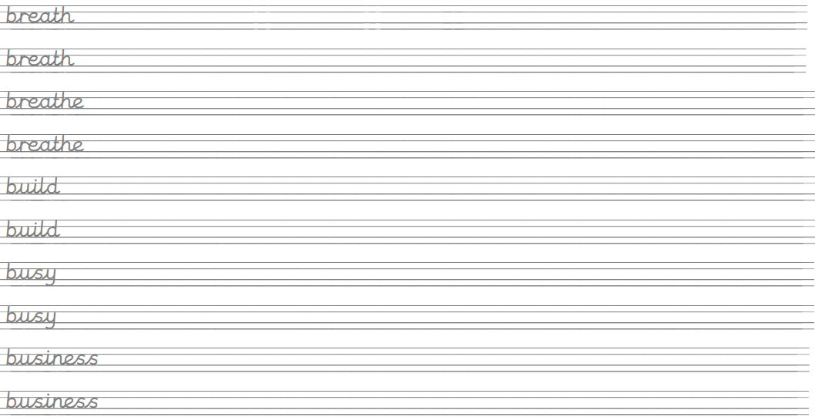

Create sentences using these words and write them up in your neatest handwriting. Take your time and make sure you form your letters correctly.
Remember, any piece of writing you do at home can be used to show Mrs Mistry for pen licence when we return to school!

