
Friday 7th May 2021 L.O: To understand texts- comparison skills C: Boy
Our task is to compare the headmasters at St Peter’s and Repton
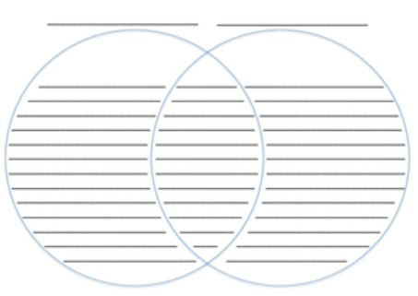
- Paddlers: Complete your Venn Diagram with the Teacher. Snorkellers: Complete your Venn Diagram independently. Divers: Complete your Venn Diagram using evidence from the text. RED PEN CHALLENGE: Why do headmasters no longer act this way?
Repton Headmaster
St Peter’s Headmaster

