
Year 4 Distance Learning – w.b. 04.05.20
For more detailed information on activities, please see plans below the timetable!

Monday | Reading | Maths | Times Tables/Number Bonds/Telling the Time/Measuring | Playtime! | Writing | Grammar  and  Spelling | Lunchtime! | RE | French | PE
Tuesday | Reading | Maths | Times Tables/Number Bonds/Telling the Time/Measuring | Playtime! | Writing | Grammar  and  Spelling | Lunchtime! | History/Geography | Music | PE
Wednesday | Reading | Maths | Times Tables/Number Bonds/Telling the Time/Measuring | Playtime! | Writing | Grammar  and  Spelling | Lunchtime! | Science | Circle time/PSHCE | PE
Thursday | Reading | Maths | Times Tables/Number Bonds/Telling the Time/Measuring | Playtime! | Writing | Grammar  and  Spelling | Lunchtime! | Art/DT |  | PE
Friday | Reading | Maths | Times Tables/Number Bonds/Telling the Time/Measuring | Playtime! | Writing | Grammar  and  Spelling | Lunchtime! | Computing | Handwriting | PE

Reading
Please read either your school or a home reading book for 30 minutes every day.
Monday – During your reading today, write down 3 words that you don’t know the meaning of. Look up the meaning. Can you put these words into a sentence of your own?
Tuesday – During your reading today, write down 3 words that the author has chosen on purpose to have an effect on the reader. Explain what image this makes the reader think of. For example: snatched reminds someone of grabbing something from someone quickly, taking something that does not belong to them in a nasty way.
Wednesday – After your reading today, summarise what you have read and tell an adult. Can you summarise it in 50 words? 25 words? 10 words?
Thursday – After your reading today, write down how a character is feeling. Use evidence from the text to prove you are correct.
Friday – After your reading today, make a prediction about what will happen next. See if it is correct in your reading next week!

Maths
This week your Maths does not need to be submitted on to Showbie.
Please go to https://whiterosemaths.com/homelearning/year-4/ and watch the daily videos for ‘Summer Term Week 1’ then answer the questions that are on the PowerPoint that you can find on the class page on our website. Again, you may find it easier to download the video prior to needing to use it as the White Rose website can get very busy.

Times Tables/Number Bonds/Telling the Time/Measuring
Spend some time revising these different areas of maths.
Over the week you could:
- Practise whichever ‘Maths Minutes’ you are on at the moment.
- You could watch a Percy Parker video on YouTube or play TT Rockstars.
- Have a look at some of the maths games you could play!
Complete some more Maths on Century Tech this week too.
Writing
Your English this week will be on Showbie.
This week we are continuing to look at Formal Letters and writing our own formal letters of thanks. Use the Formal Letter checklist on the Year 4 page of the school website to help you remember everything you need to include!

Monday – Look back at your work from last week – remind yourself of the features of formal letters and the formal language you should be using. Read through the example letter of thanks on the Year 4 page of our school website and think about what your letter of thanks might look like. Look back at your plan from last week and write the introduction paragraph for your letter.

Tuesday – Write the first paragraph of your letter explaining one of your reasons for wanting to thank the person you have chosen.

Wednesday – Write the second paragraph of your letter explaining your second reason for wanting to thank the person you have chosen. Write the conclusion paragraph and end your formal letter correctly.

Thursday – Reread your letter; making sure you edit and improve it. Have you used conjunctions to explain your reasons? Have you used expanded noun phrases to describe in detail? If possible, send your letter to the person you have chosen!

Friday – Guided Reading; please spend your English time today on Century Tech on the “Primary English – KS2 Reading” course.
You may like to spend 10-15 minutes a day on this, or do it all in one day – it’s up to you.
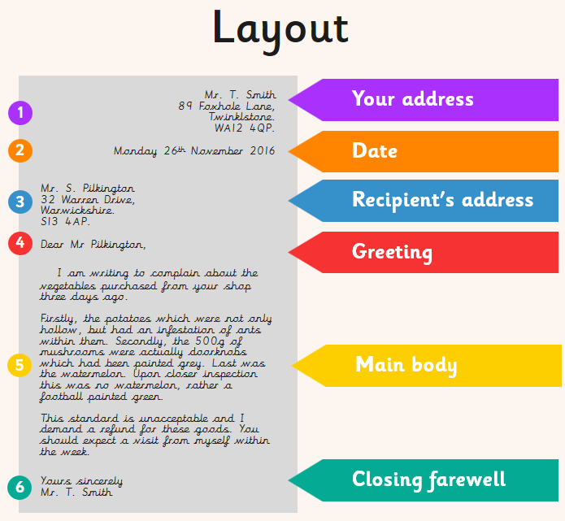
You should include:
- features of formal letters
- paragraphs
- subordinate conjunctions (because, if, when, although)
- expanded noun phrases
- different sentence types (compound, complex and simple)

Example Structure:
- your address and date at the top right hand of the page
- the recipients address on the left hand of the page
- formal greeting;
If you don’t know who to address your letter to, then you should begin with Dear Sir or Madam
If you know the name of the person you are writing to, then you should begin with Dear Mr, Mrs or Miss along with their surname, e.g. Dear Mr Smith
- introduction; introduce yourself and explain why you are writing the letter.
Who are you? Why are you writing this letter?
- first paragraph; the first reason you want to thank the person
- second paragraph; the second reason you want to thank the person
- conclusion
- closing farewell;
If you don’t know who to address your letter to, you should end with Yours faithfully,
If you know the name of the person you are writing to, then you should end with Yours sincerely,
- your name

Grammar and Spelling

Grammar
Please spend your grammar time this week on Century Tech on the “Primary SPaG – KS2” course.
You may like to spend 10-15 minutes a day on this, or do it all in one day – it’s up to you.

Spelling

Please practise the following spellings every day this week.

Impatient | Disqualify | Illegible
Syrup | Dependable | Crinkly
You might like to write out the words in different colours, try ‘look, cover, say, write, check,’ write sentences using the spellings in or ask an adult to test you on your spellings.
RE
What did the Buddha teach about not being greedy or selfish?
Read the story of The Golden Plate (you will find it on the Year 4 page of the school website).
Create a story board for the story of The Golden Plate.
Challenge: what do you think the moral of this story is? What is the Buddha trying to teach Buddhists?
French
Go to: https://www.french-games.net/frenchtopics.
Select Animals and then Animals – Farm.
Go through the tutorial and then play the games!
PE
Mr Gooch’s Weekly Challenge – See the video on the website for this week’s challenge. What score can you get?

Please make sure you get lots of physical exercise even whilst you are at home.

Joe Wicks is also doing a daily P.E. session for children from 9am every day this week!
Here is the link for his YouTube channel should you wish to participate. https://www.youtube.com/user/thebodycoach1

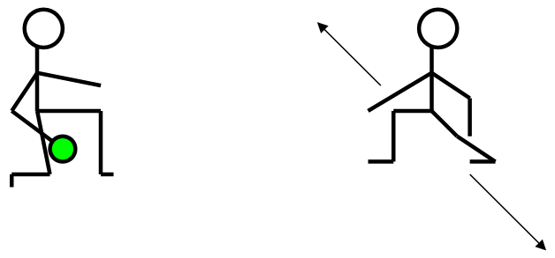
Roller Circuit:
• Roll a Tennis ball to your partners right
• Partner rolls back one handed
• Roll out to the left
• Again, partner rolls back
• Repeat

HARDER STATION: Increase the number of tennis balls or speed of throw

EASIER STATION: Roll directly to partner

Remember GoNoodle is free to sign up to and play or the videos are on YouTube.
Which videos have you done?

History/Geography
Friday 8th May is VE day. It will be the 75th anniversary of Victory over Europe, when the nation will join together to commemorate the service and sacrifice of the WWII generation then and now.
Read through the PowerPoint on the Year 4 page of our school website to find out more about VE day and choose one of the activities on the final 4 slides to complete.

Music
Continue to create (compose) your own piece of music. If you finished your composition last week – practice it and improve it! Play it to someone else in your household – what do they think about it?
Use: https://www.classicsforkids.com/games/compose_your_own_music.php to help you!

Science
Watch:
- https://www.bbc.co.uk/bitesize/clips/ztwkjxs
- https://www.youtube.com/watch?v=AxNdr0Bcx20 (you only need to watch until 5:05)
Create a poster explaining why sound travels faster in solids than in liquids or gases: Try to use diagrams to help you illustrate your explanation and give examples of when sound might travel through solids, liquids and gases.

Circle time/PSHCE
Find positive stories in the news and share these with others.
Use: https://www.bbc.co.uk/newsround to help you!
Art/DT
Art
Take a look at the Roy Litchenstine PowerPoint on our class page. Can you recreate the below piece of work? You may want to think about using paint and a cotton bud or the end of a paint brush to recreate his work.

Cooking
As this Friday is VE day, you may want to make up a picnic for your family to enjoy safely inside your home or in your garden to celebrate. Maybe you could take a picture and Tweet it to us at Binfield School.
Computing
Choose one activity from this week’s home learning to complete on PowerPoint (e.g. Science, Re, History).
Using the Helpful Hints PowerPoint on our Year 4 page of the school website, can you create a PowerPoint presentation with text, pictures, sounds and transitions showing your learning for that lesson?

Handwriting
Practice writing the following spellings correctly within the handwriting lines. Make sure your handwriting is joined like the example.
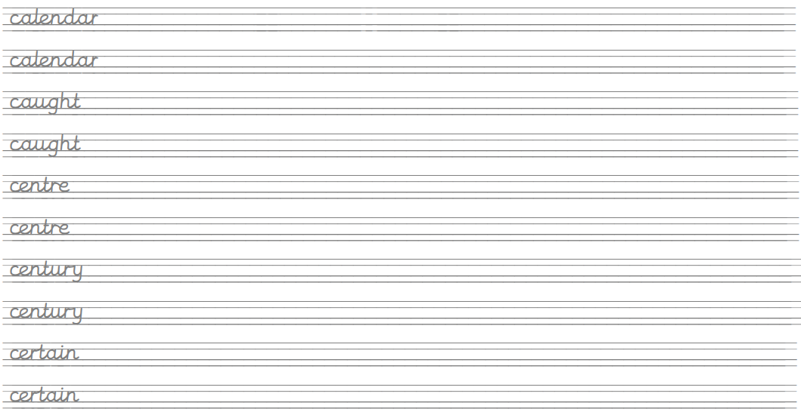

Create sentences using these words and write them up in your neatest handwriting. Take your time and make sure you form your letters correctly.
Remember, any piece of writing you do at home can be used to show Mrs Mistry for pen licence when we return to school!

