English 1: Look at this picture:
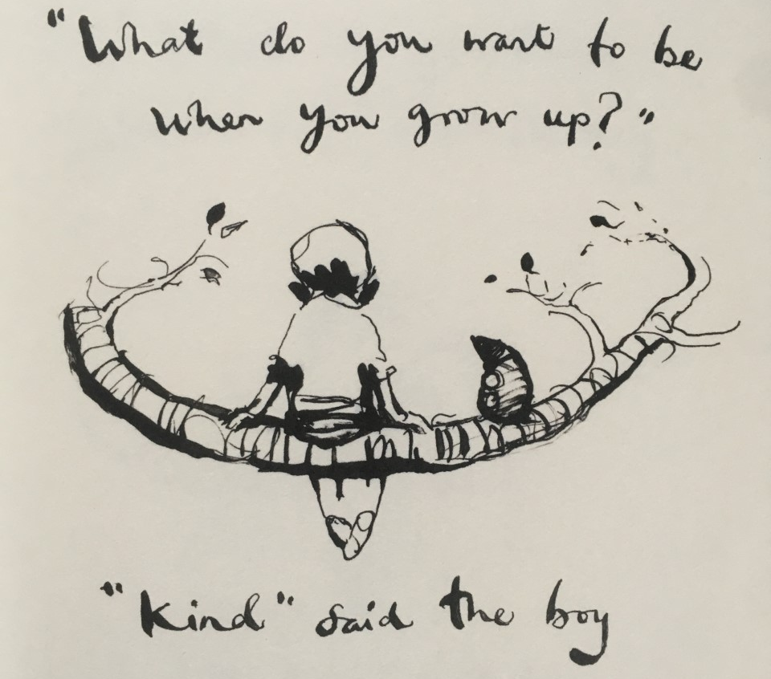
What do you think the boy looks like? What kind of person might the boy be?
Try to describe the boy using adjectives and expanded noun phrases, e.g. messy, dark hair / kind, thoughtful friend.
Activity: create a bubble map of expanded noun phrases which describe what the boy looks like/what his personality is like.

English 2: look back at your expanded noun phrases from last lesson.
How did you describe the boy? Close their eyes and imagine the child.
Activity: draw a picture of the boy, making sure his appearance meets the descriptions you gave yesterday. If you reach a part of the boy that you haven’t described, you should add an expanded noun phrase for this part in red pen to your work from last lesson, e.g. if you are drawing the boy’s shoes but haven’t described what they are like.
Extension: think of your own answer to the question, “what do you want to be when you grow up?” Try to choose a quality rather than an actual job like an astronaut! e.g. kind, thoughtful, considerate etc. You could draw/write the question and the answer around the boy, like in the original picture.

English 3: look back at your expanded noun phrases from last lesson.
Activity: Begin to turn your expanded noun phrases into descriptive sentences.
Remember to use full stops and capital letters!
e.g. The kind, thoughtful boy wore black, polished shoes with his laces tied up neatly.

English 4: look back at your expanded noun phrases from Tuesday’s lesson.

Activity: continue to write your own descriptive sentences about the boy using the expanded noun phrases from the first lesson.

English 5: red pen edit your work from yesterday; have you used capital letters and full stops correctly? Can you correct their spellings?
Challenge: use a thesaurus to look up different adjectives (https://kidthesaurus.com/)

