
Year 4 Distance Learning – w.b. 18.05.20
For more detailed information on activities, please see plans below the timetable!

Monday | Reading | Maths | Times Tables/Number Bonds/Telling the Time/Measuring | Playtime! | Writing | Grammar  and  Spelling | Lunchtime! | RE | French | PE
Tuesday | Reading | Maths | Times Tables/Number Bonds/Telling the Time/Measuring | Playtime! | Writing | Grammar  and  Spelling | Lunchtime! | History/Geography | Music | PE
Wednesday | Reading | Maths | Times Tables/Number Bonds/Telling the Time/Measuring | Playtime! | Writing | Grammar  and  Spelling | Lunchtime! | Joy of Moving
Thursday | Reading | Maths | Times Tables/Number Bonds/Telling the Time/Measuring | Playtime! | Writing | Grammar  and  Spelling | Lunchtime! | Art/DT |  | PE
Friday | Reading | Maths | Times Tables/Number Bonds/Telling the Time/Measuring | Playtime! | Writing | Grammar  and  Spelling | Lunchtime! | Computing | Handwriting | PE

Reading
Please read either your school or a home reading book for 30 minutes every day.
Monday – During your reading today, write down 3 words that you don’t know the meaning of. Look up the meaning. Can you put these words into a sentence of your own?
Tuesday – During your reading today, write down 3 words that the author has chosen on purpose to have an effect on the reader. Explain what image this makes the reader think of. For example: snatched reminds someone of grabbing something from someone quickly, taking something that does not belong to them in a nasty way.
Wednesday – After your reading today, summarise what you have read and tell an adult. Can you summarise it in 50 words? 25 words? 10 words?
Thursday – After your reading today, write down how a character is feeling. Use evidence from the text to prove you are correct.
Friday – After your reading today, make a prediction about what will happen next. See if it is correct in your reading next week!

Maths
This week your Maths does not need to be submitted on to Showbie.
This week we are looking at multiplication and division.
Watch the daily videos on https://whiterosemaths.com/homelearning/year-4/ ‘Summer Term Week 3’ then answer the question on the PowerPoint on our class page. You will find the answers on here too.

Times Tables/Number Bonds/Telling the Time/Measuring
Spend some time revising these different areas of maths.
Over the week you could:
- Practise whichever ‘Maths Minutes’ you are on at the moment.
- You could watch a Percy Parker video on YouTube or play TT Rockstars.
- Have a look at some of the maths games you could play!
Complete some more Maths on Century Tech this week too.
Writing
This week your English will be on Showbie.
We are going to make our own Non-Chronological Reports about our new species of dragon this week!
Remember: a non-chronological report is a non-fiction report which is not written in time order. It is focused on a single topic and includes lots of facts about this topic.

Monday – Look back at the Non-Chronological Report examples from last week and remind yourself of the features of Non-Chronological reports. You may want to re-watch the video from last week too: https://www.bbc.co.uk/teach/class-clips-video/english-ks1-ks2-how-to-write-a-non-chronological-report/zvbtscw.

Plan your Non-Chronological Report about your new dragon species using the template on the Year 4 page of our school website.
Use the Non-Chronological Report checklist (also on the Year 4 page of the school website) to make sure you have included everything a Non-Chronological Report needs!
You should include:
- a title for your Non-Chronological Report
- your sub-headings
- some notes about what you will write under each sub-heading
- some notes about what you will write in your introduction

Remember: you are NOT writing your report today, you are just planning it and thinking about what you will write about.

Your sub-headings could include:
- What does the dragon look like?
- Where does it live?
- What does it eat?
- How does it hunt?

Tuesday – write your introduction and the first 2 sub-headings today.
You can use the Non-Chronological Report template or create your own!

You should include:
- fronted adverbials (interesting sentence starters)
- expanded noun phrases to describe
- conjunctions (when, if, although, but, because, so)

Wednesday – write your last 2 sub-headings today.

You should include:
- fronted adverbials (interesting sentence starters)
- expanded noun phrases to describe
- conjunctions (when, if, although, but, because, so)

**Remember, you can look back at the Non-Chronological Report examples from last week to help you with vocabulary and sentence ideas.**

Thursday – Reread your work from this week: Does it make sense? Are there any spelling mistakes? Have you used fronted adverbials, expanded noun phrases and conjunctions? Add them in if you haven’t! Then you can complete your Non-Chronological Report by drawing and writing captions for any pictures or diagrams you want to include.

Friday – Guided Reading; please spend your English time today on Century Tech on the “Primary English – KS2 Reading” course.
You may like to spend 10-15 minutes a day on this, or do it all in one day – it’s up to you.

Grammar and Spelling
Grammar
Please spend your grammar time this week on Century Tech on the “Primary SPaG – KS2” course.
You may like to spend 10-15 minutes a day on this, or do it all in one day – it’s up to you.

Spelling

Please practise the following spellings every day this week.

Irregular | Irrelevant | Irresponsible
Neigh | Thistle | Encourage
You might like to write out the words in different colours, try ‘look, cover, say, write, check,’ write sentences using the spellings in or ask an adult to test you on your spellings.
RE
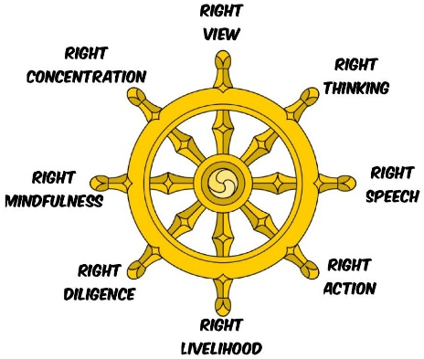
This is a Dharma wheel:
Buddhists use the Dharma wheel to represent the Eight-Fold Path.
The wheel represents the Eight-Fold Path because it has 8 spokes. The Buddha's teaching goes round and round like a great wheel that never stops. The eight spokes on the wheel represent the eight stages of the Eight-Fold Path Just as every spoke is needed for the wheel to keep turning, Buddhists need to follow each step of the path.
Can you create your own way of remembering the Eight-Fold Path?
You might:
- represent the Eight-Fold Path along an actual path
- draw a series of pictures as visual clues to the stages
- order the stages in order of importance to you
Challenge: Which stage on the 8-Fold path would make the biggest difference to your life? Why?
Would this difference be positive?

French
Go to: https://www.french-games.net/frenchtopics.
Select School and then School – School Subjects.
Go through the tutorial and then play the games!
PE
Mr Gooch’s Weekly Challenge – See the video on the website for this week’s challenge. What score can you get?

Please make sure you get lots of physical exercise even whilst you are at home.

Joe Wicks is also doing a daily P.E. session for children from 9am every day this week!
Here is the link for his YouTube channel should you wish to participate. https://www.youtube.com/user/thebodycoach1
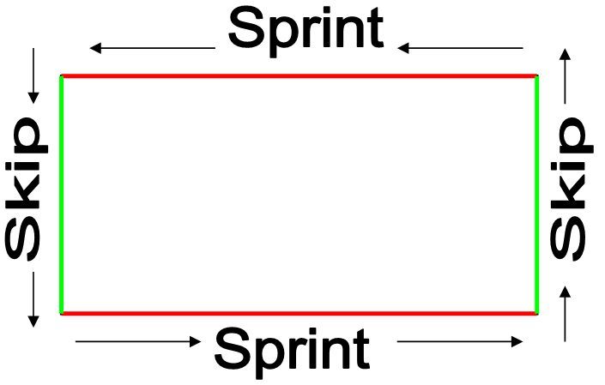
Kangaroo Skipping Circuit:
- Start at the line
- Sprint along the long lines
- Skip along the short lines
- Work around the rectangle
- Repeat

HARDER STATION: Perform High Knees in each corner OR Increase height of skip
EASIER STATION: Skip along the short lines and jog along the long lines

Remember GoNoodle is free to sign up to and play or the videos are on YouTube.
Which videos have you done?

History/Geography
This week we would like you to watch all of the videos on the Mayans at: https://www.bbc.co.uk/bitesize/topics/zq6svcw. Please make some notes about the Mayans. Then on Showbie, using the facts that you have learnt from the videos about the Mayans and your knowledge from last year of the Egyptians, write a piece answering the question: ‘Who had more impact on the world? The Mayans or the Ancient Egyptians?’ Make sure you write under the Foundation Subjects tab.
Music
Over the past few weeks, you have learned the musical notes and their positions, composed your own piece of music and written your composition down! You have been busy!
This week, you are going to perform your composition to someone in your household!
Spend some time this week practising your composition – you might practice on the website (https://www.classicsforkids.com/games/compose_your_own_music.php) or you might have a musical instrument at home that you can play it on! Use the special music paper you wrote on last week to help you!
At the end of the week, perform your composition in a mini-concert!
Science
There is no Science work this week due to Joy of Moving.
Circle time/PSHCE
There is no Circle time/PSHCE work this week due to Joy of Moving.
Art/DT
Art
This week you will be completing your final piece for our Pop Art topic. Sketch out a dragon picture inspired by Andy Warhol. Use bright and bold colours to paint or colour it in the style of Andy Warhol.

Cooking
This week, as it is nearly summer, we’d like you to create a summer inspired pudding that would complement a summer BBQ.

Computing
Using what you have learned over the last 2 weeks: create your own instruction guide to using Microsoft PowerPoint or Microsoft Word to help someone who hasn’t used them before.

Handwriting
Practice writing the following spellings correctly within the handwriting lines. Make sure your handwriting is joined like the example.
You will find some Handwriting videos from Mrs Kelley on our Year 4 page of the school website which might help you!
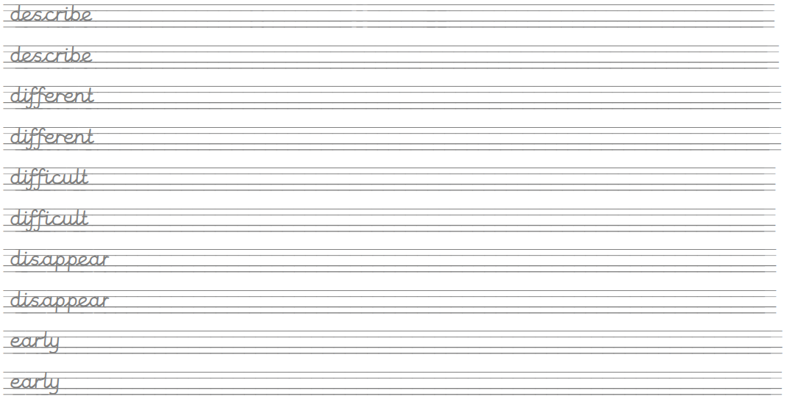

Create sentences using these words and write them up in your neatest handwriting. Take your time and make sure you form your letters correctly.
Remember, any piece of writing you do at home can be used to show Mrs Mistry for pen licence when we return to school!

