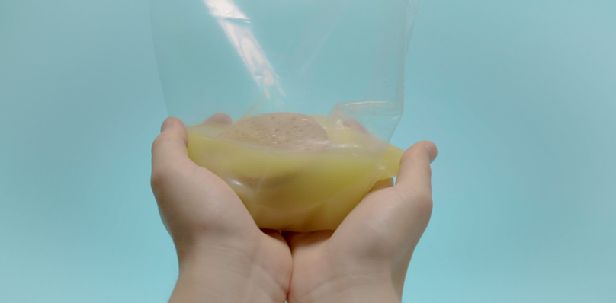 | 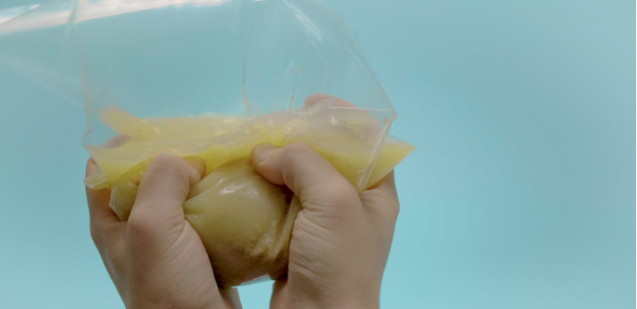 | 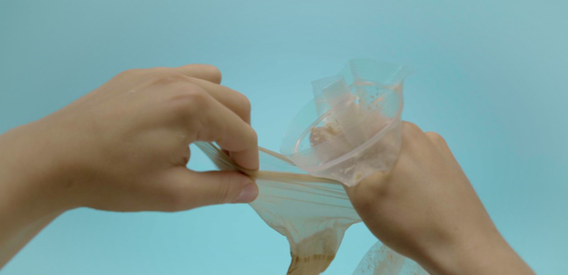
The muscle in the stomach relaxes to let the food through. It then travels into the small intestine where enzymes complete the breakdown of the food into smaller particles. | The leftover undigested waste and water travels through the colon where the water is absorbed. | The undigested waste is stored in the rectum until it is pushed out of the anus.
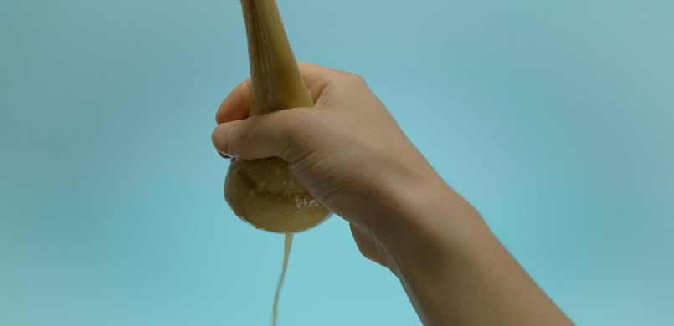 | 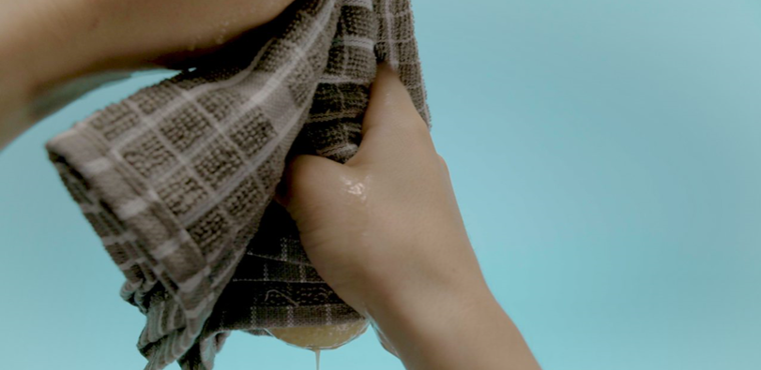 | 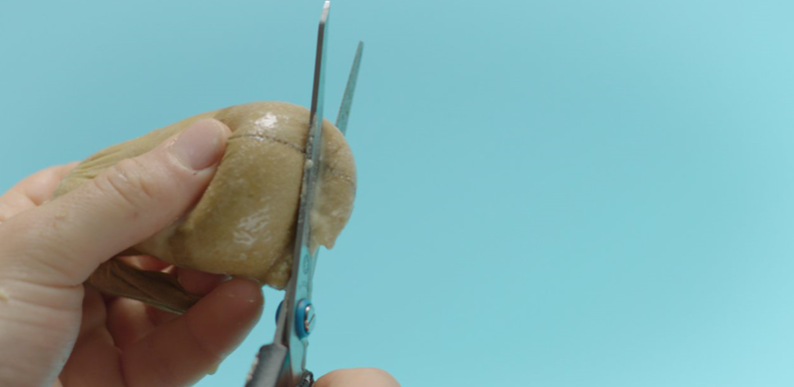
The swallowed food travels down the oesophagus and into the stomach. The food is mixed with the stomach acid. Enzymes in the stomach acid start to break down protein, sugars and fats etc. into smaller pieces. | The food then goes into the large intestine. All of the food particles that the body needs are absorbed by villi. They absorb proteins, fats, sugar, starch, minerals and vitamins into the bloodstream. | Food is put into the mouth and our teeth bite and grind the food into smaller pieces. Saliva is produced and enzymes in the saliva begin to break down starch in the food. The food is swallowed.

