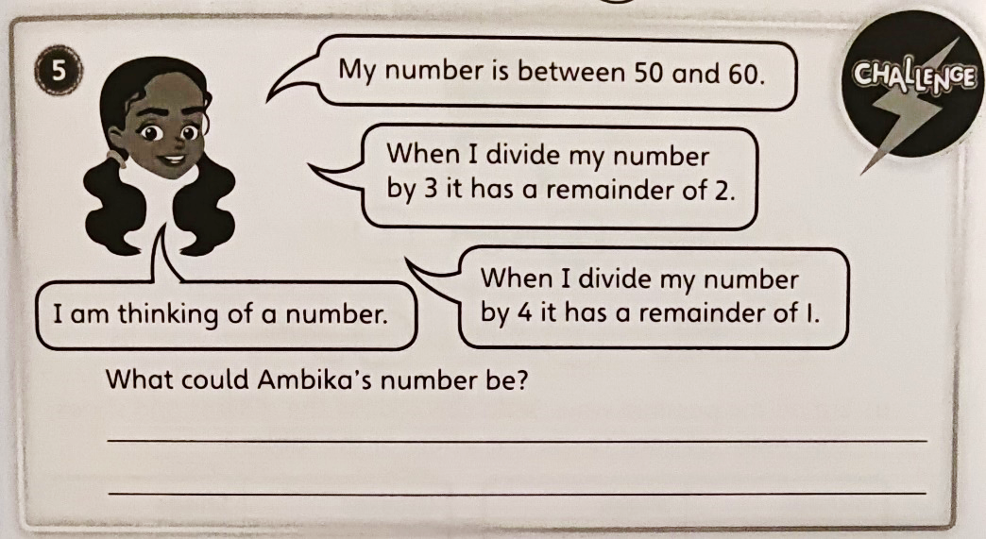
Red Pen Question
Red Pen Question
Red Pen Question
Red Pen Question

