Our spelling focus this week is: to, too or two

Spend 15 minutes each day on your spelling activities:
Monday | Go to: https://www.bbc.co.uk/bitesize/topics/z22yqhv/articles/zc4jpbk  Watch the videos and read the information.  Complete the “To, Too and Two Quiz.”  In your reading today, keep an eye out for any sentences which use to, too and two!  How do you know the author has used the correct one?
Tuesday | Can you find and correct the errors?  Mum had promised two take Ben and Jill too the zoo. The to children were so excited that they could hardly wait for Saturday to come. They wanted two take their baby sister but Mum said that she was to young.  They arrived at the zoo at two o’clock. They had too pay to get in and Mum bought them too bags of nuts to feed too the animals.  Ben wanted to go two see the lions first. Jill liked the lions but they didn’t roar or snarl the way Ben wanted them too. Mum said that probably they were to full of meat to be interested in Ben.  Jill dragged the others over two the elephants’ enclosure. Ben didn’t want to get to close two the too huge elephants while Jill tried to feed them some nuts. They gave the rest of the nuts too the monkeys and watched while two little monkeys had a fight over them.  They tried two visit every animal in the zoo but there were too many two see in one day. Mum said they could come again when their sister was old enough too come two.
Wednesday | Make your own colourful poster like the one below to help you remember which spelling to use!  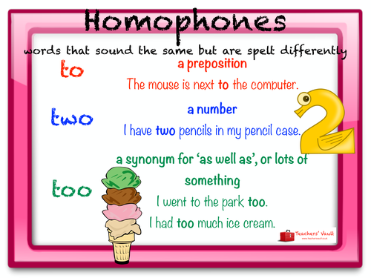
Thursday | Play the “To, Too, Two Game” PowerPoint on our class page!  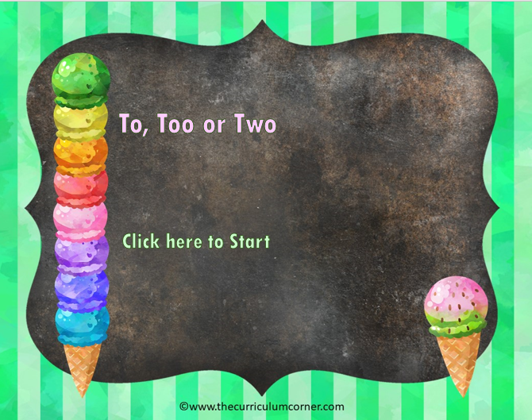
Friday | Test yourself! How well have you learned your spellings?  

