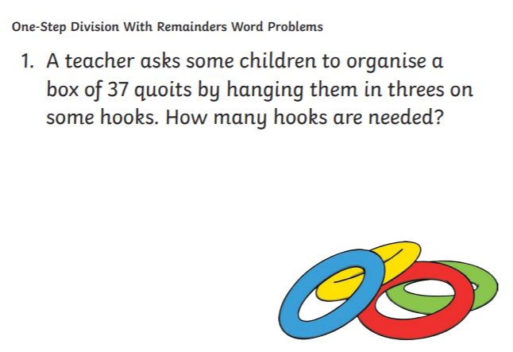
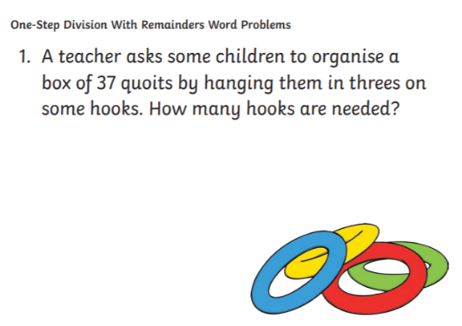
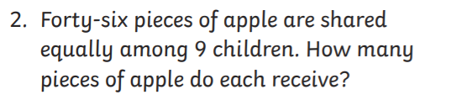

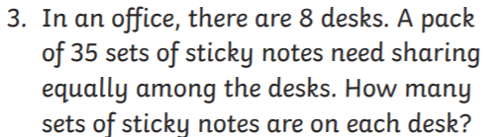

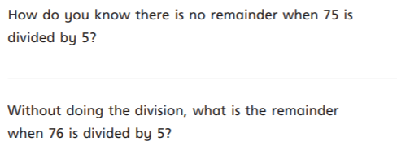
19.03.2021
L.O: Multiplication and Division
C: Divide 2-digits by 1-digit (3)
Challenge
19.03.2021
L.O: Multiplication and Division
C: Divide 2-digits by 1-digit (3)
Challenge

