You no longer need to post Maths on Showbie.
Maths will continue to be White Rose with a Century Tech nugget relating to the work set on a Friday to be completed online.
Tasks are to be completed at home using the daily worksheets provided on our class page.
Answer pages have been included for marking at home.
Monday – Thursday you can also complete extra challenges.
You will find these below. The answers will be posted on our class pages too.

Week: 06/07/20

This week the videos are not in the usual place. Please click the link for each day to be taken to the correct video.
Monday 6th July

Please watch this video on interpreting charts: https://vimeo.com/432265669

Please complete the worksheet on our class pages. We have posted the answers sheet too. Then if you feel like a challenge, try to answer these questions.

Challenge:

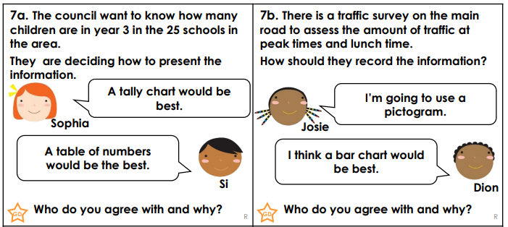
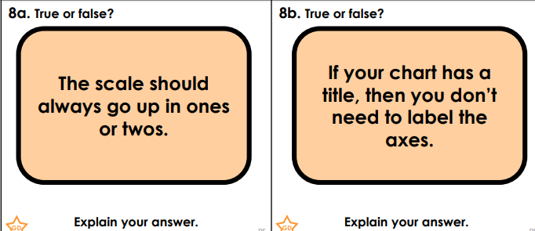
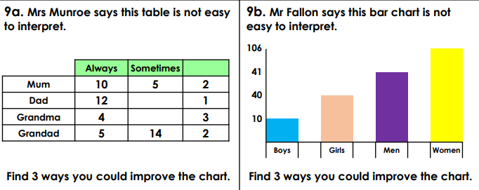

Tuesday 7th July

Please watch this video on comparing sum and difference: https://vimeo.com/432265829

Please complete the worksheet on our class pages. We have posted the answers sheet too. Then if you feel like a challenge, try to answer these questions.

Challenge:

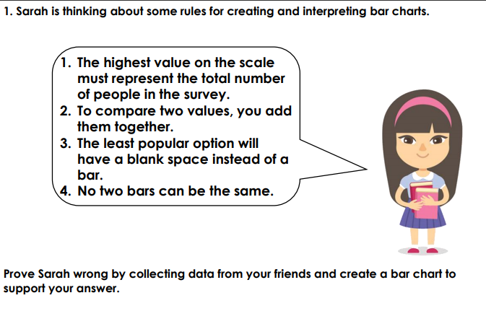
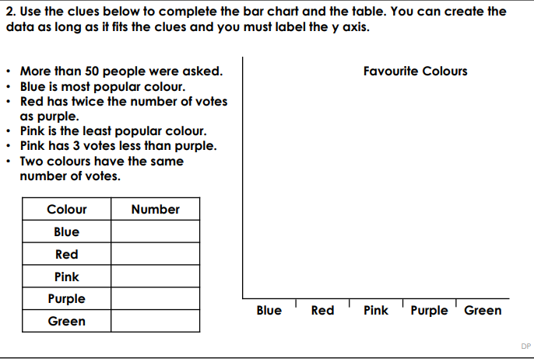

Wednesday 8th July

Please watch this video on introducing line graphs: https://vimeo.com/432265995

Please complete the worksheet on our class pages. We have posted the answers sheet too. Then if you feel like a challenge, try to answer these questions.

Challenge:

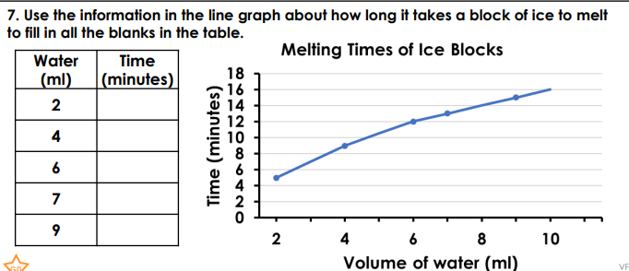
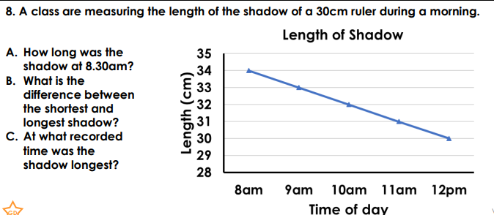
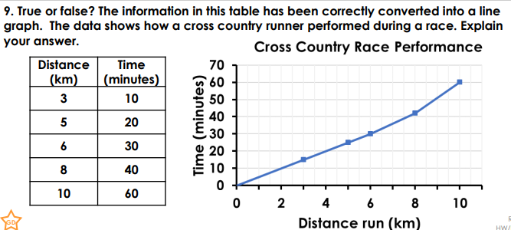

Thursday 9th July

Please watch this video on line graphs: https://vimeo.com/432266309

Please complete the worksheet on our class pages. We have posted the answers sheet too. Then if you feel like a challenge, try to answer these questions.

Challenge:

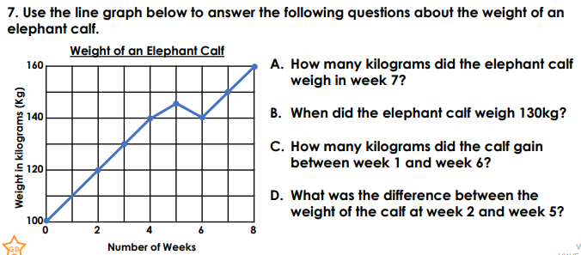

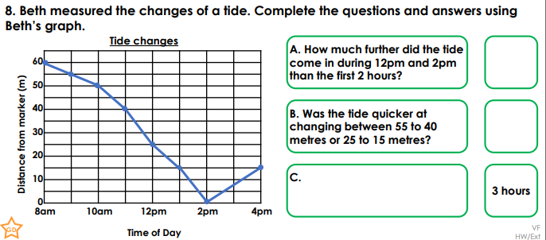
Friday 10th July
Please complete the 4 nuggets that have been set on Century Tech.

Then complete this interesting challenge on Nrich:
https://nrich.maths.org/247

