Monday | TT Rockstars | Collective Worship | Maths  See daily plan on class page | Playtime! | English, including Reading | Spelling/  Handwriting | Lunchtime! | RE | Finish!
Tuesday | TT Rockstars | Collective Worship | Maths  See daily plan on class page | Playtime! | English, including Reading | Spelling/  Handwriting | Lunchtime! | Circle Time – Year 5 task from your new teacher! | Finish!
Wednesday | TT Rockstars | Collective Worship | Maths  See daily plan on class page | Playtime! | English, including Reading | Spelling/  Handwriting | Lunchtime! | Art | Finish!
Thursday | TT Rockstars | Collective Worship | Maths  See daily plan on class page | Playtime! | English, including Reading | Spelling/  Handwriting | Lunchtime! | Maths Games/  Practise anything you have found tricky this week or do some of the optional activities. | Finish!
Friday | TT Rockstars | Collective Worship | Maths  See daily plan on class page | Playtime! | English, including Reading | Spelling/  Handwriting | Lunchtime! | PE - an activity outside such as walking | Finish!

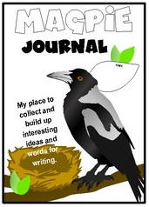
Reading
Spend 30 minutes each day either reading your own book OR completing Century Tech nuggets for “Primary English – KS2 Reading.”
(If you have a Lexia login then you can also go on Lexia for your reading.)

You can find some eBooks online at: https://www.oxfordowl.co.uk/for-home/find-a-book/library-page/

There is also a reading comprehension on our class page if you would like to complete it.

Challenge: Continue to add to your “Magpie Journal” and write down any impressive words from your reading that caught your attention and you would like to use in your own writing!

Maths
You no longer need to post Maths on Showbie.
**Maths on White Rose has been repeated again this week. We have found an alternative White Rose resource and you will need to look at the Maths Guidance document on our class page every day for both the link you will need and extra challenges.**
Maths will continue to be White Rose with a Century Tech nugget relating to the work set on a Friday (to be completed online).
Tasks are to be completed at home using the daily worksheets provided on our class page.
Answer pages have been included for marking at home.
Monday – Thursday you can also complete extra challenges. These challenges are trickier for those who are whizzing through the White Rose Maths.
The answers will be posted on our class pages too.
For those that want to challenge themselves even further, the below BBC Bitesize links may be useful.
https://www.bbc.co.uk/bitesize/articles/ztfrsk7 - interpret charts.
https://www.bbc.co.uk/bitesize/articles/zrdm8hv - comparing data
https://www.bbc.co.uk/bitesize/articles/zqv8bqt - introducing lines graphs.
Writing
Your English should be sent on Showbie this week.
This week we are going to be using paragraphs in our writing!
Please ensure you look at the English Guidance document on our class page for your English activities.

Grammar and Spelling
Grammar – You will find your daily grammar activity linked to your writing task on the English Guidance document on our class page.
This week, your Grammar activities on Century Tech are to finish completing the SPaG diagnostic questions.
Monday – Diagnostic Advanced Spelling
Tuesday – Diagnostic Advanced Punctuation
Wednesday – Diagnostic Verb Forms
Thursday – Diagnostic Sentence Structure 1
Friday – Diagnostic Sentence Structure 2
**If you have completed the diagnostic questions set, have a look at the previous SPaG nuggets you have already completed. If you have scored under 100% on any of these nuggets, have another go and see if you can improve your score!**
Spelling – our spelling focus for this week is to, too or two.
Look at the “Spelling” document on our class page and work through the activities for this week.

RE
We are going to be looking at the final fold of the Eight-Fold Path this week: Right Livelihood.
Read through the new Eight-Fold Path PowerPoint (3) on the Year 4 page of the school website.
(You might also like to look back at the previous Eight-Fold Path PowerPoint from w/b 11.05.20).
Activity 1: find your booklet from last week.
Illustrate the final fold of the Eight-Fold Path we have looked at today: Right Livelihood
Write a description of the ‘fold.’ What does it mean? What should Buddhists do to follow this ‘fold.’?
Activity 2: complete the ‘Diamond 9’ activity sheet on our class page.
Order the job cards to show which ones might be the best jobs for Buddhists to choose to help them lead good lives.
Make sure you explain the reasoning behind your decisions.
You might like to refer to some of the other folds of the Eight-Fold Path in your explanation; not just Right Livelihood.
Challenge: What do you think about following the Eight-Fold Path as a way to live? Give reasons for your answer.
Collective Worship
Look at the “Collective Worship” document on our class page and work through the activities and questions this week.

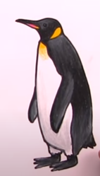
Art
For Art this week, follow this link to draw an Emperor Penguin: https://www.youtube.com/watch?v=Y1APW_4J8dw

If you have time, you could also draw a cartoon penguin: https://www.youtube.com/watch?v=MilR2D3cJRY

Handwriting
Look at the “Handwriting” document on our class page and work through the activities for this week.
Circle time
Watch the welcome video from your new Year 5 teacher on the school website and complete the task they have set for you!
Additional Activities
If you have some extra time, you may like to look at some of the lessons on BBC Bitesize: https://www.bbc.co.uk/bitesize/tags/z63tt39/year-4-and-p5-lessons
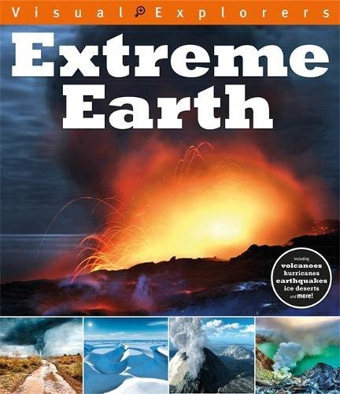
Geography Project (optional):
On our Year 4 class page, there are some “Extreme Earth” PowerPoints. Spend some time over the next few weeks reading through the PowerPoints and learning about ‘Extreme Earth.’ You may even like to do some research of your own on the computer or by looking in books you have at home!
Here are some BBC Bitesize links you may want to look at:
https://www.bbc.co.uk/bitesize/articles/zxwjr2p - volcanoes.
https://www.bbc.co.uk/bitesize/articles/zbwckmn - weather and climate.
https://www.bbc.co.uk/bitesize/articles/zdqybdm – mountains.
https://www.bbc.co.uk/bitesize/articles/zkm2xyc – Latitude and Longitude.
https://www.bbc.co.uk/bitesize/articles/z4jbrj6 – Time zone.
https://www.bbc.co.uk/bitesize/topics/z849q6f/articles/zj89t39 - Earthquakes.
https://www.bbc.co.uk/bitesize/articles/zdysjhv – Hurricanes.
Using your knowledge of PowerPoint or Word, create a presentation which shows what you have learned about ‘Extreme Earth.’ Remember to include: text, pictures and diagrams. The text should be in your own words and not just copied from the PowerPoints or the internet/books.
**Take your time with this project! It should take you around 4-5 weeks to learn about ‘Extreme Earth’ and create your presentation.**
Suggested timetable:
Week 1: read through some of the PowerPoints and begin to make notes/draw diagrams.
Week 2: read through the rest of the PowerPoints and make notes/draw diagrams. If time, do some more research.
Week 3: continue to do your own research and make notes/draw diagrams.
Week 4: begin to type up your learning in PowerPoint/Word.
Week 5: finish typing up your learning in PowerPoint/Word and add any images/diagrams etc.
Spend some time in Week 5 or Week 6, editing your presentation.

