Date:
LO: To understand conditional selection
C: Everyday scenarios
Conditional Selection

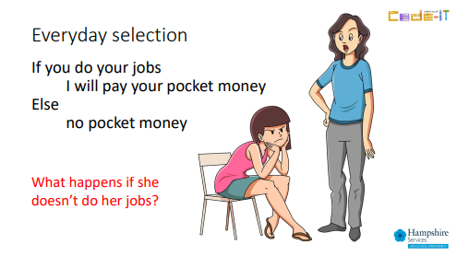
- In the box below, come up with your own example of conditional selection.

- In the box below, come up with your own example of conditional selection which has more than one condition and action. An example has been done for you.

If you like chocolate
Smile

If you have a brother
Stand up

If you like playing games
Jump

- What do you predict will happen in the following scenarios?
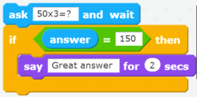
- What would happen if you put the answer 160 in?

- What do you think would happen if you put the answer 150 in?

