
Year 4 Distance Learning – w.b. 01.06.20
For more detailed information on activities, please see plans below the timetable!

Monday | Reading | Maths | Times Tables/Number Bonds/Telling the Time/Measuring | Playtime! | Writing | Grammar  and  Spelling | Lunchtime! | RE | French | PE
Tuesday | Reading | Maths | Times Tables/Number Bonds/Telling the Time/Measuring | Playtime! | Writing | Grammar  and  Spelling | Lunchtime! | History/Geography | Music | PE
Wednesday | Reading | Maths | Times Tables/Number Bonds/Telling the Time/Measuring | Playtime! | Writing | Grammar  and  Spelling | Lunchtime! | Science | Circle time/PSHCE | PE
Thursday | Reading | Maths | Times Tables/Number Bonds/Telling the Time/Measuring | Playtime! | Writing | Grammar  and  Spelling | Lunchtime! | Art/DT |  | PE
Friday | Reading | Maths | Times Tables/Number Bonds/Telling the Time/Measuring | Playtime! | Writing | Grammar  and  Spelling | Lunchtime! | Computing | Handwriting | PE

Reading
Please read either your school or a home reading book for 30 minutes every day.
Monday – During your reading today, write down 3 words that you don’t know the meaning of. Look up the meaning. Can you put these words into a sentence of your own?
Tuesday – During your reading today, write down 3 words that the author has chosen on purpose to have an effect on the reader. Explain what image this makes the reader think of. For example: snatched reminds someone of grabbing something from someone quickly, taking something that does not belong to them in a nasty way.
Wednesday – After your reading today, summarise what you have read and tell an adult. Can you summarise it in 50 words? 25 words? 10 words?
Thursday – After your reading today, write down how a character is feeling. Use evidence from the text to prove you are correct.
Friday – After your reading today, make a prediction about what will happen next. See if it is correct in your reading next week!

Maths
This week your Maths will be on Showbie. Visit https://whiterosemaths.com/homelearning/year-4/ and look at ‘Summer Week 4’. The worksheets are no longer available on White Rose, so you will find the questions as always on our website. Please try to post your answers daily on Showbie. Friday’s challenge does not need to be posted on Showbie. The challenge is available on White Rose for this.
Times Tables/Number Bonds/Telling the Time/Measuring
Spend some time revising these different areas of maths.
Over the week you could:
- Practise whichever ‘Maths Minutes’ you are on at the moment.
- You could watch a Percy Parker video on YouTube or play TT Rockstars.
- Have a look at some of the maths games you could play!
Complete some more Maths on Century Tech this week too.
Writing
This week your English does not need to be submitted on to Showbie.
We are going to be writing instructions this week!
Monday – Read through the instructions for “How to Look After a Pet Dragon” on the Year 4 page of the school website. Write a checklist of everything you will need to include when you are writing your own instructions this week.
Tuesday – Imagine our class is writing a dragon keeper’s handbook. It would need to have lots of information about how to care for dragons, like:

*How to feed a baby dragon | *Caring for a dragon’s teeth
*How to house your pet | *How to keep a dragon’s fire bright
*How to find a lost baby dragon | *How to communicate with a dragon
*How to ride a dragon | *How to teach a dragon to sing

Choose one of the examples above or think of your own idea for what a dragon keeper would need to learn to do.

Create a bubble map of the instructions you would need to give to teach the dragon keeper!

For example: my bubble map for “how to feed a dragon” might have these ideas -

- collect dragon food like mice and rats
- put the food on a flat rock
- get a bucket of water for the dragon to drink
- move back before letting the dragon out
- wear a disguise so the dragon doesn’t eat you

Wednesday – Write your instructions telling people how to look after the dragon.

You should include:
- an introduction
- imperative (‘bossy’) verbs (put, take, jump, move, give etc.)
- adverbs (carefully, gently, slowly etc.)
- time connectives (first, next, after, finally etc.)

Try to add lots of detail to your instructions! Use the example instructions and word mat to help you.

Thursday – Read through your instructions. Have you included everything you need to? Use the “Instructions Checklist” on the Year 4 page of our school website to help you. Have you included lots of detail? Have you used the correct spellings? Make any corrections you have identified and add in anything you have forgotten. You may like to draw some pictures or diagrams to illustrate your instructions.

Friday – Guided Reading; please spend your English time today on Century Tech on the “Primary English – KS2 Reading” course.
You may like to spend 10-15 minutes a day on this, or do it all in one day – it’s up to you.

Grammar and Spelling
Grammar
Please spend your grammar time this week on Century Tech on the “Primary SPaG – KS2” course.
You may like to spend 10-15 minutes a day on this, or do it all in one day – it’s up to you.

Spelling

Please practise the following spellings every day this week.

Permission | Discussion | Expression
Exercise | Numerous | Readjust
You might like to write out the words in different colours, try ‘look, cover, say, write, check,’ write sentences using the spellings in or ask an adult to test you on your spellings.
RE
Key Question: Can the Buddha’s teachings make the world a better place?
Think about what you have learned about Buddhism so far.
Complete the following activities to help you answer our key question.
- Choose one of the Buddha’s teachings that we have learned about and explain the story/belief. (e.g. The Golden Plate or The Eight-Fold Path)
- What do these teachings teach Buddhists?
- Can the Buddha’s teaching in your example make the world a better place? Explain your thinking.
Challenge: If you followed the Buddha’s teachings, would the world be a better place? Give an example.
French
Go to: https://www.french-games.net/frenchtopics.
Select School and then School – Classroom Objects.
Go through the tutorial and then play the games!
PE
Mr Gooch’s Weekly Challenge – See the video on the website for this week’s challenge. What score can you get?

Please make sure you get lots of physical exercise even whilst you are at home.

Joe Wicks is also doing a daily P.E. session for children from 9am every day this week!
Here is the link for his YouTube channel should you wish to participate. https://www.youtube.com/user/thebodycoach1

Remember GoNoodle is free to sign up to and play or the videos are on YouTube.
Which videos have you done?

History/Geography
This half term we will be looking at Extreme Earth. First though, we need to know what the Earth is made up of. Look at the PowerPoint on our class page. Draw and label the layers of the Earth and write a short paragraph explaining what each layer is. This does not need to be posted on Showbie.
Music
Create a soundtrack for a piece of film!
A soundtrack is a piece of music that goes with a film or television show.
A good soundtrack matches the film it is about. It does this by using music elements.
These include:
- tempo; this means the speed of the music. An exciting adventure film might have music with a fast tempo. A serious, sad film might have music with a slow tempo.
- pitch; this is whether the notes are high or low. If the film is about a large creature or a big spaceship, lots of low notes might be used. A film about fairies or insects might have music with lots of high notes.
- dynamics; this means whether music is loud or quiet (the musical word for quiet is ‘soft’). Loud music might show something exciting is happening. Quiet music might show a sad event, or maybe even something scary. Music starting quietly and getting louder (the musical term for this is ‘crescendo’) could show that the main point of the film is happening.
- pulse; the steady beats in a piece of music. A film about soldiers could have a steady marching beat played on a drum.
- duration; this is the length of notes being played. Short notes could suggest film characters running around. Long notes might suggest a king or queen moving in a stately manner.
Your task: Choose a scene from a film you enjoy watching and create a soundtrack for it. Try watching the scene with no sound on to pay attention to the actors’ faces and body language. This will give you a sense of what the scene is really about.
You don’t need to be able to play an instrument. You could use different percussion instruments. ‘Percussion’ means an instrument which makes a noise when you hit it. You could even try making your own percussion instruments.
There are also computer programs for creating music like: https://www.classicsforkids.com/games/compose_your_own_music.php.
Science
Watch: http://www.switchedonkids.org.uk/what-is-electricity and https://www.bbc.co.uk/bitesize/clips/z9t9mp3
Activity 1: Complete the Energy Sources matching activity on the Year 4 page of the school website.
Challenge: Write an explanation underneath each of the pictures to show your understanding of where electricity comes from.
Activity 2: Using the appliances cards, complete the Mains or Battery? activity (both of these resources are on the Year 4 page of the school website).
**Note: you do NOT have to print out the appliances cards, you can just look at them online to give you ideas for the activity.**
Challenge: Amy says, “Electricity just comes out of plugs.” Do you agree? Explain your reasoning.

Circle time/PSHCE
Spend some time together as a family taking this quiz: https://www.kidzworld.com/quizzes/what-animal-personality-are-you/
Which animals are you and your family most like?
Art/DT
Art This week we continue to look at Pop Art. Please draw and either paint or colour your own version of one of these comic strip inspired pieces.

Cooking As it is the beginning of summer see if you can make some scones to have with clotted cream and jam. There is a fabulous Mary Berry recipe if you follow this link: https://www.bbc.co.uk/food/recipes/tea_time_scones_77839

Computing
Use: https://www.bbc.co.uk/bitesize/topics/zf2f9j6/articles/z3c6tfr to practise your typing skills!

Handwriting
Practice writing the following spellings correctly within the handwriting lines. Make sure your handwriting is joined like the example.
You will find some Handwriting videos from Mrs Kelley on our Year 4 page of the school website which might help you!
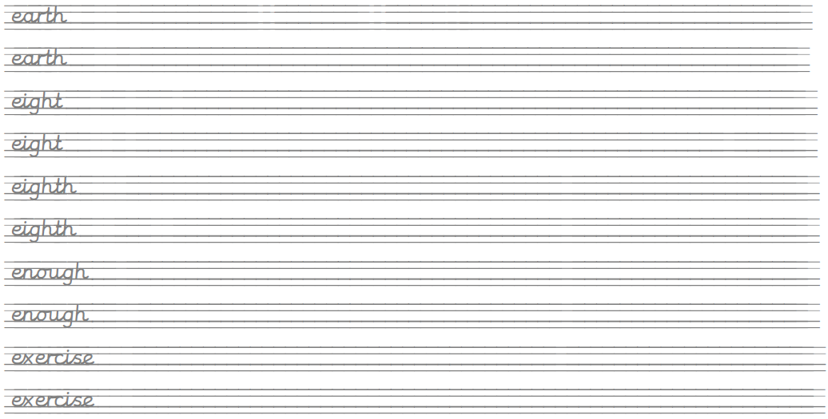
Create sentences using these words and write them up in your neatest handwriting. Take your time and make sure you form your letters correctly.
Remember, any piece of writing you do at home can be used to show Mrs Mistry for pen licence when we return to school!

