Spend 5 minutes each day on your handwriting activities:
Monday | Warm your hands up ready for writing this week:  https://www.youtube.com/watch?v=o7U4jFs1jo4&safe=active  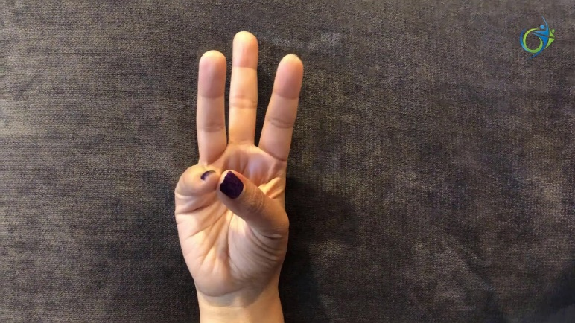
Tuesday | Copy these handwriting patterns:  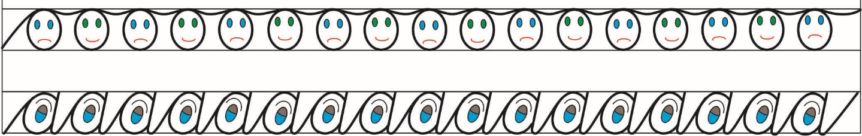
Wednesday | Write the following words out neatly in your best handwriting:  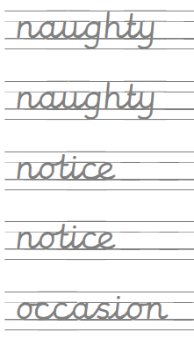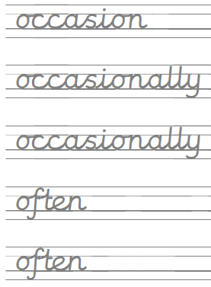
Thursday | SUMMER HOLIDAYS!
Friday | SUMMER HOLIDAYS!

