Our spelling focus this week is: word endings and suffixes!

Spend 15 minutes each day on your spelling activities:
Monday | Words Ending in '-sure', '-ture' or '-cher'  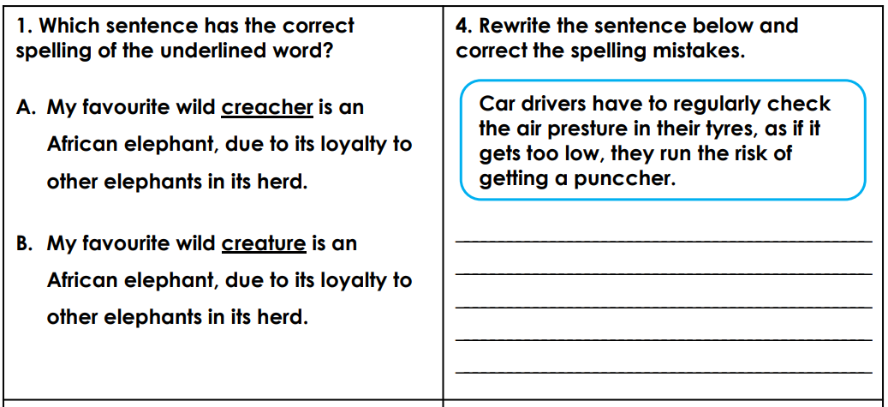  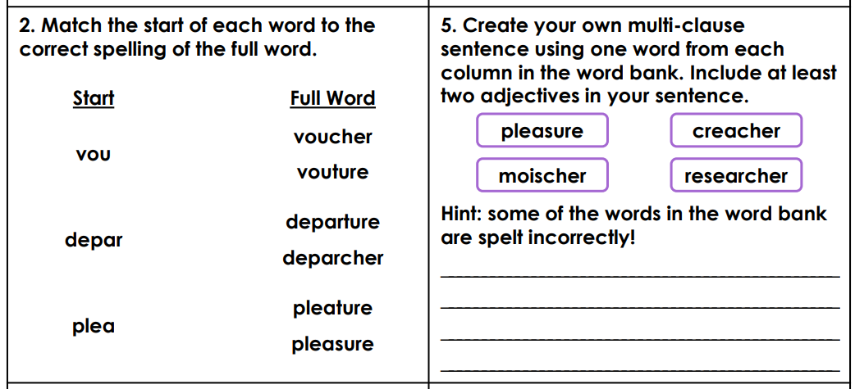  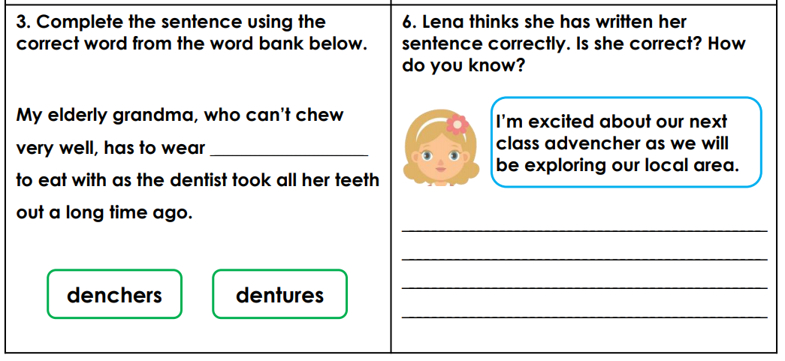

Tuesday | Adding Suffixes  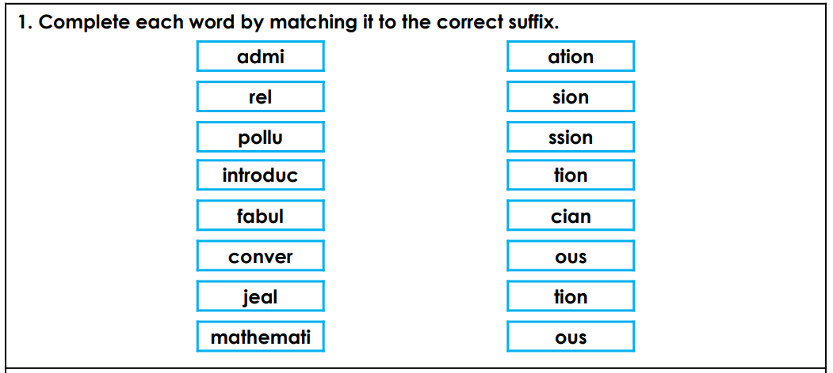  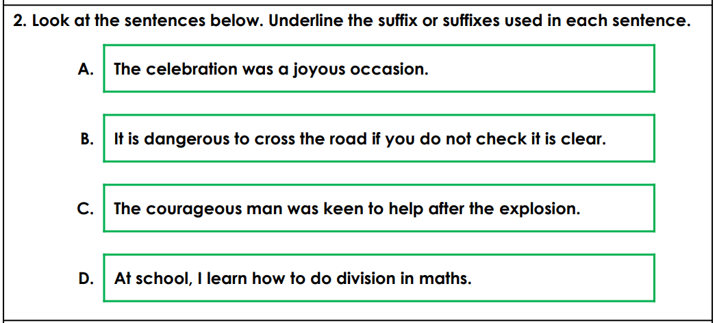  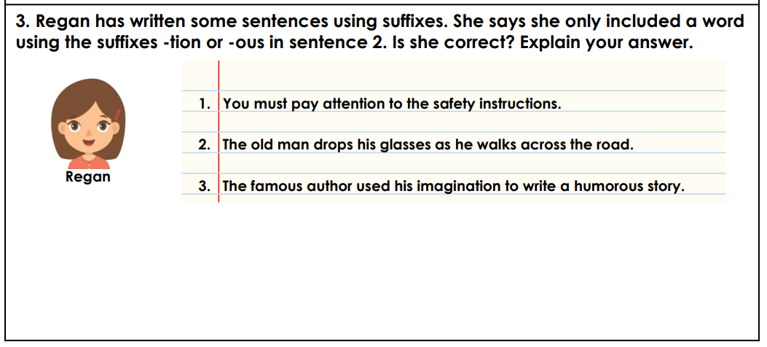

Wednesday | Are there any words that you keep spelling wrong?  Has your mum or dad had to keep reminding you of the correct spelling for the same word(s) all the way through lockdown?  Has Microsoft Word put a red, squiggly line under the same word every time you type it?  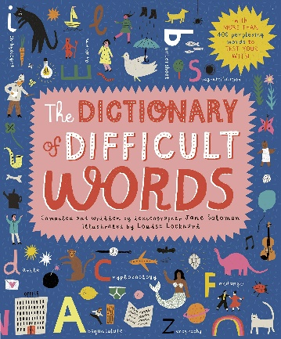  Now’s your time to practise spelling those tricky words that always seem to catch you out!  You might like to:  - draw a poster to help you  - think of a mnemonic  - write the tricky part of the word out in red  - do ‘Look, Cover, Say, Write, Check.’  Don’t let your tricky words catch you out in Year 5!
Thursday | SUMMER HOLIDAYS!
Friday | SUMMER HOLIDAYS!

