Monday | TT Rockstars | Collective Worship | Maths  See daily plan on class page | Playtime! | English, including Reading | Spelling/  Handwriting | Lunchtime! | RE | Finish!
Tuesday | TT Rockstars | Collective Worship | Maths  See daily plan on class page | Playtime! | English, including Reading | Spelling/  Handwriting | Lunchtime! | Circle Time | Finish!
Wednesday | TT Rockstars | Collective Worship | Maths  See daily plan on class page | Playtime! | English, including Reading | Spelling/  Handwriting | Lunchtime! | Art | Finish!
Thursday | SUMMER HOLIDAYS! |  |  | Playtime! | SUMMER HOLIDAYS! |  | Lunchtime! | SUMMER HOLIDAYS! | Finish!
Friday | SUMMER HOLIDAYS! |  |  | Playtime! | SUMMER HOLIDAYS! |  | Lunchtime! | SUMMER HOLIDAYS! | Finish!

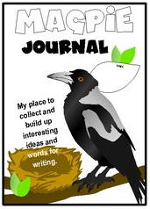
Reading
Spend 30 minutes each day either reading your own book OR completing Century Tech nuggets for “Primary English – KS2 Reading.”
(If you have a Lexia login then you can also go on Lexia for your reading.)

You can find some eBooks online at: https://www.oxfordowl.co.uk/for-home/find-a-book/library-page/

There is also a reading comprehension on our class page if you would like to complete it.

Challenge: Continue to add to your “Magpie Journal” and write down any impressive words from your reading that caught your attention and you would like to use in your own writing!

Maths
This week we have uploaded a fun summer themed maths booklet for you to work your way through this week during the three Maths sessions. There are answers on the website too. Don’t worry if you don’t complete it all as there is quite a bit to do, but just try to complete as much as you can. If you get time, go onto Purple Mash to play some Maths games.
Writing
You do not need to send your English on Showbie this week.
This week we are going to be making a book with our story from last week.
Please ensure you look at the English Guidance document on our class page for your English activities.

Grammar and Spelling
Grammar – You will find your daily grammar activity linked to your writing task on the English Guidance document on our class page.
Activities have been set for you on Century Tech:
Monday – Simple Tense
Tuesday – Adding a Verb in the Correct Tense
Wednesday – Checking Tenses
Spelling – our spelling focus for this week is word endings and suffixes!
Look at the “Spelling” document on our class page and work through the activities for this week.
RE
What have you done so far today?
Did you follow the Eight-Fold Path today? Which folds did you follow? How do you know?
Did any of the things you did today go against any of the folds? How do you know?
Look back at the things you have done today – if you were a Buddhist, is there anything you would have done differently to make sure you were following the Eight-Fold Path? Anything you would have had to think carefully about before you did it?
If you followed the Eight-Fold Path everyday would you be leading a ‘good’ life? How do you know?
What would make it ‘good’?
Activity: Imagine you are a Buddhist. Write a diary entry explaining how following The Eight-Fold Path affects your life.
Example:
Dear Diary,
Today at school, some people were talking about one of our friends. I stayed out of it and didn’t get involved. This is because I am a Buddhist and The Eight-Fold Path teaches me that I should practice Right Speech. In other words I should not lie, be rude or be unkind to others. Because of this, I make sure that in life I take care to respect everyone I can. I try not to get involved when people are talking about others.
Challenge: try to include how easy you think it is to follow these folds.
Collective Worship
Look at the “Collective Worship” document on our class page and work through the activities and questions this week.
Art
We thought we would find some summer themed art this week for you.
https://www.youtube.com/watch?v=nESSB_6Y9Ik – hiking/backpacking.
https://www.youtube.com/watch?v=0eFiI9i2dso – camping.
https://www.youtube.com/watch?v=lIOjk00njxM – visiting a waterfall
https://www.youtube.com/watch?v=mriqDaknrLk&list=PLnoO3k54vcBQOYILzlnnzJEBhWBNpiKLA&index=7&t=0s – camper van
https://www.youtube.com/watch?v=EsxpmVXUf-I&list=PLnoO3k54vcBQOYILzlnnzJEBhWBNpiKLA&index=8 – a S’more
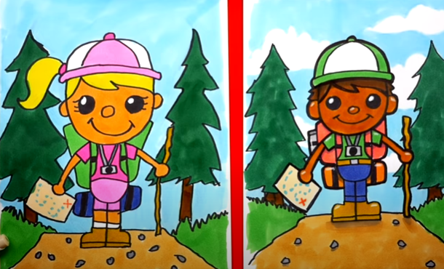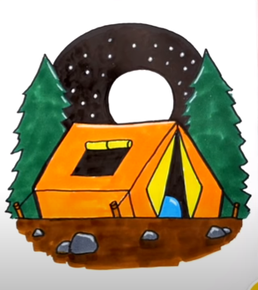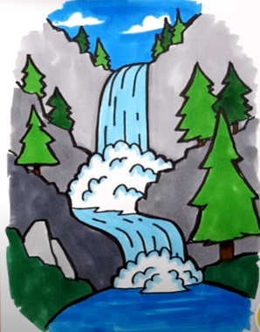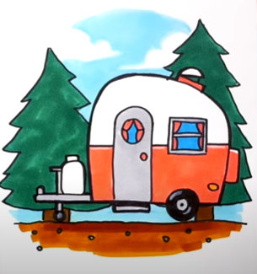

You might also want to make one of the following summer themed pieces of art:
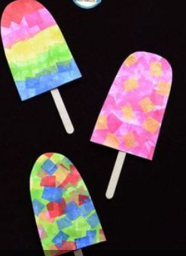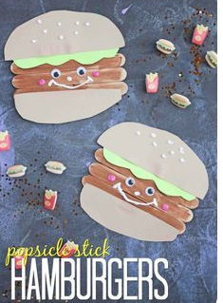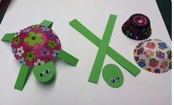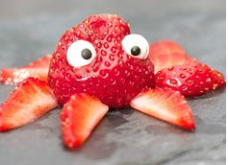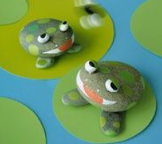
If you’d really like a challenge, you may want to try growing your own vegetables from scraps left over from preparing meals at home. Check out this video:
https://www.youtube.com/watch?v=n6QnKAyBKu4
Handwriting
Look at the “Handwriting” document on our class page and work through the activities for this week.
Circle time
Complete the “My A to Z of the Year” activity on our class page. It would be lovely for you to share some of your memories with us on Showbie!
Additional Activities
If you have some extra time, you may like to look at some of the lessons on BBC Bitesize: https://www.bbc.co.uk/bitesize/tags/z63tt39/year-4-and-p5-lessons

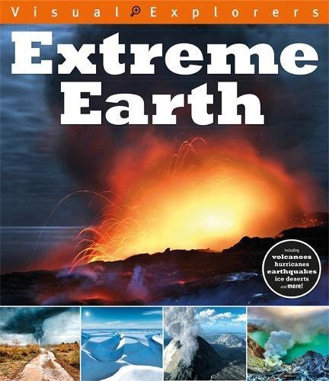
Geography Project (optional):
On our Year 4 class page, there are some “Extreme Earth” PowerPoints. Spend some time over the next few weeks reading through the PowerPoints and learning about ‘Extreme Earth.’ You may even like to do some research of your own on the computer or by looking in books you have at home!
Here are some BBC Bitesize links you may want to look at:
https://www.bbc.co.uk/bitesize/articles/zxwjr2p - volcanoes.
https://www.bbc.co.uk/bitesize/articles/zbwckmn - weather and climate.
https://www.bbc.co.uk/bitesize/articles/zdqybdm – mountains.
https://www.bbc.co.uk/bitesize/articles/zkm2xyc – Latitude and Longitude.
https://www.bbc.co.uk/bitesize/articles/z4jbrj6 – Time zone.
https://www.bbc.co.uk/bitesize/topics/z849q6f/articles/zj89t39 - Earthquakes.
https://www.bbc.co.uk/bitesize/articles/zdysjhv – Hurricanes.
Using your knowledge of PowerPoint or Word, create a presentation which shows what you have learned about ‘Extreme Earth.’ Remember to include: text, pictures and diagrams. The text should be in your own words and not just copied from the PowerPoints or the internet/books.
**Take your time with this project! It should take you around 4-5 weeks to learn about ‘Extreme Earth’ and create your presentation.**
Suggested timetable:
Week 1: read through some of the PowerPoints and begin to make notes/draw diagrams.
Week 2: read through the rest of the PowerPoints and make notes/draw diagrams. If time, do some more research.
Week 3: continue to do your own research and make notes/draw diagrams.
Week 4: begin to type up your learning in PowerPoint/Word.
Week 5: finish typing up your learning in PowerPoint/Word and add any images/diagrams etc.
Spend some time in Week 5 or Week 6, editing your presentation.

