
Year 4 Distance Learning – w.b. 11.05.20
For more detailed information on activities, please see plans below the timetable!

Monday | Reading | Maths | Times Tables/Number Bonds/Telling the Time/Measuring | Playtime! | Writing | Grammar  and  Spelling | Lunchtime! | RE | French | PE
Tuesday | Reading | Maths | Times Tables/Number Bonds/Telling the Time/Measuring | Playtime! | Writing | Grammar  and  Spelling | Lunchtime! | History/Geography | Music | PE
Wednesday | Reading | Maths | Times Tables/Number Bonds/Telling the Time/Measuring | Playtime! | Writing | Grammar  and  Spelling | Lunchtime! | Science | Circle time/PSHCE | PE
Thursday | Reading | Maths | Times Tables/Number Bonds/Telling the Time/Measuring | Playtime! | Writing | Grammar  and  Spelling | Lunchtime! | Art/DT |  | PE
Friday | Reading | Maths | Times Tables/Number Bonds/Telling the Time/Measuring | Playtime! | Writing | Grammar  and  Spelling | Lunchtime! | Computing | Handwriting | PE

Reading
Please read either your school or a home reading book for 30 minutes every day.
Monday – During your reading today, write down 3 words that you don’t know the meaning of. Look up the meaning. Can you put these words into a sentence of your own?
Tuesday – During your reading today, write down 3 words that the author has chosen on purpose to have an effect on the reader. Explain what image this makes the reader think of. For example: snatched reminds someone of grabbing something from someone quickly, taking something that does not belong to them in a nasty way.
Wednesday – After your reading today, summarise what you have read and tell an adult. Can you summarise it in 50 words? 25 words? 10 words?
Thursday – After your reading today, write down how a character is feeling. Use evidence from the text to prove you are correct.
Friday – After your reading today, make a prediction about what will happen next. See if it is correct in your reading next week!

Maths
This week your Maths will be on Showbie. Please try to upload your work daily to be marked. This week please use White Rose home learning for ‘Summer Term Week 2’ https://whiterosemaths.com/homelearning/year-4/ then answer the questions that are on the PowerPoint. You can find this on the class page on our website. Again, you may find it easier to download the video prior to needing to use it as the White Rose website can get very busy.

Times Tables/Number Bonds/Telling the Time/Measuring
Spend some time revising these different areas of maths.
Over the week you could:
- Practise whichever ‘Maths Minutes’ you are on at the moment.
- You could watch a Percy Parker video on YouTube or play TT Rockstars.
- Have a look at some of the maths games you could play!
Complete some more Maths on Century Tech this week too.
Writing
This week your English does not need to be submitted on to Showbie.
We are going to start looking at Non-Chronological Reports this week!
A non-chronological report is a non-fiction report which is not written in time order. It is focused on a single topic and includes lots of facts about this topic.

Monday – Spend some time today researching dragons and finding out as much information as you can about them. You might like to make some notes about the information you have found out as you will need this later in the week!
These websites might help you:
https://kids.kiddle.co/Dragon
https://kids.britannica.com/kids/article/dragon/353064
https://www.softschools.com/facts/fiction/dragons_facts/2727/
https://www.factmonster.com/features/creature-catalog/dragons
https://www.funkidslive.com/new/dragon-facts-myths-disneys-petes-dragon/

Tuesday – Today, you are going to create a newly discovered species of dragon! Draw your new dragon species and annotate your drawing with lots of facts about your dragon, e.g. what is the new species called? What does it look like? Where does it live? What does it eat? How does it hunt? etc. You can use ideas from your research and/or make up your own ideas!
Make sure you use expanded noun phrases when describing.
Try to use conjunctions to add information to your sentences.

Example:
The deadly, fire-breathing dragon lives at the top of the rock-strewn mountain so he can observe his prey from afar.
Because the red, coarse-skinned dragon has the sharpest claws of any mammal, he always captures and kills his innocent prey without fail.

Wednesday – Share your dragon species with an adult and tell them everything you know about your new species. Is there anything else the adult would like to find out about your dragon? Add the answers to your adult’s questions to your picture from yesterday in a different colour.

Thursday – Watch: https://www.bbc.co.uk/teach/class-clips-video/english-ks1-ks2-how-to-write-a-non-chronological-report/zvbtscw and read through the Non-Chronological Report examples on the Year 4 page of our website. Create a bubble map of the features of Non-Chronological Reports.

Friday – Guided Reading; please spend your English time today on Century Tech on the “Primary English – KS2 Reading” course.
You may like to spend 10-15 minutes a day on this, or do it all in one day – it’s up to you.

Grammar and Spelling

Grammar
Please spend your grammar time this week on Century Tech on the “Primary SPaG – KS2” course.
You may like to spend 10-15 minutes a day on this, or do it all in one day – it’s up to you.

Spelling

Please practise the following spellings every day this week.
There is a video from Mrs Mccarthy on the Year 4 page of the school website with a top tip for spelling “believe.”

Uniquely | Grotesquely | Fatigued
Precious | Normally | Believe
You might like to write out the words in different colours, try ‘look, cover, say, write, check,’ write sentences using the spellings in or ask an adult to test you on your spellings.
RE
The Buddha believed greed and selfishness could be stopped. He taught that to live a good life without being selfish or greedy would make the world a better place.
To help people know what to do and not to do he gave them the Eight-Fold Path.
This path is sometimes called The Middle Way; it is a middle way between extremes. The Buddha had once lived a life of luxury as a prince. He had also tried a life of extreme self-denial. He taught that following the Eight-Fold Path, a middle way, leads to happiness and freedom from suffering.
Look at the Eight-Fold Path PowerPoint on the Year 4 page of our school website.
Think carefully and decide which stage of the Eight-Fold Path is the most important to you. Create a poster explaining this stage to others and giving examples of how they could live like this in their own lives. You might like to draw pictures to help your explanation.
Challenge: Would the Buddha’s teaching about your stage of the Eight-Fold path make the world a better place if everyone tried their best to do this? How/Why?
French
Go to: https://www.french-games.net/frenchtopics.
Select School and then School – Classroom Objects.
Go through the tutorial and then play the games!
PE
Mr Gooch’s Weekly Challenge – See the video on the website for this week’s challenge. What score can you get?

Please make sure you get lots of physical exercise even whilst you are at home.

Joe Wicks is also doing a daily P.E. session for children from 9am every day this week!
Here is the link for his YouTube channel should you wish to participate. https://www.youtube.com/user/thebodycoach1

Press Up Circuit:
- Lie Flat on front with feet in the air
- Place hands on mat; shoulder width apart
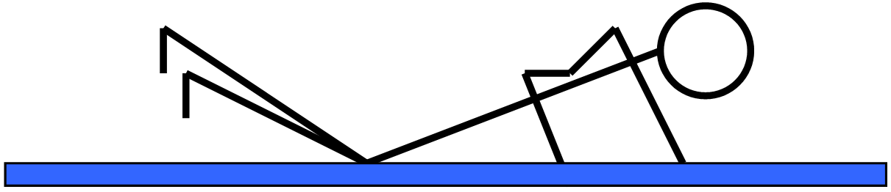
- Keep looking at the mat, body in straight line
- Push body away from mat and lower to ground
- Repeat

HARDER STATION: Perform press ups from the feet

EASIER STATION: Perform press ups against a wall

Remember GoNoodle is free to sign up to and play or the videos are on YouTube.
Which videos have you done?

History/Geography
On our class page, there is a PowerPoint full of information about different Mayan Cities and temples for History this week. Read through all of the information then decide on your favourite two temples or cities. Choose either the Paddling, Snorkelling or Diving work to complete. Please then answer the red pen question and put your answer on Showbie under our Foundation Subjects tab.
Music
Over the past few weeks, you have learned the musical notes and their positions and composed your own piece of music.
This week, you are going to write your music down! Using your knowledge of the musical notes and their positions, draw the notes you have used in your composition on special music paper (you will find this on the Year 4 page of our website).
Remember that the notes will look different depending on whether they are played for 1 count, 2 counts, 3 counts etc.
Use: https://www.classicsforkids.com/games/compose_your_own_music.php and https://www.classicsforkids.com/games/note_names.php to help you with the notes.

Science
Your Science this week is a Sound investigation!
Read the Soundproofing Investigation PowerPoint on the Year 4 page of our school website.
You will also find a video from Mrs Peters on our Year 4 page showing you how to carry out the investigation at home.
Carry out the Soundproofing investigation – making sure it is a fair test.
Record your results on the Sound Investigation sheet (you will find this on the Year 4 page of our school website).
Challenge: Why was it important for our investigation to be a fair test?
Circle time/PSHCE
Create an ‘I’m bored’ jar with your family. Fill the jar with ideas of things to do, such as ‘Read a book’, ‘Build a castle from Lego’, or ‘Play with my baby sister’.
Next time you’re bored, reach in for an idea…
Art/DT
Art
This week we will be looking at dragons linked with our English work (don’t worry we will still be looking at Pop Art). Look at the PowerPoint on our class page. Look at the dragons and think about the media used, mood and effect. Using Austin’s butterfly techniques of critical analysing, (if you can’t remember please watch it again https://www.youtube.com/watch?v=hqh1MRWZjms), you will draw 4 dragons. Each one should show an improvement on the last.
Cooking
Mrs Mccarthy has been baking a cake this week! Watch how she makes it on the Year 4 page of our website.
Have a go at making a cake like Mrs Mccarthy!
I wonder who can make a better cake…?
Computing
Choose one activity from this week’s home learning to complete on Microsoft Word (e.g. Science, RE, History).
Using the using Microsoft Word PowerPoint on our Year 4 page of the school website, can you create a Word document with different fonts, different text sizes, different text colours, pictures, text boxes and shapes showing your learning for that lesson?

Handwriting
Practice writing the following spellings correctly within the handwriting lines. Make sure your handwriting is joined like the example.
You will find some Handwriting videos from Mrs Kelley on our Year 4 page of the school website which might help you!
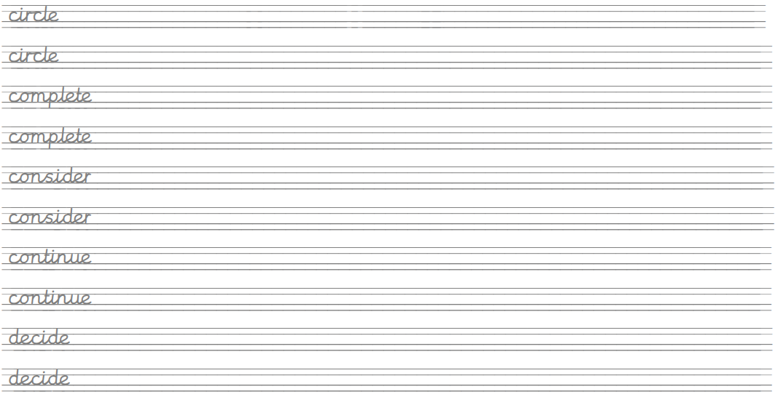

Create sentences using these words and write them up in your neatest handwriting. Take your time and make sure you form your letters correctly.
Remember, any piece of writing you do at home can be used to show Mrs Mistry for pen licence when we return to school!

