Our guide to British horticulture
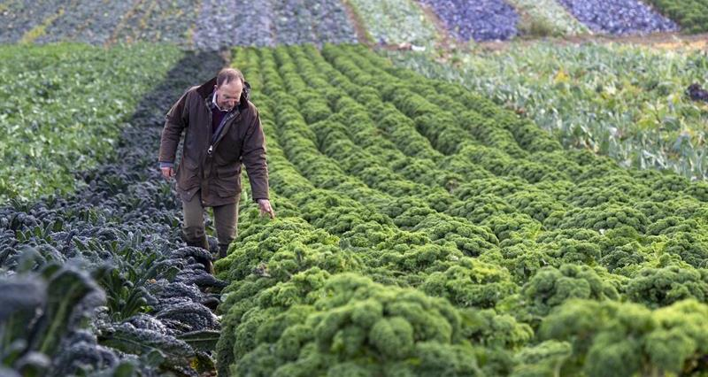

Did you know...
- British farmers produce 3.5m tonnes of fruit and vegetables every year – on 153,000 hectares of land.
- In addition, British farmers grow 14,000 hectares of plants and flowers.
- The farm gate value of UK fruit, vegetables, plants and flowers is around £3.5bn.
- The UK horticulture industry employs approximately 40,000 permanent workers, plus 70,000 seasonal workers each year. UK growers meet strict health and safety and welfare requirements through the Red Tractor and Ethical Trade Initiative assurance schemes. These regulations and standards are in place to not only protect worker welfare, but also to give you peace of mind that your food has been picked in an ethical environment.
- Self-sufficiency of Fruit & Veg continues to decline each year. Britain currently produce around 56% of the vegetables we consume and 16% of the fruit we consume.
- The government’s Eat Well Guide recommends 40% of our diet should be made up of fruits and vegetables – this is equivalent to 7-a-day. Currently, UK consumers only eat on average 3 portions of fruit and veg a day.
While some fruits and vegetables may be more plentiful during certain seasons, farmers use a variety of methods to help extend the growing season. Not only does this mean that you can enjoy British produce for longer, it also reduces the need to import. Methods used by British farmers include:

Polytunnels
A polytunnel is a tunnel like structure, covered in plastic sheeting that is similar to a glasshouse. It allows the plants to grow in a much warmer temperature while protecting them from frost and weather damage to extend the growing season.
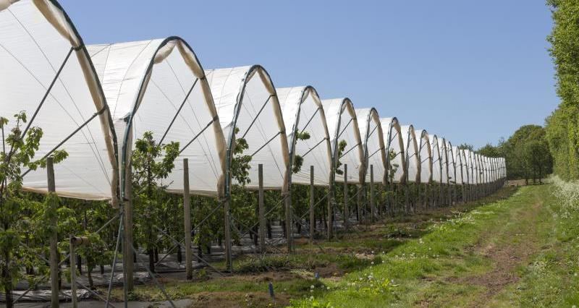

Environmental measures
Some farmers plant trees and hedges near growing crops to provide more shelter and protection from the weather.

Eating seasonally
Many fruits and vegetables are harvested throughout the year using different technologies. Because of longer growing seasons and good storage conditions, some British crops – like carrots, cauliflowers, potatoes and frozen British peas – are available to eat all year round, while others are more seasonal.

