Did you know...

- ​On average everyone in Britain eats nearly 9,000 peas per year.
- There are 35,000 hectares of peas grown in the UK each year, equivalent to about 70,000 football pitches. This produces about 160,000 tonnes of frozen peas - that's 2 billion 80 gram portions.
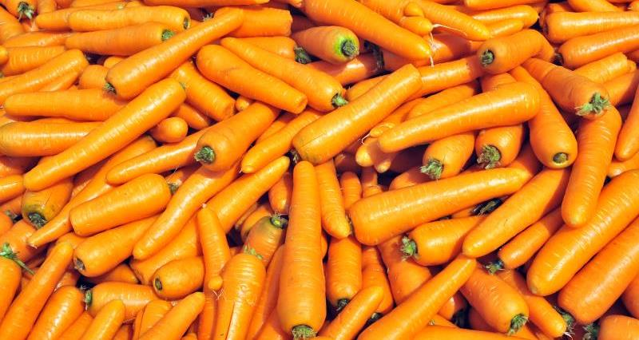
- We Brits eat our way through £290 million or 700,000 tonnes worth of carrots every year – that’s approximately 100 carrots per person.
- Each year 22 billion seeds are planted in Britain, producing around 100 carrots per year for every member of the population.
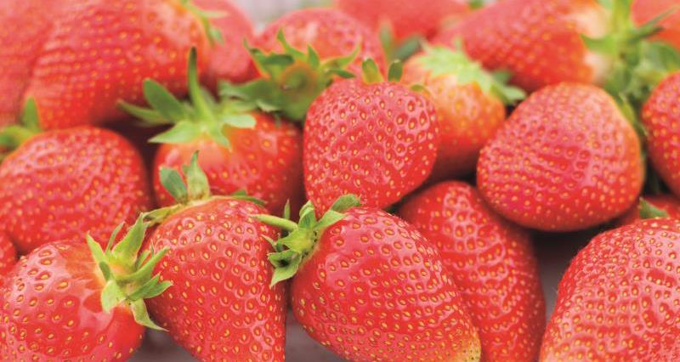
- Strawberries are high in fibre, low in calories and sugar, and contain no fat.
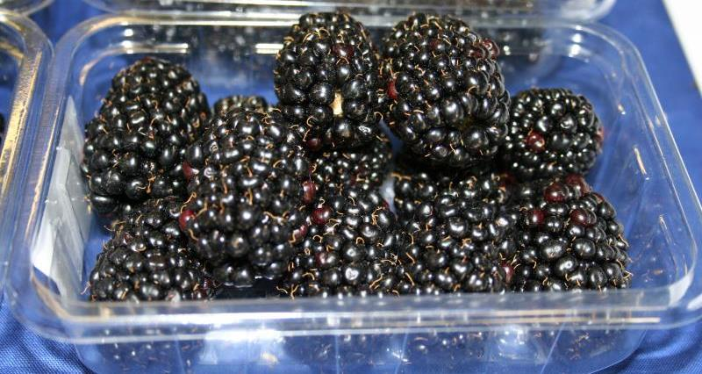
- The British blackberry season begins in July, reaches its peak in August and continues until the first frosts in November.
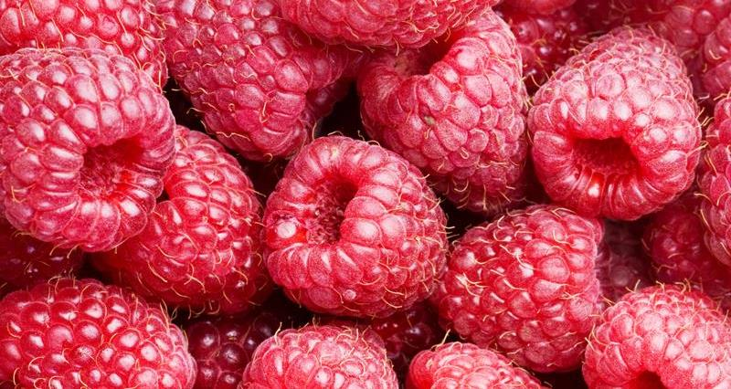
- Just one cup of raspberries contains 12% of your RDA of Vitamin K which supports healthy bones.
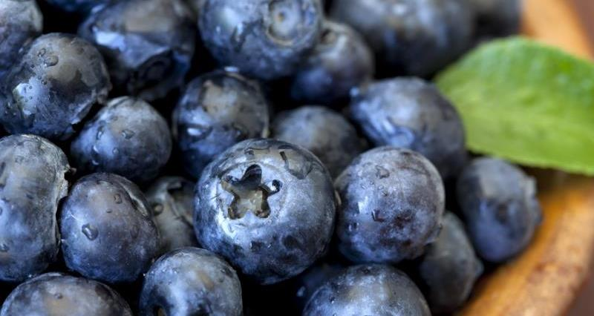
- British blueberries are available from June until September and the start of the season usually features the Duke variety. To guarantee local fruit can be supplied until late September, growers have planted special varieties for full flavour and a greater shelf life.
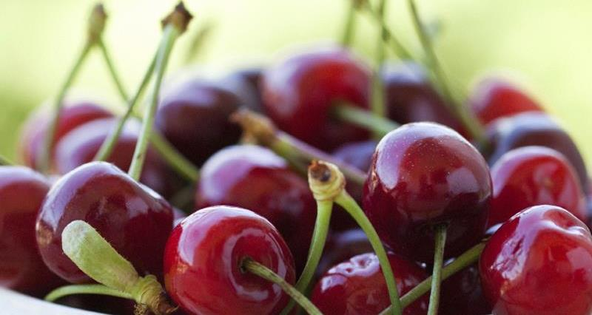
100g of cherries provide 25% of the recommended daily allowance of vitamin C.

