Coronavirus: Furloughed workers to be encouraged to take fruit picking jobs to help UK harvest
Monday 27 April 2020 10:47, UK
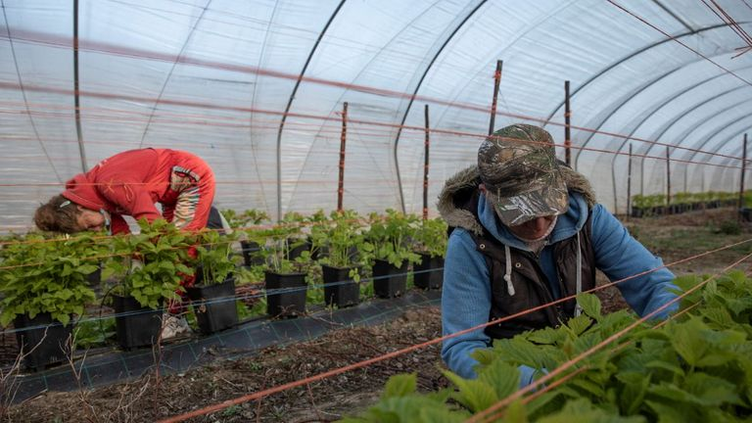
Some of the millions of British workers furloughed during the coronavirus lockdown will be encouraged to take a second job picking fruit and vegetables, the government has said.
Giving the daily COVID-19 briefing, Environment Secretary George Eustice said only a third of the migrant workers who normally picked fruit and vegetables were currently in the country.
"We're also very aware that we're about to start the British season in fresh produce, in soft fruits and salads.
"We estimate that probably only about a third of the migrant labour that would normally come to the UK is here, and was probably here before lockdown.
Advertisement
Farmers voiced fears that without the workforce, crops may be left in the ground to rot and be wasted as the nati on moves to feed itself during the coronavirus pandemic.
They also argue that harvesting crops is skilled work and many Eastern European workers return to the same farms each year.
Up to 80,000 workers help farmers harvest their crops across the UK, the vast majority from Eastern Europe. Only 10-15% of those workers are based in the UK and the rest fly in for the season.


