Call for Brits to pick fruit and veg amid coronavirus outbreak
18 March 2020 | by FarmingUK Team | Arable, News
172
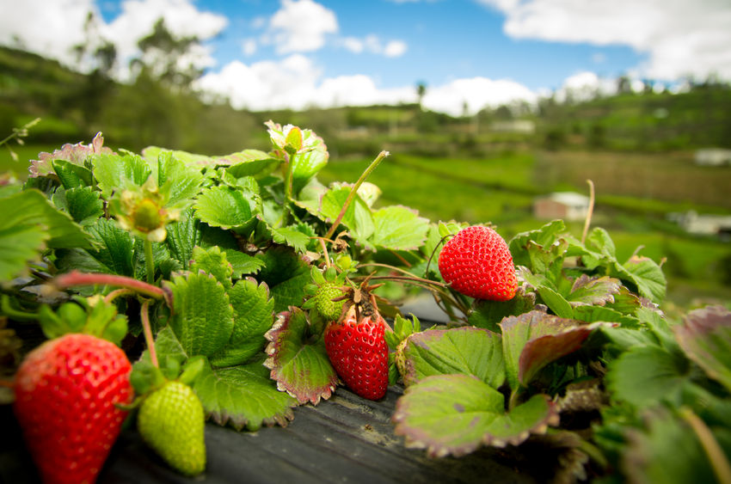
There's an urgent need for British workers to help harvest crops in the UK due to travel restrictions impacting on EU workers being able to fill these roles
A UK workforce is needed to help farms harvest crops following the impact of the coronavirus pandemic on seasonal labour travelling from abroad.

Travel restrictions and tighter border controls around the world are having a major impact on the number of people willing or able to travel during the outbreak.

With the soft fruit-picking season due to get fully underway in April, labour specialists HOPS are now inviting British people to apply for jobs picking and packing fruit and veg.
The paid positions could provide an income for students, job seekers and anyone who has been laid off work due to the impact of Covid-19, such as those working in hospitality and catering.

HOPS Operations Director, Sarah Boparan said farmers urgently need a UK labour force who can help harvest crops to feed the nation.

"At a time when international travel is restricted and people are panic buying due to the Coronavirus, it is crucial that growers can provide enough British produce to our supermarkets and local shops," he said.

“As the peak season for soft fruit picking gets underway, HOPS are calling on British workers to help support the industry in jobs that are usually filled by EU workers.

“We are aware that there are many people facing continued periods away from their usual employment or studies and HOPS can offer paid positions for those who are willing to work.”

Interested applicants will be asked to complete an online application form after they have reviewed the information about the work involved.
Successful applicants will receive training on the farm. To apply for a position on one of HOPS farms in the UK, complete the online form.

