HOW FOOD BANKS WORK

As a nation, we don’t expect anyone to be left hungry or destitute. Illness, disability, family breakdown or the loss of a job can happen to any of us. Our network of food banks provides the best possible emergency food to people locked into poverty.
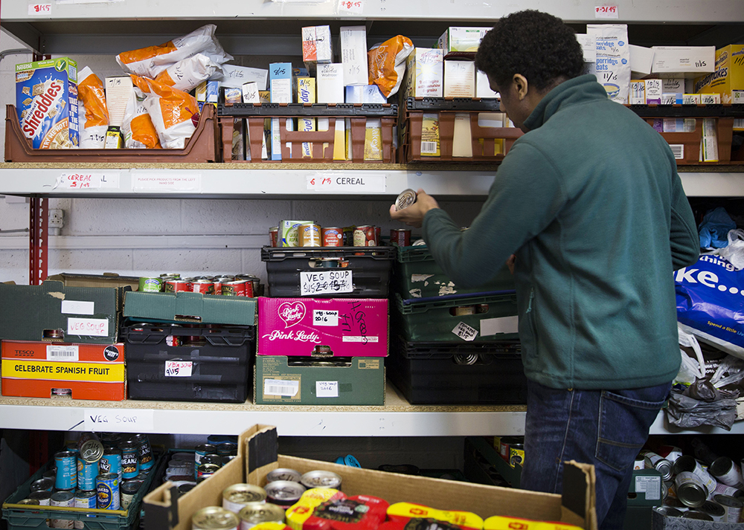
There are over 1,200 food bank centres in our network. The services provided by food banks may vary from area to area as they react to the needs of their community to provide help and support to local people in crisis.
Food donations
Non-perishable in-date food is donated by the public at a range of places, such as schools, churches and business, as well as supermarket collection points. It is then sorted into emergency food parcels by more than 40,000 volunteers, to be given to people in need.
Food vouchers
Care professionals such as health visitors, schools and social workers identify people in crisis and issue them with a food bank voucher. This means people can receive a food bank parcel of three days’ nutritionally balanced, non-perishable food from their local food bank.

More than food
Our food bank network helps people break free from poverty by providing additional support to help people resolve the crises that they face. Food banks rely on the support of local communities to help end hunger. Find your nearest food bank here.
Food banks rely on the support of local communities to help stop UK hunger, find your nearest food bank here.

