What’s in a food parcel?

Food banks provide a minimum of three-days’ nutritionally balanced, non-perishable tinned and dried foods that have been donated people in the local community
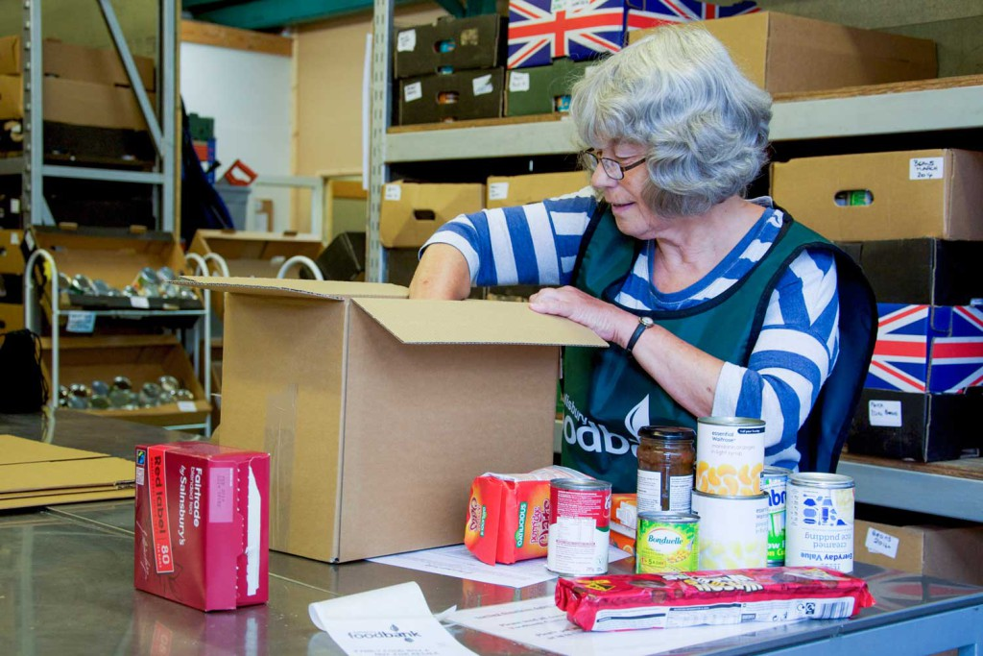
We’ve worked with nutritionists to develop a food parcel that contains sufficient nutrition for adults and children, for at least three days of healthy, balanced meals for individuals and families.
A typical food parcel includes:
- Cereal
- Soup
- Pasta
- Rice
- Tinned tomatoes/ pasta sauce
- Lentils, beans and pulses
- Tinned meat
- Tinned vegetables
- Tea/coffee
- Tinned fruit
- Biscuits
- UHT milk
- Fruit juice
Many food banks also provide essential non-food items such as toiletries and hygiene products.
If you’re organising a collection for your local food bank, please check with them first to see which items they are currently in need of.

Dietary requirements
When visiting a food bank centre, one of its volunteers will run through the food parcel packing list with you to check any special dietary requirements that you may have.
If they have the facilities to do so, some food banks can also provide fresh food. Please get in touch with your local foodbank to find out more.

