Challenge Answers
Monday:
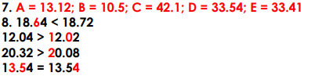

Tuesday
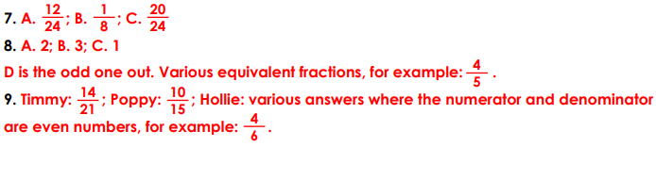
Wednesday
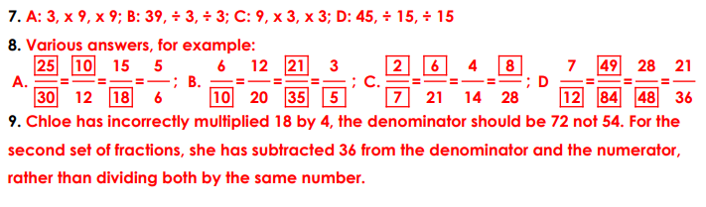
Thursday


