Spend 5 minutes each day on your handwriting activities:
Monday | An activity to strengthen your writing hand!  Walk a Ball  Use the fingers to “walk” a small ball up and down your leg. You could walk the ball up one leg, across your stomach and down the other leg.  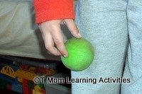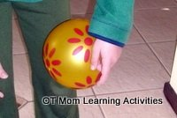  Make it harder: Use just your tripod fingers (thumb, index and middle fingers) to walk the ball.
Tuesday | Copy these handwriting patterns:  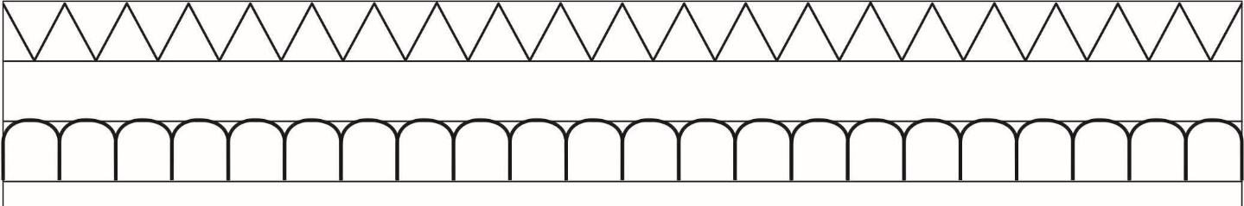
Wednesday | Practice your bottom joins: https://www.teachhandwriting.co.uk/continuous-cursive-joins-choice-1.html  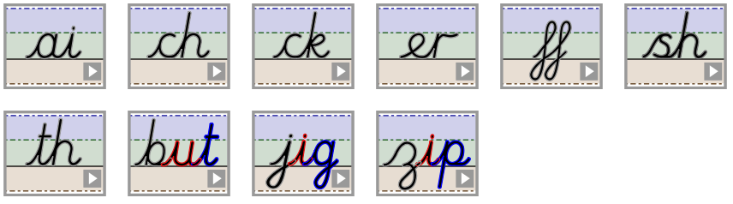
Thursday | Write the following words out neatly in your best handwriting:  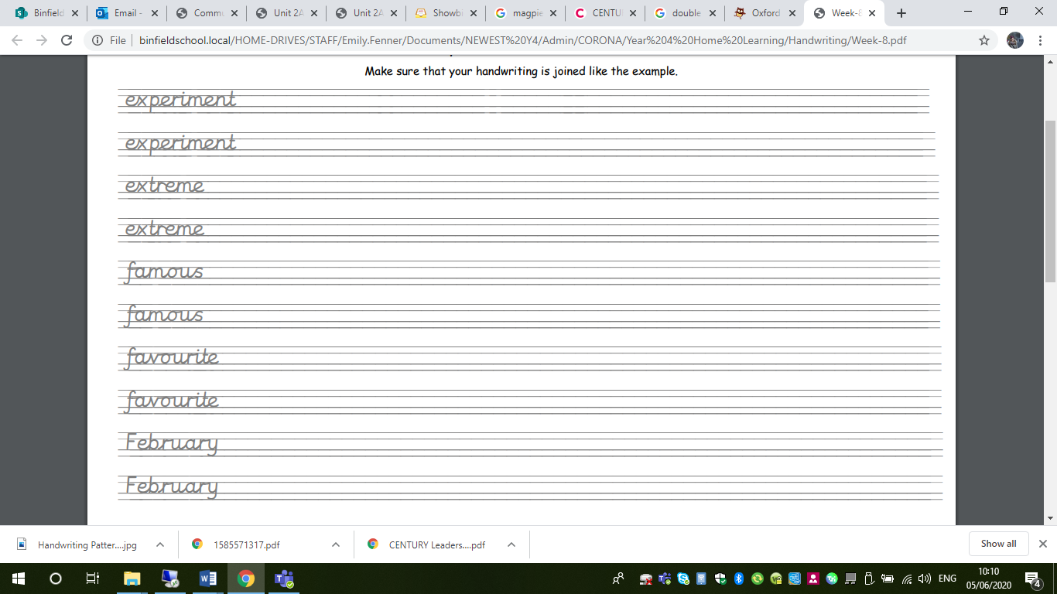
Friday | Write out some of your spellings from this week which have a silent letter, for example:
  autumn  column  hymn | glisten  castle  thistle

