Your English should be sent on Showbie this week.

This week in English we are going to be looking at using impressive vocabulary to help us write a setting description.
Monday | Complete the “Adjectives” nugget set on Century Tech.  Use: https://www.bbc.co.uk/bitesize/articles/znpbgwx to recap expanded noun phrases.  Watch the video and read the information under the “Learn” section.  Complete Activities 1, 2 and 3 under the “Practice” section.
Tuesday | Complete the “Prepositions” nugget set on Century Tech.  You may wish to use: https://www.bbc.co.uk/bitesize/articles/zh8nscw to help you.  Go to: https://www.literacyshed.com/the-images-shed.html  Scroll down to the “Landscapes” video.  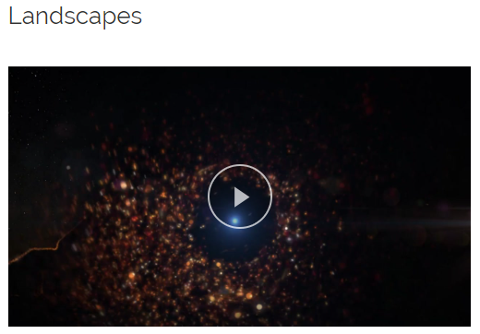  Watch the film all the way through once.  Then choose one of the beautiful settings you have seen in the video – pause the video on this setting.  What can you see?  Imagine you were ‘in’ the picture – what would you be able to hear? Smell? Taste? Touch?  Create a bubble map of adjectives and expanded noun phrases which describe the setting.  Make sure you use prepositions to add more detail to your descriptions!  Use the “Prepositions Word Mat” on the Year 4 page of the school website to help you.
Wednesday | Complete the “Proper Nouns” nugget set on Century Tech.  Look back at your setting and bubble map from yesterday.  Have you used impressive vocabulary?  Your job today is to improve the vocabulary you have used!  Look up the adjectives from your bubble map in a thesaurus and find some synonyms for your words.  Add your impressive vocabulary to your bubble map in a different colour.  (If you don’t have a thesaurus at home, you could use an online thesaurus: https://www.thesaurus.com/)  You could also use the vocabulary word mats on the Year 4 page of the school website and  some words from your “Magpie Journal” to help you too!  **There are lots of different word mats on the school website – choose the word mat for your setting.**
Thursday | Complete the “Common Nouns” nugget set on Century Tech.  Using your bubble map and the vocabulary mats (on the Year 4 page of the school website), start writing your setting description.  Remember to include:  - Correct punctuation: capital letters (for proper nouns), full stops, commas, exclamation marks, questions marks etc.  - Expanded noun phrases  - Impressive vocabulary  - Prepositions
Friday | Complete the “Collective Nouns” nugget set on Century Tech.  Finish your setting description.  Read it out loud – does it make sense? Have you used the correct punctuation? Have you used commas in your expanded noun phrases? Have you used impressive vocabulary?  Make any corrections you need to.  If you spot any repeated words or words you have used in your writing lots before – use a thesaurus or a word mat to find an impressive synonym to use instead!

