You no longer need to post Maths on Showbie.
Maths will continue to be White Rose with a Century Tech nugget relating to the work set on a Friday to be completed online.
Tasks are to be completed at home using the daily worksheets provided on our class page.
Answer pages have been included for marking at home.
Monday – Thursday you can also complete extra challenges.
You will find these below. The answers will be posted on our class pages too.

Week: 08/06/20

Monday 8th June

Watch ‘Summer Week 5 lesson 1’ Recapping tenths and hundredths. https://whiterosemaths.com/homelearning/year-4/

Please complete the worksheet on our class pages. We have posted the answers sheet too. Then if you feel like a challenge, try to answer these questions.

Challenge:

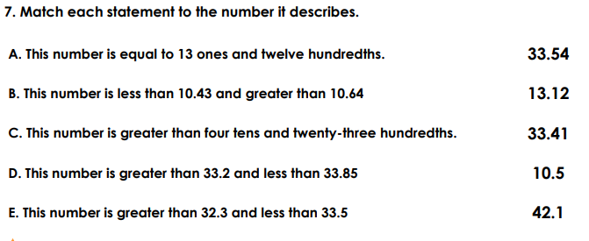

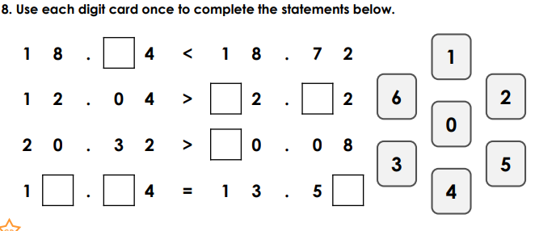

Tuesday 9th June

Watch ‘Summer Week 5 lesson 2’ Equivalent Fractions 1. https://whiterosemaths.com/homelearning/year-4/

Please complete the worksheet on our class pages. We have posted the answers sheet too. Then if you feel like a challenge, try to answer these questions.

Challenge:

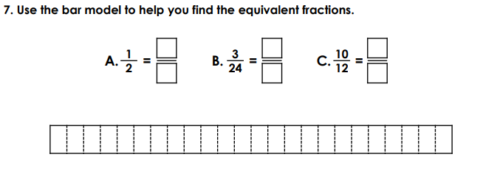

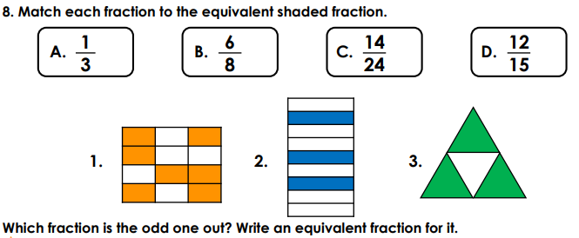

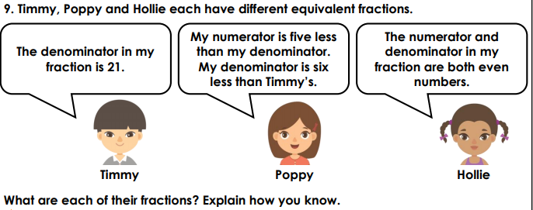

Wednesday 10th June

Watch ‘Summer Week 5 lesson 3’ Equivalent Fractions 2. https://whiterosemaths.com/homelearning/year-4/

Please complete the worksheet on our class pages. We have posted the answers sheet too. Then if you feel like a challenge, try to answer these questions.

Challenge:
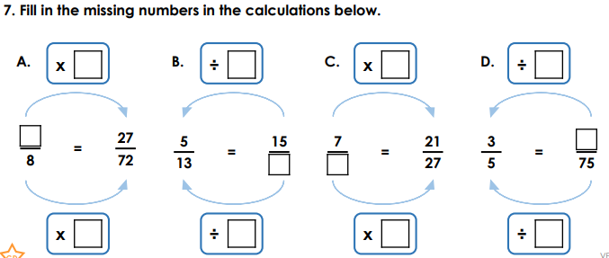

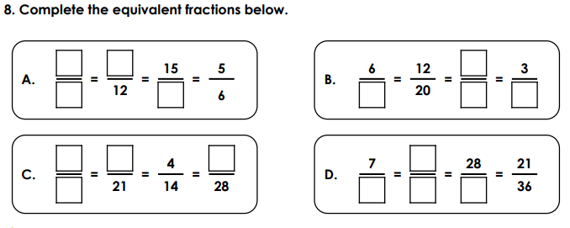
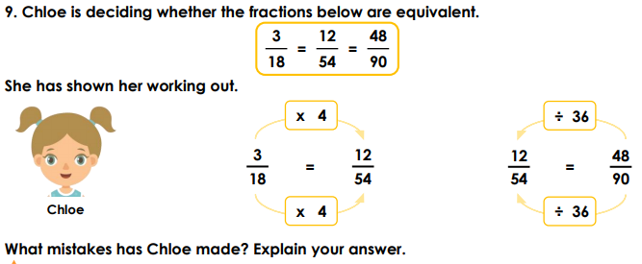

Thursday 11th June

Watch ‘Summer Week 5 lesson 4’ Fractions greater than 1. https://whiterosemaths.com/homelearning/year-4/

Please complete the worksheet on our class pages. We have posted the answers sheet too. Then if you feel like a challenge, try to answer these questions.

Challenge:

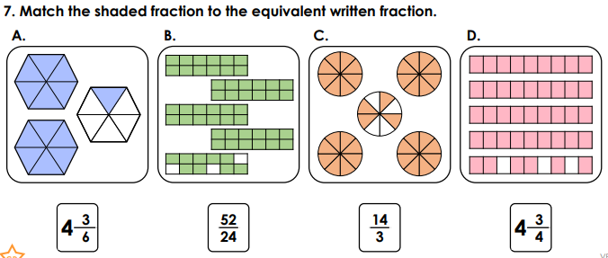

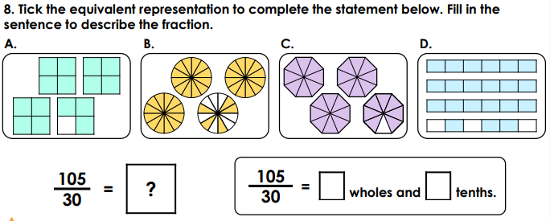

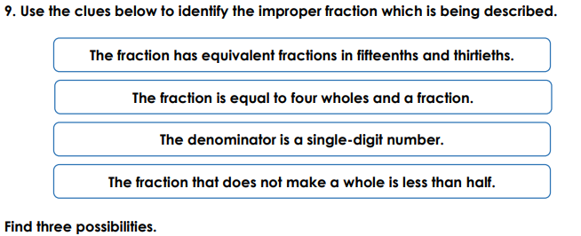

Friday 12th June
Please complete the nugget on Century Tech – Equivalent Fractions 1. This has been set for you.

