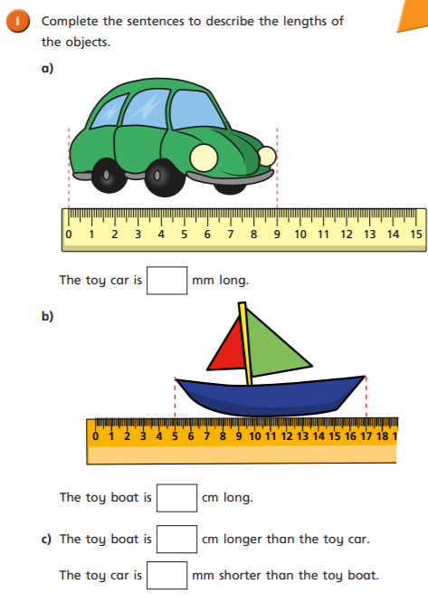
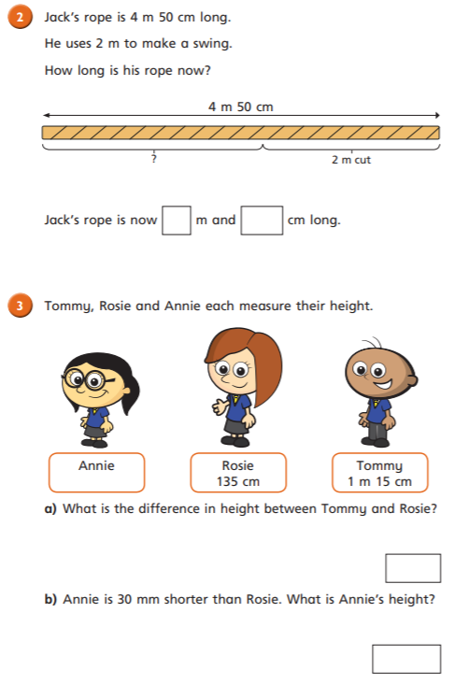
06.05.2021
LO: To use measure
C: Subtract lengths

06.05.2021
LO: To use measure
C: Subtract lengths

