Spend 5 minutes each day on your handwriting activities:
Monday | An activity to strengthen your writing hand!  Twirl a Beanbag  Using a beanbag, position the fingers under the beanbag, holding it level.  Keeping the beanbag level, slowly rotate the bean bag 360 degrees, using your fingers and thumb.  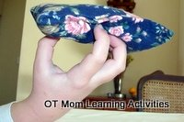  You could also try using a small bag of dried beans, popcorn or rice, if you don't have a beanbag to hand!
Tuesday | Copy these handwriting patterns:  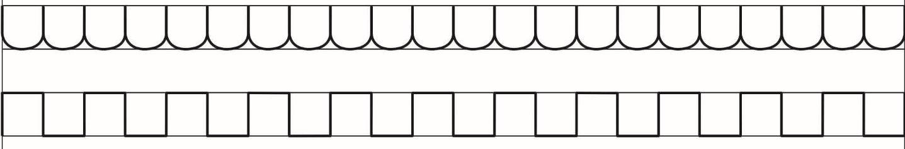
Wednesday | Practice your bottom to c shaped letter joins: https://www.teachhandwriting.co.uk/continuous-cursive-joins-choice-1.html  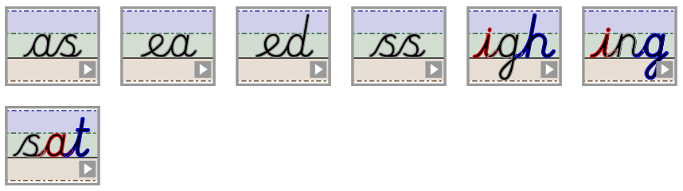
Thursday | Write the following words out neatly in your best handwriting:  forward, forward, forwards, forwards, fruit, fruit, grammar, grammar, group, group
Friday | Write out some of your spellings from this week, for example:  forgotten, topped, beginning, skipped, snapped, sadder, shopping, begged, slipped, flatten

