Doubling Consonants before adding suffixes – w/b 10.06.20
The following information is available at: https://www.spellzone.com/unit09/quest2_p4-5/index.cfm if you would like to look at the website.

The Spelling Rules for Adding Suffixes:
When to double a letter.
To understand the doubling rule, it helps to know about vowel and consonant patterns in words.

One way to make a vowel sound long is to put e on the end:
tap, tape bit, bite cod, code tub, tube

In two-syllable words, the first vowel is usually long if there is only one consonant between it and the next vowel:
paper even pilot robot music

The first vowel is short if there are two consonants between it and the next vowel:
magnet bottom butter fatter dinner

Watch: https://www.youtube.com/watch?v=4TjcT7Gto3U&feature=youtu.be to recap long and short vowel sounds.
There are two kinds of suffixes:
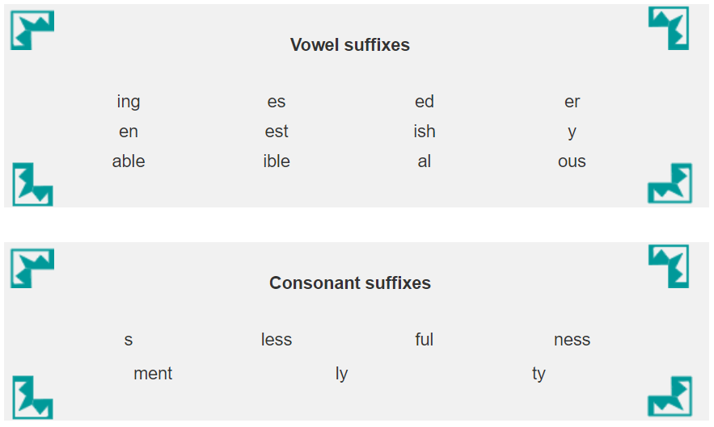
The Doubling Rule
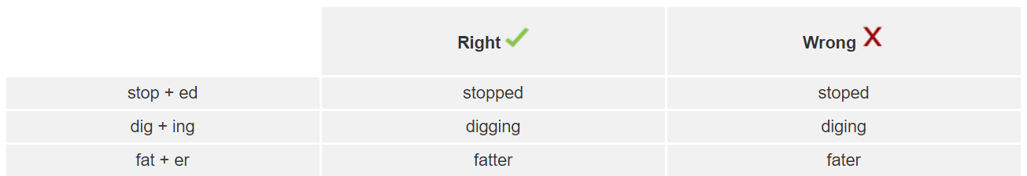
If you add a vowel suffix to a short vowel word, which only has one consonant at the end, you must double the consonant. If you don’t, the vowel sound will change to a long one.

Visit: https://www.spellzone.com/unit09/quest2_p4-5/index.cfm to hear these words being read aloud to you.

To help you remember this rule, think of the second vowel as an invader. He is trying to attack the first vowel and make it change its ways. If he can get near enough, he will make it say its long sound.

Here, there is a strong wall of two consonants. This will protect the short vowel from attack. The invader can’t get close, so the first vowel can carry on as before.


See how much you’ve learned by completing the mini test at the bottom of this web link: https://www.spellzone.com/unit09/quest2_p4-5/index.cfm


