You no longer need to post Maths on Showbie.
Maths will continue to be White Rose with a Century Tech nugget relating to the work set on a Friday to be completed online.
Tasks are to be completed at home using the daily worksheets provided on our class page.
Answer pages have been included for marking at home.
Monday – Thursday you can also complete extra challenges.
You will find these below. The answers will be posted on our class pages too.

Week: 15/06/20

Monday 15th June

Watch ‘Summer Week 6 lesson 1’ Adding 2 or more fractions. https://whiterosemaths.com/homelearning/year-4/

Please complete the worksheet on our class pages. We have posted the answers sheet too. Then if you feel like a challenge, try to answer these questions.

Challenge:

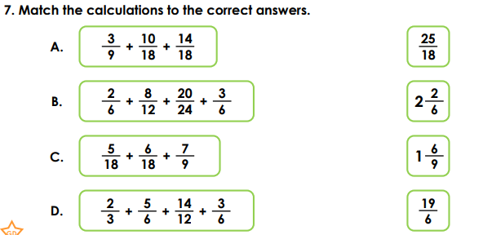

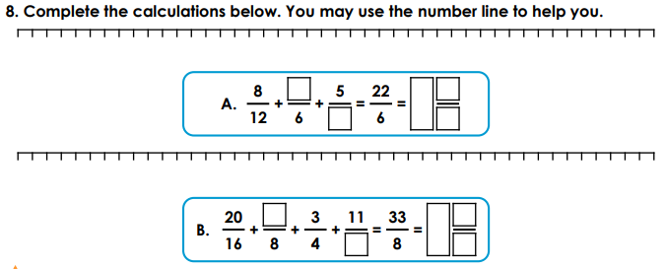

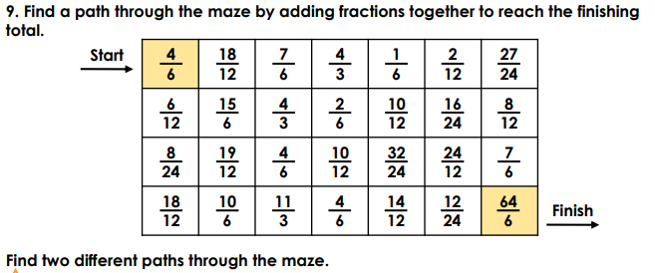

Tuesday 16th June

Watch ‘Summer Week 6 lesson 2’ Subtract 2 fractions. https://whiterosemaths.com/homelearning/year-4/

Please complete the worksheet on our class pages. We have posted the answers sheet too. Then if you feel like a challenge, try to answer these questions.

Challenge:

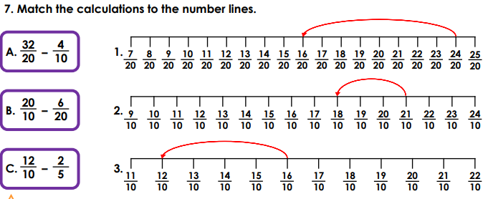
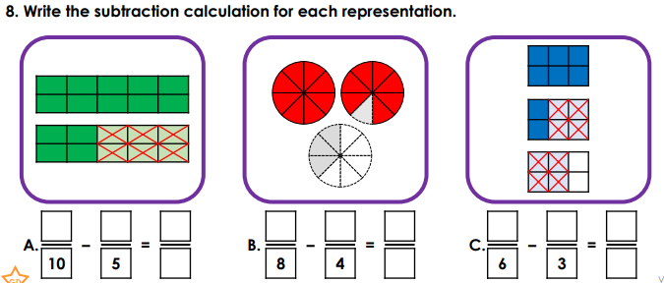
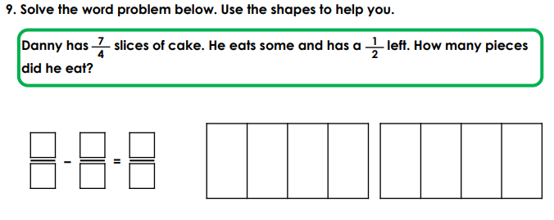

Wednesday 17th June

Watch ‘Summer Week 6 lesson 3’ Fractions of a quantity. https://whiterosemaths.com/homelearning/year-4/

Please complete the worksheet on our class pages. We have posted the answers sheet too. Then if you feel like a challenge, try to answer these questions.

Challenge:

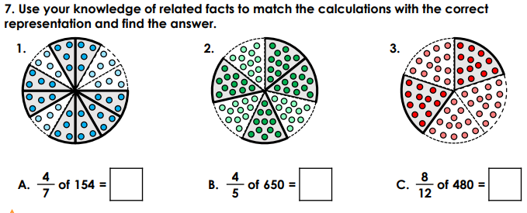
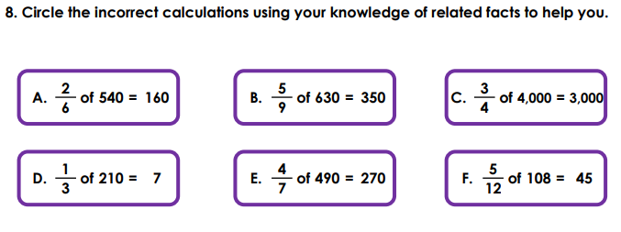
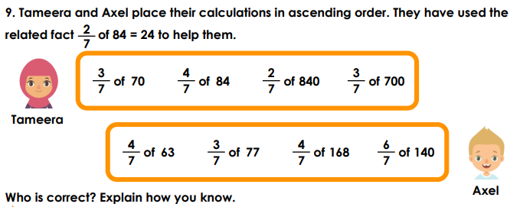

Thursday 18th June

Watch ‘Summer Week 6 lesson 4 Calculate quantities’. https://whiterosemaths.com/homelearning/year-4/

Please complete the worksheet on our class pages. We have posted the answers sheet too. Then if you feel like a challenge, try to answer these questions.

Challenge:

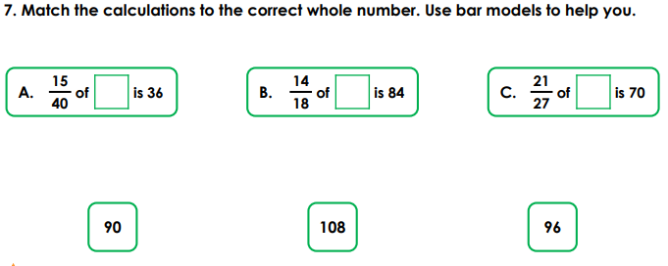
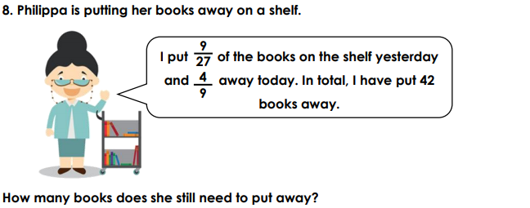
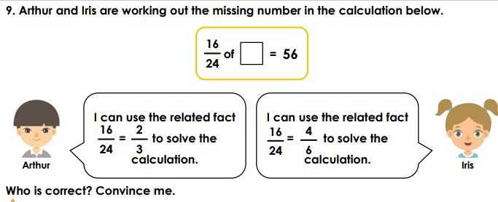

Friday 19th June
Please complete the nugget on Century Tech – Adding and subtracting fractions. This has been set for you.

