Use this t-shirt template to design your own sports team shirt. It could be football, basketball, swimming, tennis; any sport you like. Make sure it is bright, colourful and eye catching.

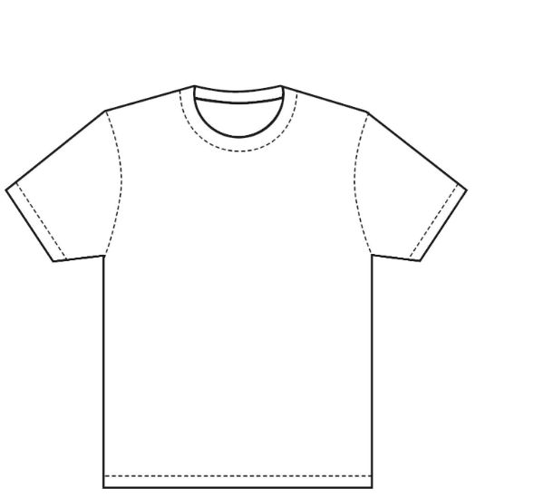
Examples:


