Spend 5 minutes each day on your handwriting activities:
Monday | An activity to strengthen your writing hand!  Go to: https://www.youtube.com/watch?v=r2tBH_XyeJc and have a go at the finger fitness exercises!  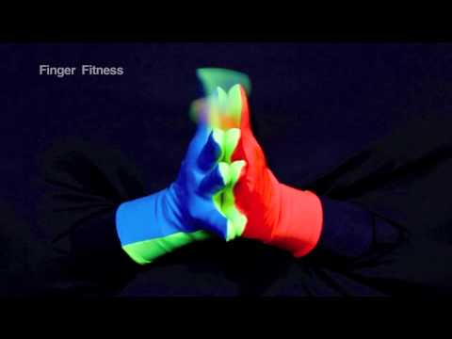
Tuesday | Copy these handwriting patterns:  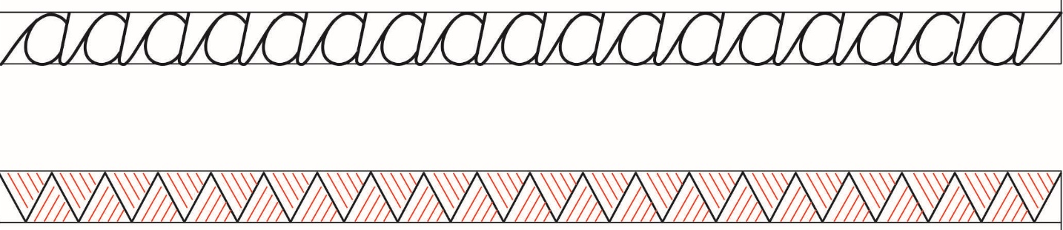
Wednesday | Practice your top ‘e’ letter joins: https://www.teachhandwriting.co.uk/continuous-cursive-joins-choice-1.html  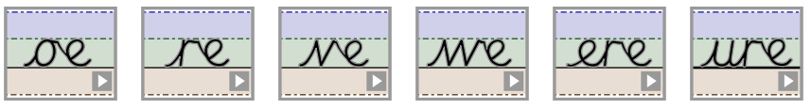
Thursday | Write the following words out neatly in your best handwriting:  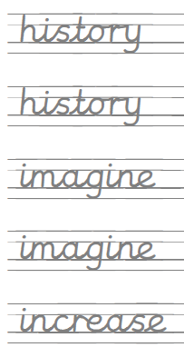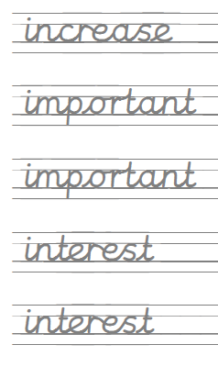
Friday | Write out some of your spellings from this week, for example:  

