Our spelling focus this week is: their, there or they’re

Spend 15 minutes each day on your spelling activities:
Monday | Go to: https://www.bbc.co.uk/bitesize/articles/zk2c92p  Watch the videos and read the information.  Complete activities 1, 2, 3 and 4.  In your reading today, keep an eye out for any sentences which use their, there and they’re!  How do you know the author has used the correct one?
Tuesday | Can you find and correct the errors?  They’re are lots of different animals at the zoo but there not all friendly! The tigers will growl loudly at the public but their only protecting they’re babies. However, when any little children are near their cages it terrifies them so they run away to there parents. There are also lions at the zoo who spend their days eating meat, sunbathing and sitting near they’re lake. The lions are golden in colour and their definitely majestic. Finally, the zoo has there own collection of pythons. They’re brown and green skin is good camouflage and there really long which is useful when they kill their prey in the wild.
Wednesday | Make your own colourful poster like the one below to help you remember which spelling to use!  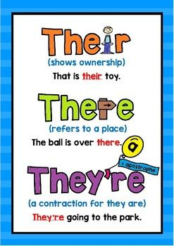
Thursday | Play some spelling games to help you!  http://www.games.galacticphonics.com/homonyms/interactive/theretheirtheyre/theretheirtheyre.htm  https://kids.classroomsecrets.co.uk/resource/year-3-there-their-or-theyre-game/
Friday | Test yourself! How well have you learned your spellings?  

