You no longer need to post Maths on Showbie.
Maths will continue to be White Rose with a Century Tech nugget relating to the work set on a Friday to be completed online.
Tasks are to be completed at home using the daily worksheets provided on our class page.
Answer pages have been included for marking at home.
Monday – Thursday you can also complete extra challenges.
You will find these below. The answers will be posted on our class pages too.

Week: 29/06/20

This week the videos are not in the usual place. Please click the link for each day to be taken to the correct video.
Monday 29th June

Please watch this video on subtracting two 4 digit numbers – no exchange: https://vimeo.com/427996624

Please complete the worksheet on our class pages. We have posted the answers sheet too. Then if you feel like a challenge, try to answer these questions.

Challenge:

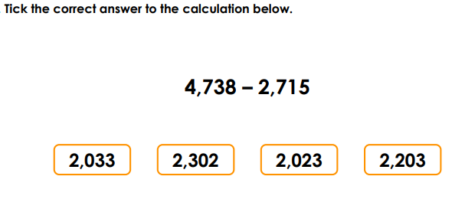
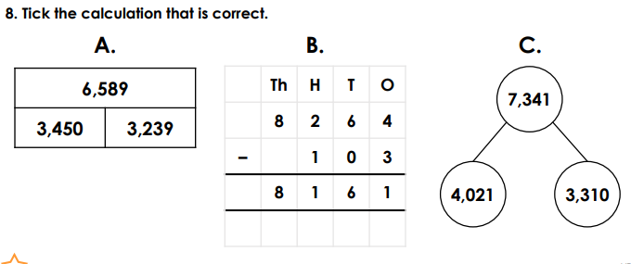

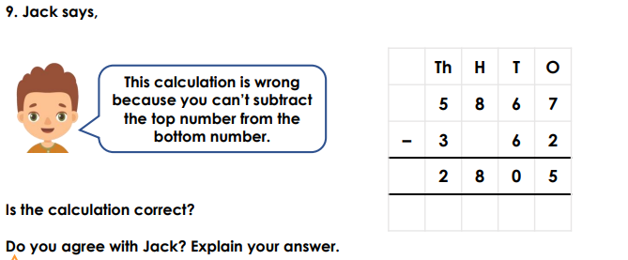

Tuesday 30th June

Please watch this video on subtracting two 4 digit numbers – 1 exchange: https://vimeo.com/428000196

Please complete the worksheet on our class pages. We have posted the answers sheet too. Then if you feel like a challenge, try to answer these questions.

Challenge:

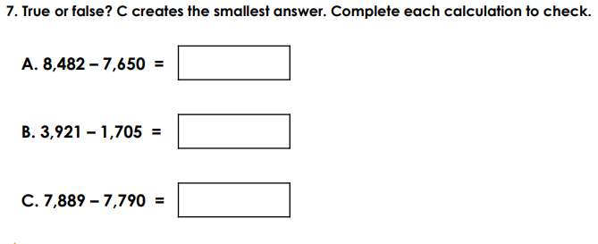
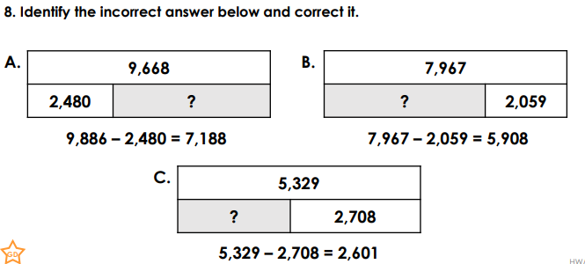
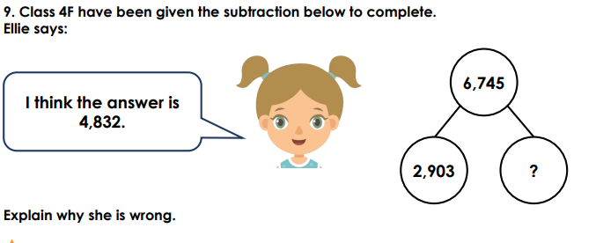

Wednesday 1st July

Please watch this video on subtracting two 4 digit numbers – more than 1 exchange: https://vimeo.com/428000367

Please complete the worksheet on our class pages. We have posted the answers sheet too. Then if you feel like a challenge, try to answer these questions.

Challenge:

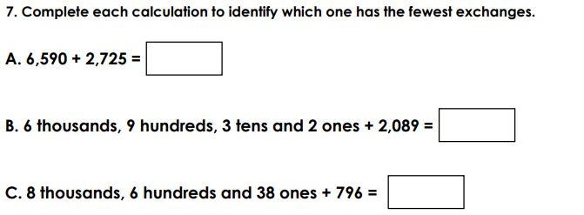

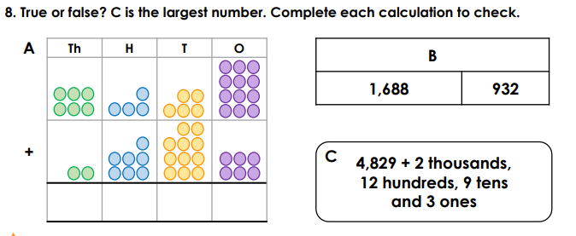
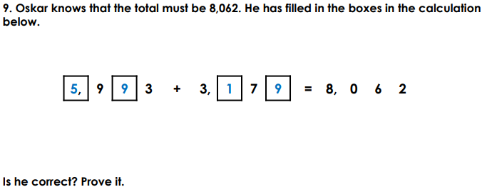

Thursday 2nd July

Please watch this video on Efficient subtraction: https://vimeo.com/428003455

Please complete the worksheet on our class pages. We have posted the answers sheet too. Then if you feel like a challenge, try to answer these questions.

Challenge:

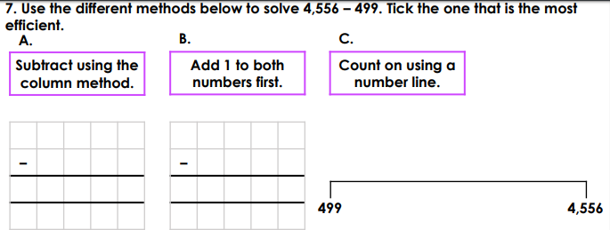
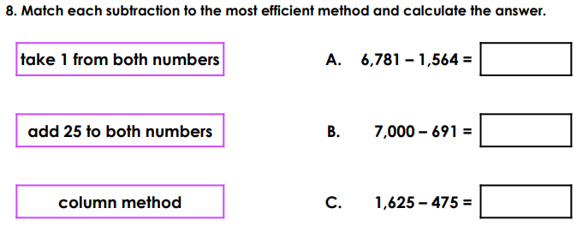
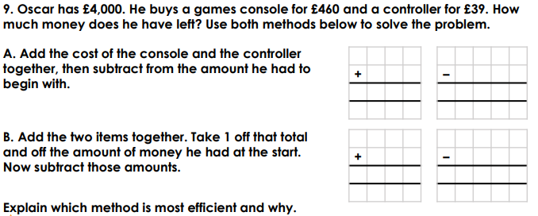

Friday 3rd July
Please complete the 3 nuggets that have been set on Century Tech.
Then complete this fun and interesting Nrich challenge. You’ll have surprising results!
https://nrich.maths.org/11014

Try it yourself with three more subtractions.
Do you always get the same answer?
What do you notice in the 2nd video?

