Monday
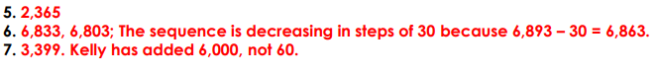

Tuesday
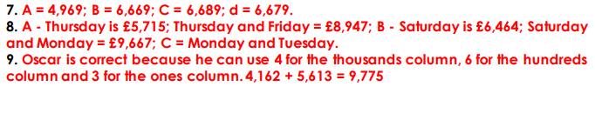
Wednesday
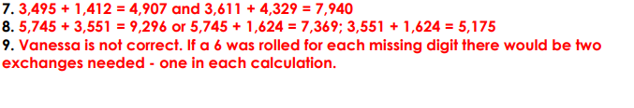

Thursday


