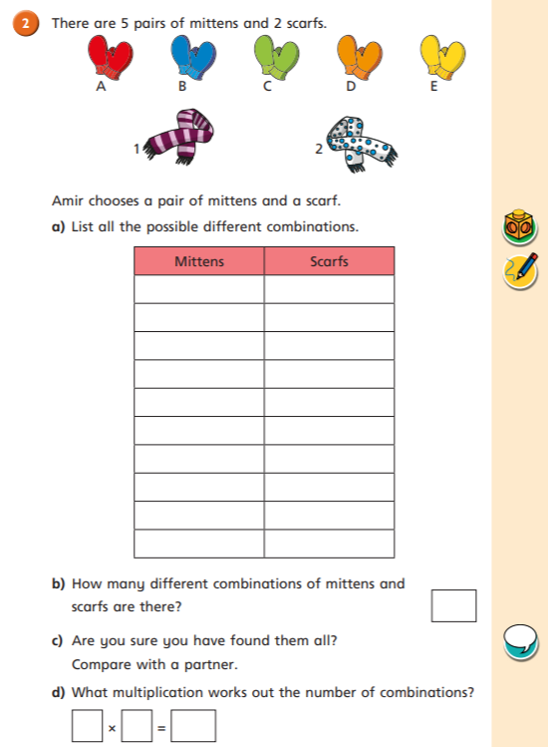

22/03/2021
LO: To multiply and divide
C: How many ways?
22/03/2021
LO: To multiply and divide
C: How many ways?

