Spend 5 minutes each day on your handwriting activities:
Monday | An activity to strengthen your writing hand!  Crumple Paper  Crumple a sheet of newspaper or scrap paper in your hand until it is a tight ball.  Try to do it while holding your hand in the air. That way, the fingers work harder!  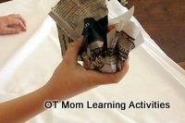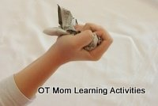  Tip: Do this whenever paper needs to be thrown away - scrunch it up with one hand and throw it in the bin!
Tuesday | Copy these handwriting patterns:  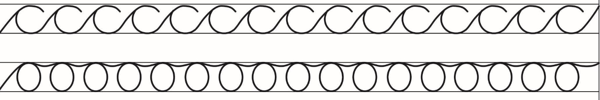
Wednesday | Practice your bottom to e letter joins: https://www.teachhandwriting.co.uk/continuous-cursive-joins-choice-1.html  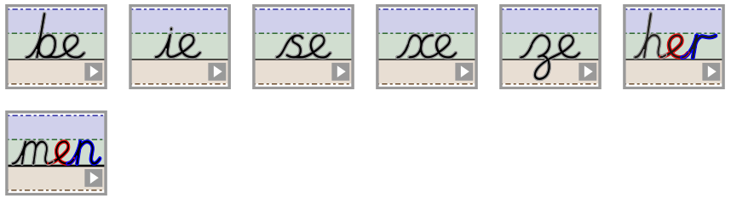
Thursday | Write the following words out neatly in your best handwriting:  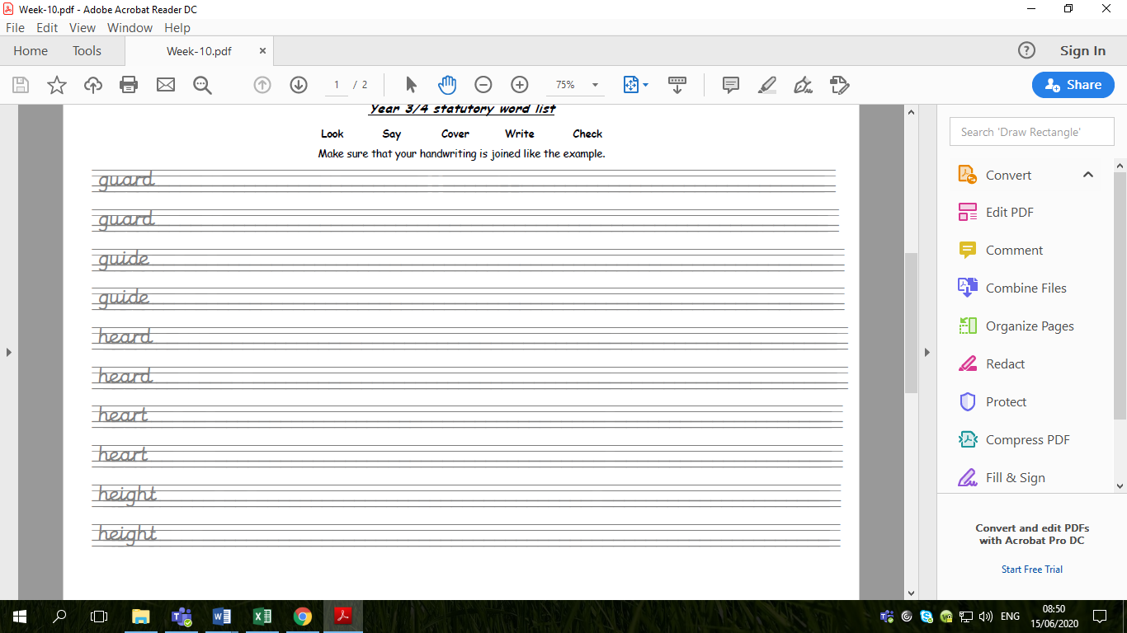
Friday | Write out some of your spellings from this week, for example:  

