Our spelling focus this week is: the suffix -ation

Spend 15 minutes each day on your spelling activities:
Monday | Go to: https://www.bbc.co.uk/bitesize/topics/zqqsw6f/articles/zcb8k7h  Watch the videos and read the information.  In your reading today, keep an eye out for any words that have the suffix -ation!  Make a note of them.
Tuesday | Practise writing some spellings that follow our spelling rule for this week – write the suffix  -ation in a different colour so that it stands out.  plantation, information, explanation, temptation, alteration, exploration, accusation, preservation, sensation, preparation  Example: information
Wednesday | Choose some of the words you are finding trickiest to spell and create a fun way to help you remember it, for example a mnemonic.  Example: in-for-ma-t-ion  You might like to make a poster or draw a picture to help you remember the correct spellings!
Thursday | Complete some spelling activities to help you!  https://www.spellzone.com/word_lists/games-13196.htm  Can you choose the right word?  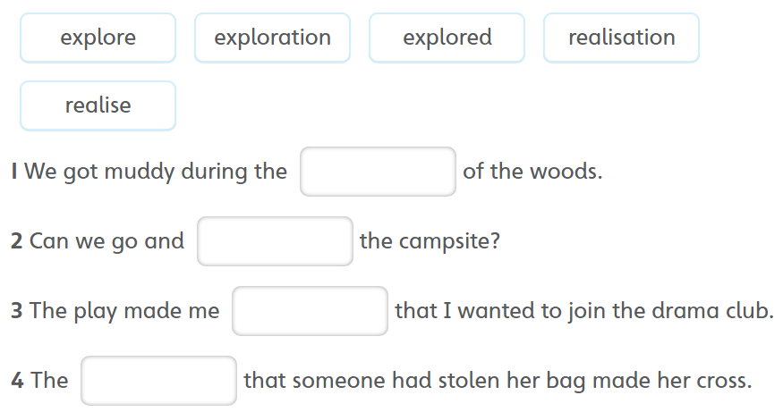  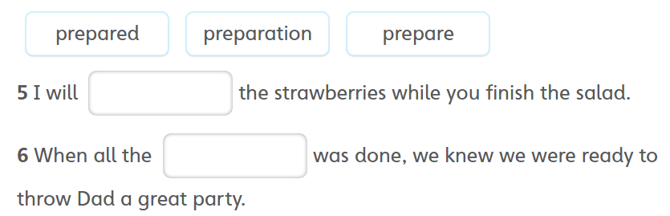  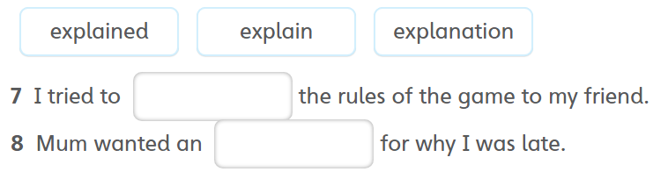  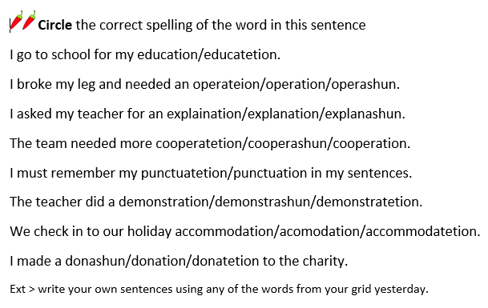
Friday | Test yourself! How well have you learned your spellings?  Do ‘look, cover, say, write, check’ and see how many words you have spelled correctly!

