You no longer need to post Maths on Showbie.
Maths will continue to be White Rose with a Century Tech nugget relating to the work set on a Friday to be completed online.
Tasks are to be completed at home using the daily worksheets provided on our class page.
Answer pages have been included for marking at home.
Monday – Thursday you can also complete extra challenges.
You will find these below. The answers will be posted on our class pages too.

Week: 22/06/20

This week the videos are not in the usual place. Please click the link for each day to be taken to the correct video.
Monday 22nd June

Watch this video on 1’s, 10’s, 100’s and 1000’s https://vimeo.com/425562383
Please complete the worksheet on our class pages. We have posted the answers sheet too. Then if you feel like a challenge, try to answer these questions.

Challenge:

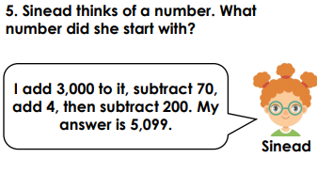
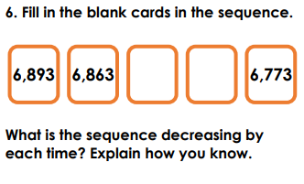
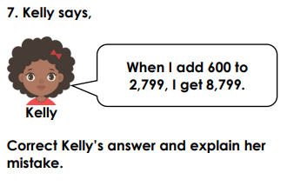

Tuesday 23rd June

Please watch this video on adding 2 digit numbers without exchange https://vimeo.com/425562628

Please complete the worksheet on our class pages. We have posted the answers sheet too. Then if you feel like a challenge, try to answer these questions.

Challenge:

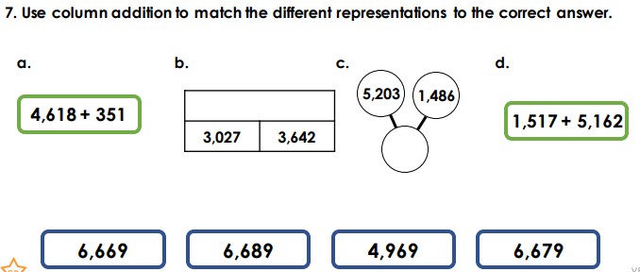

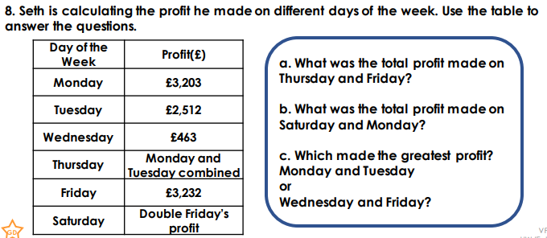
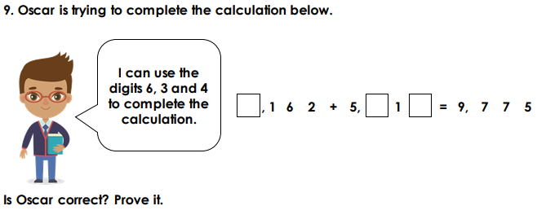

Wednesday 24th June

Please watch this video on adding two 4 digit numbers with one exchange https://vimeo.com/425562776

Please complete the worksheet on our class pages. We have posted the answers sheet too. Then if you feel like a challenge, try to answer these questions.

Challenge:

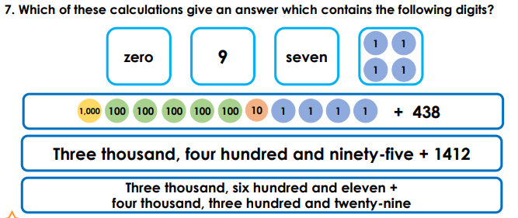

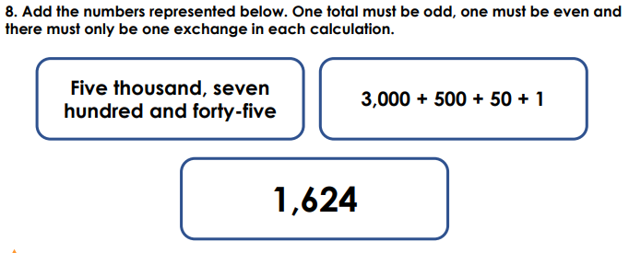
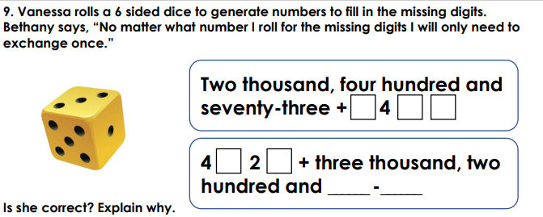

Thursday 25th June

Please watch this video on adding two 4 digit numbers with more than one exchange https://vimeo.com/425563010

Please complete the worksheet on our class pages. We have posted the answers sheet too. Then if you feel like a challenge, try to answer these questions.

Challenge:

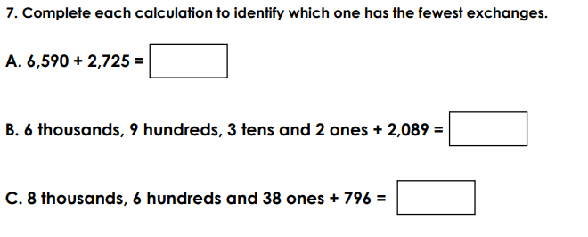

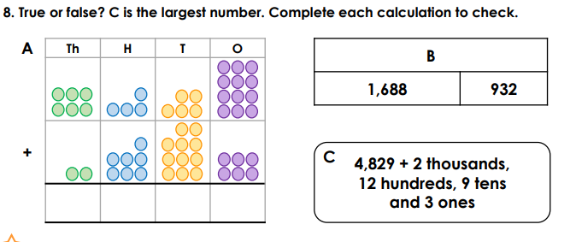

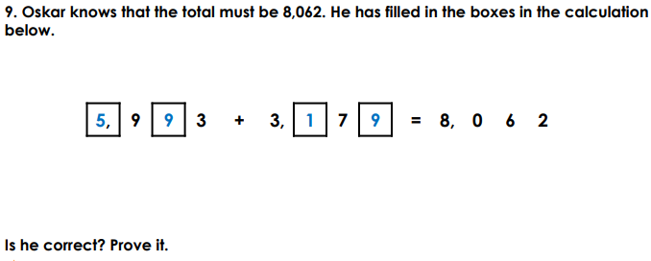
Friday 26th June
Please complete the 3 nuggets that have been set on Century Tech.

