
Reception distance learning – wb 8.6.2020
For more detailed information on activities, please see plans below the timetable!
Monday | Maths | Read Write Inc | Playtime! | Reading | RE | Lunchtime! | Fine motor skills | Writing
Tuesday | Maths | Read Write Inc | Playtime! | Reading | PE | Lunchtime! | Fine motor skills | Writing
Wednesday | Maths | Read Write Inc | Playtime! | Reading | Art | Lunchtime! | Fine motor skills | Writing
Thursday | Maths | Read Write Inc | Playtime! | Reading | Music | Lunchtime! | Fine motor skills | Writing
Friday | Maths | Read Write Inc | Playtime! | Reading | Mindfulness | Lunchtime! | Fine motor skills | Writing

Starting this week, the timetable and learning activities have changed slightly to closely mirror the learning that is being done in school by those children who are attending. The main focus is Reading, Writing and Maths.

Evidence of all writing tasks is now to be uploaded to Showbie.

Maths -
Monday – This week we are recapping sharing into groups. Last time we shared into groups of two to find halves. This week we are going to share into lots of different groups, making sure they are equal! Grab some resources and practice sharing into two equal groups again to refresh your memory.
What is 4 shared into 2 equal groups? How many are in each group?
What is 6 shared into 2 equal groups? How many are in each group?
What is 8 shared into 2 equal groups? How many are in each group?
Tuesday - Have a go at the minibeast sharing activity in the resources section. Draw the correct number of leaves for each minibeast to show what their equal share is. It might help to draw the leaves one at a time and cross them out as you go!
Wednesday – Today we are going to investigate odd and even numbers. Even numbers can be shared equally into two groups but odd numbers cannot. Investigate whether you can share these numbers equally in half.
0 1 2 3 4 5 6 7 8 9 10
Then write a list of odd and a list of even numbers.
Thursday – Complete the odd and even sock activity in the resources section
Friday – We use numicon lots at school. Look at the numicon in the picture. Using your list of odd and even numbers, what do you notice about how the odd and even numicon pieces look?
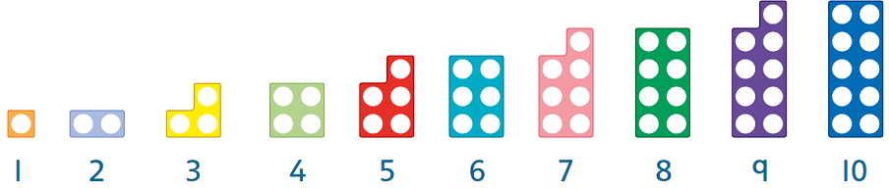

Read Write Inc.
Monday – Look at this sound chart. Can you name all the sounds? If not then watch the video on the website to refamiliarise yourself with that sound.
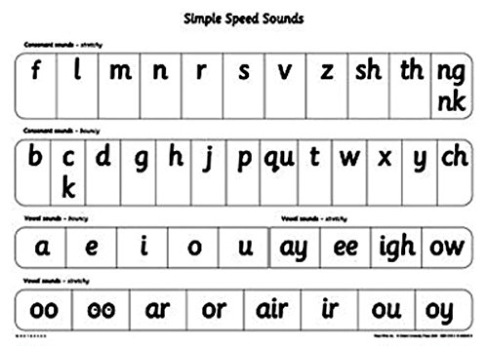
Tuesday - Play the game https://www.ictgames.com/mobilePage/helpAHedgehog/index.html Choose phase 3 options. What score can you get?
Wednesday – Choose a book and see how many words you can read in one minute. Then practice reading all the tricky words and have another go to see if you can read more words in a minute.
Thursday – Use your phonic knowledge to write the names of the animals in these pictures. Then look at the correct spelling with a grown up. How did you do? Were any of the words red words? What letters made a different sound to what you thought you needed?
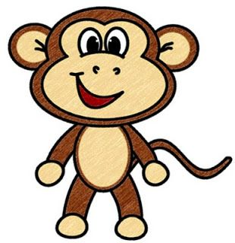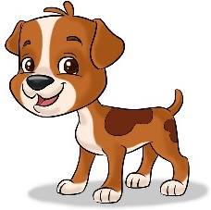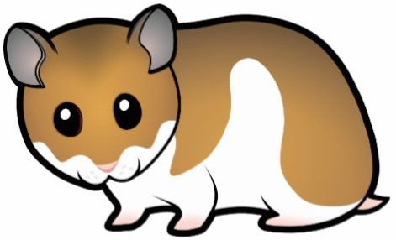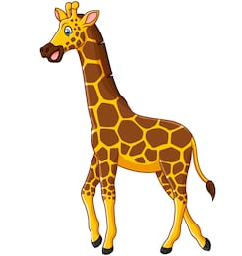

Friday – Word hunt! Grab a few books and see how long it takes you to find the word ‘like’

Reading
Monday – This week we are learning about question marks. Look through the books in your house. Can you find a question mark?
Tuesday - Listen to Mrs Bowles read ‘The Tiger who came to tea’. What questions can you hear?
Wednesday – Look at the alien words in the resources section. How many can you read? Remember to look for special friends!
Thursday – Listen to Mrs Evans read ‘We’re going on a Bear Hunt’. There are some funny words in the book. What is your favourite?
Friday – Complete the ‘houses comprehension colouring’ sheet in the resources section.
Fine Motor skills/Handwriting
Monday – This week we are learning about question marks. Practice drawing some question marks on a piece of paper.
Tuesday – Can you curve a shoelace into a question mark?
Wednesday – Practice some of the pencil warmup games from Mr Johnsons video last week.
Thursday – Using your finger, write the alphabet onto surfaces of different textures (carpet, fabric, grass)
Friday – Find a coat, jumper or shirt with buttons on it. How quickly can you do them all up? You could record your time and race someone else!

Writing
Weekly focus: Question marks
Monday – Watch Mr Johnson’s video explaining question marks. Then write your own question.
Tuesday – Copy the following questions. I have forgotten to include capital letters and question marks. Can you add them in?
what is for lunch
can cows jump over cars
what is your favourite song

Wednesday – Write a letter to a friend asking them a question. Remember to use question marks!
Thursday – Do these sentences need a question mark or a full stop? Copy then in your best writing with the correct punctuation
I have got a blue bike
Do you like eating worms
Please can I have some cake
I like reading books about pirates
Friday – Play the game ‘Guess who’. You can find a game board in the resources section. Write down two of the questions you asked.
RE
Watch the story of the good Samaritan (https://www.youtube.com/watch?v=osfQg4yKtq8).
Can you think of something kind that somebody has done for you? How could you be kind to somebody else?
PE
Find 5 items in two different colours. Then some tape, plates or similar objects to make a giant noughts and crosses. Watch the video (https://www.youtube.com/watch?v=IRDp5HcZyVA) and play the game with a partner. Change it up and make it harder by changing the movement, you could hop, skip or two footed jump between the start line and the game area.
Music
Take part in the ‘body percussion’ lesson on BBC Bitesize (https://www.bbc.co.uk/bitesize/articles/zb9djhv)
Art
Here are some traditional African patterns. Look around your house or garden. Can you find any interesting patterns? Copy it out or draw your own.
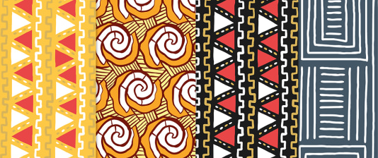
Mindfulness
Draw some pictures or write about your perfect day full of things that make you happy.
- What would you do?
- Where would you go?
- Who would you see?
- What would you eat?
- What would you wear?

Resources
Maths – Tuesday
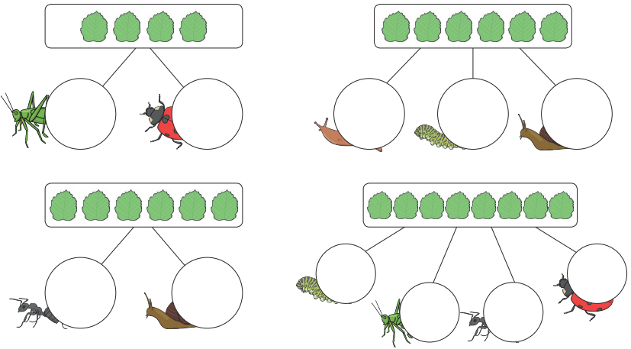

Maths – Thursday
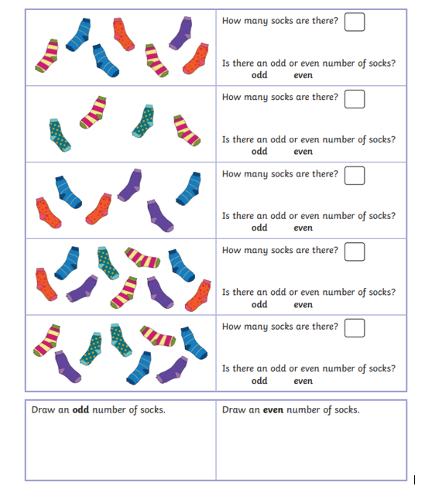
Reading – Wednesday
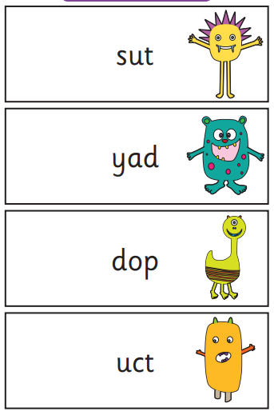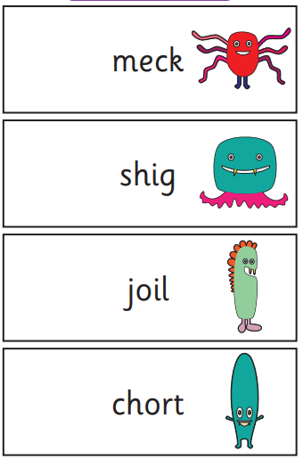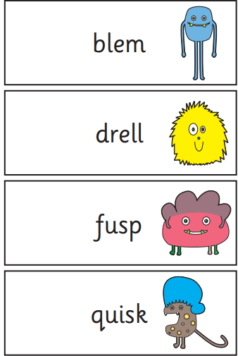

Reading – Friday

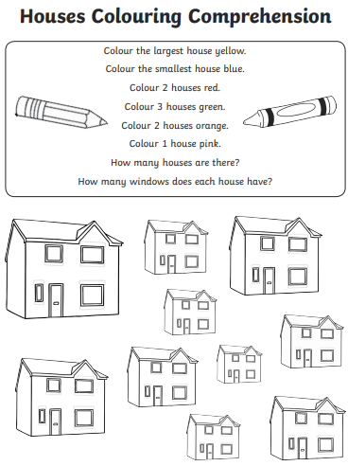
Writing – Friday


