
Reception distance learning – wb 15.6.2020
For more detailed information on activities, please see plans below the timetable!
Monday | Maths | Read Write Inc | Playtime! | Reading | RE | Lunchtime! | Fine motor skills | Writing
Tuesday | Maths | Read Write Inc | Playtime! | Reading | PE | Lunchtime! | Fine motor skills | Writing
Wednesday | Maths | Read Write Inc | Playtime! | Reading | Art | Lunchtime! | Fine motor skills | Writing
Thursday | Maths | Read Write Inc | Playtime! | Reading | Music | Lunchtime! | Fine motor skills | Writing
Friday | Maths | Read Write Inc | Playtime! | Reading | Mindfulness | Lunchtime! | Fine motor skills | Writing

Maths –

Weekly focus – Money

Monday – Can you label the coins below? The use real coins, pretend coins or cut the coins out below and put them in order from the smallest to the biggest amount of money! Watch this clip https://www.bbc.co.uk/bitesize/clips/z2g4wmn and discuss, what do we use money for, why do we need money?
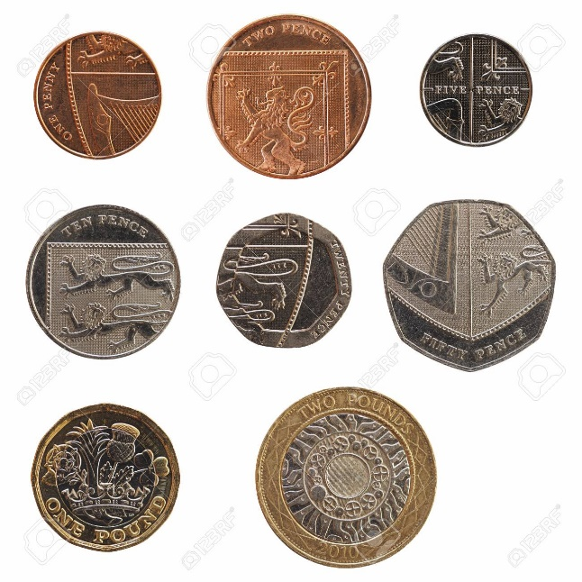
Tuesday – Go to https://www.topmarks.co.uk/money/coins-game and complete the money game!
Wednesday – Complete the worksheet found in the resource section!
Thursday – Complete the problem solving activities found in the resource section!
Friday – Complete the problem solving activities found in the resource section!

Read Write Inc.

Monday – Watch the video of Mrs Gogarty teaching green words and red words. How many words can you remember? Can you spell them?
Tuesday – Watch the video of Mrs Bowles on connecting sentences using conjunctions. Have a go yourself!
Wednesday – Go to https://www.youtube.com/watch?v=qTLdc4rQooA can you read the red words and spot where the tricky sound is? Think of some sentences that have these red words in.
Thursday – Read the story ‘The troll in the pond’ with support from an adult if necessary https://www.oxfordowl.co.uk/api/interactives/29257.html practise the green words, red words and the sounds within the story (found on pages 4-7)
Friday – Read the story again and answer the questions found on page 14

Reading
Monday – Play the game ‘fishy phonics’ select the level the children are confident with and encourage them to challenge themselves https://www.phonicsbloom.com/uk/game/fishy-phonics?phase=2
Tuesday – Go to https://www.phonicsplay.co.uk/resources/phase/4/picnic-on-pluto children will need to read the word using their phonic knowledge and figure out whether it is a real or an alien word!
Wednesday – Watch Mr Johnson’s video on question marks again (on last weeks page!). Go to https://www.roythezebra.com/reading-games/question-mark-1.html . Support your child to read the sentences and put the question mark in the correct place!
Thursday – Go to https://www.roythezebra.com/reading-games/sentences-that-make-sense-2-1.html read the sentence, why doesn’t it make sense? Put the words in the correct order to make sure it makes sense!
Friday – Watch the video of Mrs Evans’ talking about full stops. Go to https://www.roythezebra.com/reading-games/full-stop-1.html read the sentences carefully, can you put the full stops in the correct place?

Fine Motor skills/Handwriting
Monday – Practice your cursive letter formation, you can use the sheet found in the resource section to help you!
Tuesday – Watch Julia Donaldson’s ‘Paper Dolls’ here https://www.youtube.com/watch?v=0BuURAo5f3k then make your own paper dolls – you can find a template sheet within the resource section!
Wednesday – Have some playdough ready and join in with the finger gym video! https://www.youtube.com/watch?v=o9D5lfqZF3o. You can find a playdough recipe in the resource section! Save your playdough for tomorrow’s activity!
Thursday – Have some playdough ready and join in with the finger gym video! https://www.youtube.com/watch?v=BOLR3pQt8zg
Friday – Complete the mindfulness colouring rainbow found in the resource section!

Writing
Weekly focus: Creative writing – writing for a purpose
Monday – What is your favourite book? What do you like about it? Complete the book review task in the resource section or design your own!
Tuesday – Watch ‘The Jolly Postman’ https://www.youtube.com/watch?v=gpeo_0yoD0k discuss what types of letters were in the story. What letters do you like? Pretend that you are going to have a party, which character would you like to invite? What type of party would you like? Write an invitation to one of the characters from the story! You can find a template in the resource section!
Wednesday – Continue discussion from yesterday about different types of letters. Write a letter to your friend about the things you have enjoyed doing recently. It may include going for a nice walk in the sunshine, having a BBQ or splashing in your paddling pool! You can also draw a picture to go with it!
Thursday – Watch or read the story ‘Whatever Next’ https://www.youtube.com/watch?v=Nn73STXrPP0. Write a postcard from Baby Bear about his trip to the moon! See the template in the resource section! Watch the video of Mrs Gogarty to show you how to write a postcard as an example! Here are the things you need to include: Where did they go? How did they get there? Who did he go with? What did they do? What did he see?
Friday – Create and write a message in a card for your Daddy or a special loved one! See some ideas in the resource section! Watch Mr Johnsons example video on the class page if it is uploaded! (Sorry I am having computer issues but will try to get this uploaded in time!)

RE
Sing along to ‘All things bright and beautiful’ https://www.youtube.com/watch?v=FT_oDqOEGpc. Talk about the hymn. What does it make you think of? How does it make you feel? Why? Then watch the story of creation https://www.youtube.com/watch?v=teu7BCZTgDs
Complete the comic strip by drawing a picture for each box. Please see template in resource section.
PE
Listen to Mrs Evans read ‘Were going on a Bear hunt’ on the class page. Then join in with a bear hunt themed yoga session! https://www.youtube.com/watch?v=KAT5NiWHFIU.
Music
Join in with a music lesson https://www.youtube.com/watch?v=bFbQS48SYtg Have fun!
Art
Go for a walk and collect some natural objects, when you get home create a nature collage with all the things you have found!
You could look at the art of Andy Goldsworthy for inspiration.
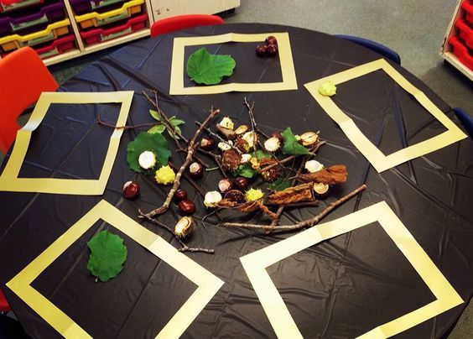

Mindfulness
https://www.youtube.com/watch?v=fkmmQawCgmk listen to the mindfulness story about the magic book. When finished, draw a picture of something from the story!

Resources
Maths – Wednesday
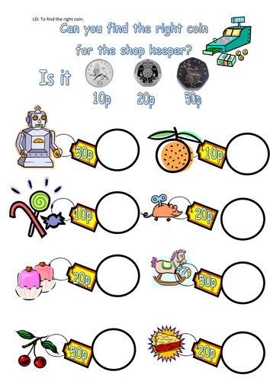

Maths – Thursday
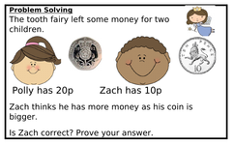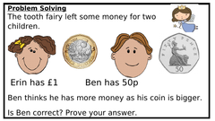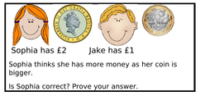

Maths – Friday
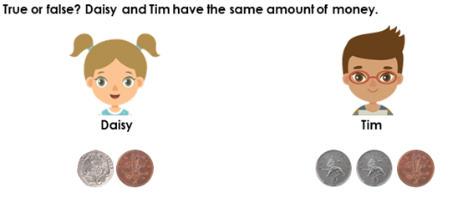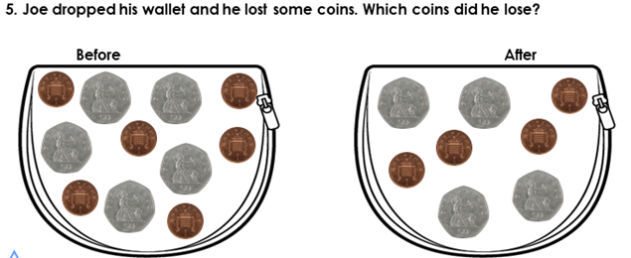

Fine Motor/ handwriting -Monday
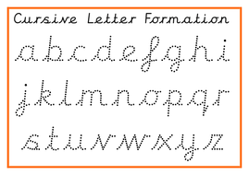

Fine motor/Handwriting– Tuesday
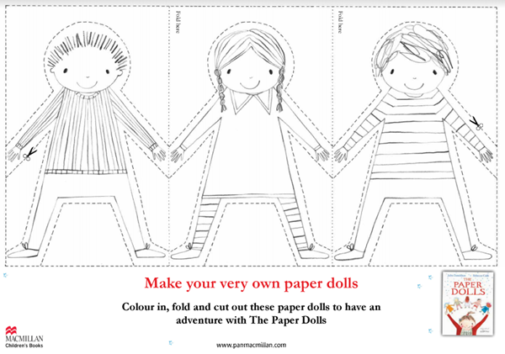

Fine motor/Handwriting– Wednesday
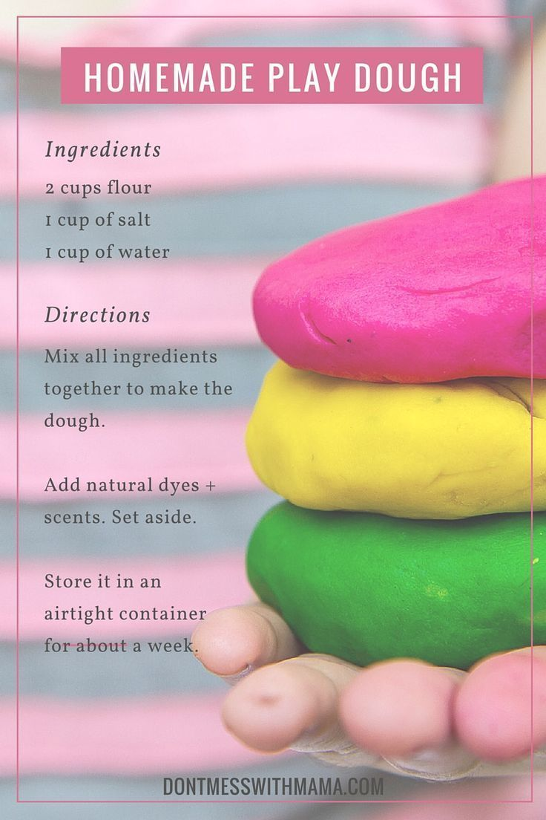

Fine motor/ Handwriting - Friday
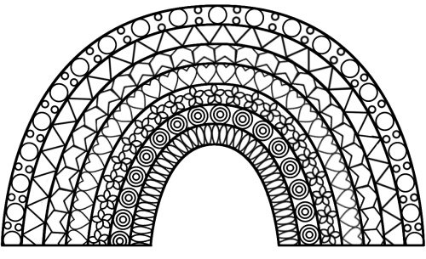

Writing -Monday
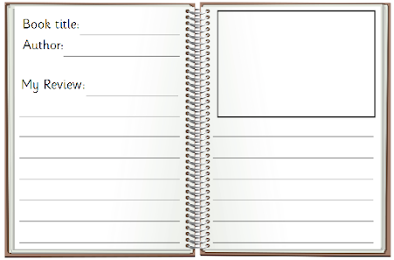

Writing – Tuesday
Dear

Please come to my party!

Date:

Time:

Address:

Writing – Thursday

To ____________________________________ 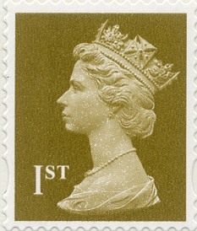
I went to _______________________________
_______________________________________
_______________________________________
_______________________________________
I saw __________________________________
_______________________________________
_______________________________________
_______________________________________
From __________________________________

Writing -Friday

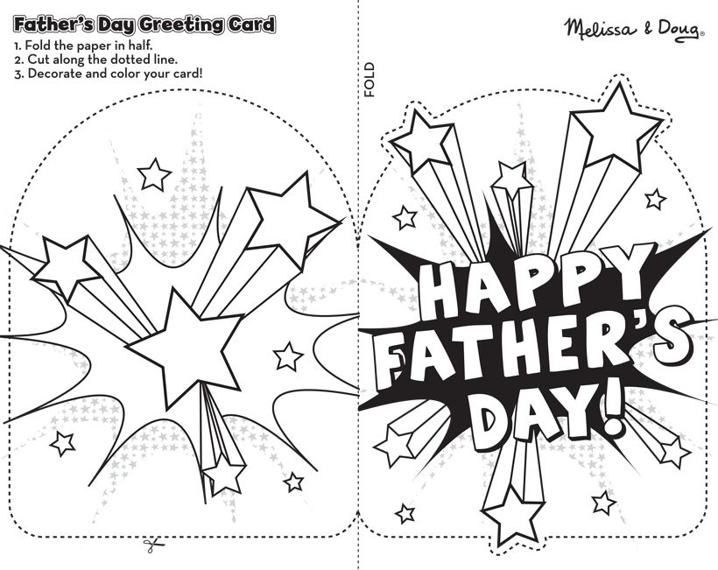
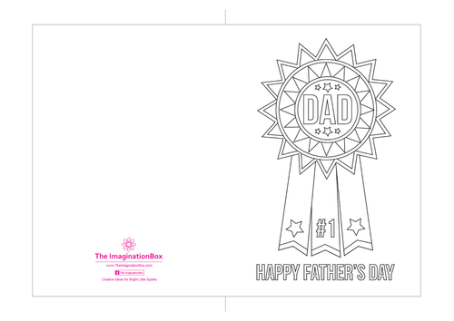

Re


